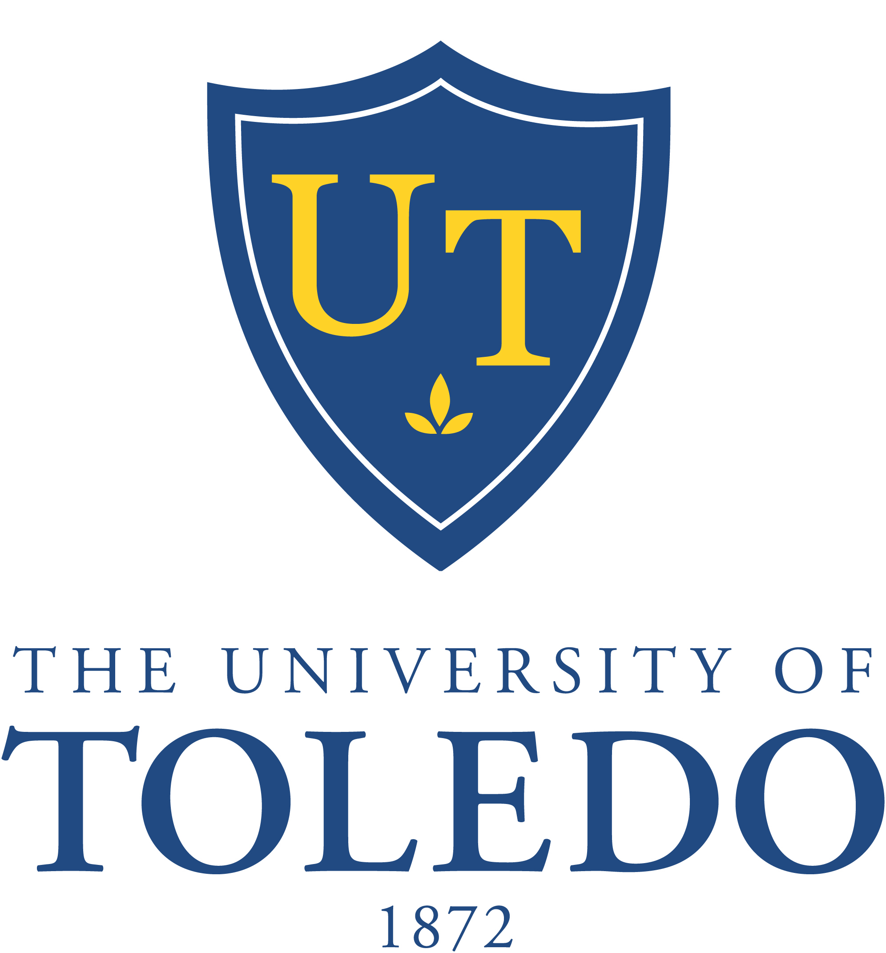

59th Meeting of the Board of Trustees

Monday, November 18, 2013
Driscoll Alumni Center, Schmakel Room
1:00 p.m.

- Call to Order

- Meeting Minutes
  - Board Meeting – September 16, 2013 (Recommended Action: Approval)
  - Committee Meetings (Information)
    - Clinical Affairs – September 17, 2013
    - Finance and Audit – October 7, 2013
    - Trusteeship and Governance – October 7, 2013
    - Academic and Student Affairs – October 15, 2013
    - Clinical Affairs – October 15, 2013

- Consent Agenda (Recommended Action: Approval)
  - Personnel Action Reports – October 15, 2013
  - Resolution No. 13-10-16: “Approval of Candidates for Degrees – Fall 2013 and Spring 2014”
  - Resolution No. 13-10-17: “Capital Request From Reserves”
  - Honorary Degree Nomination: Mr. Michael Morris
  - Compliance Plan for Health Care Operations
  - FY 2013 Plante & Moran Audited Financial Statements

- Committees
  - Academic and Student Affairs
    - Personnel Action Reports – November 18, 2013 (Recommended Action:
Approval)
- Proposed Bachelor of Arts Degree in Disability Studies (Recommended Action:
Approval)
b) Clinical Affairs
    - Review of September and October Committee Meeting Minutes (Recommended
Action: Acceptance)
    - Revised Resolution No. 13-10-18: “Inpatient Rehabilitation Hospital at The University
of Toledo” (Recommended Action: Approval)
    - Naming Opportunity: College of Medicine and Life Sciences Endowed Professorship in Nephrology (Recommended Action: Approval)
- Finance and Audit
    - Resolution No. 13-11-19: “On-Campus Housing Ground Lease Authorization”
(Recommended Action: Approval)
- Trusteeship and Governance

- Executive Session to discuss AAUP union negotiations

- Other Business

- Adjournment

