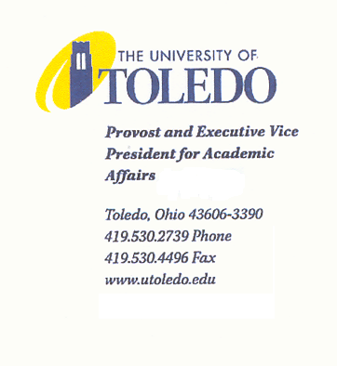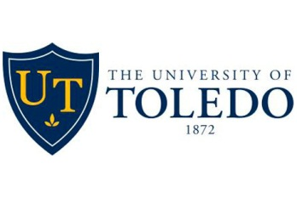October 1, 2015

TO: John A. Barrett, JD
Interim Provost and
Executive Vice President for Academic Affairs
FROM: Patricia Komuniecki, PhD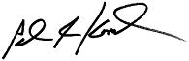
Vice Provost for Graduate Affairs and
Dean, College of Graduate Studies
Co-Chair, Academic Honors Committee

Dorothea Sawicki, PhD
Vice Provost for Health Sciences and University Accreditation
Co-Chair, Academic Honors Committee

RE: Nomination for Ms. Christi Paul for an Honorary Degree

The Academic Honors Committee (AHC) has voted to recommend the nomination of Ms. Christi Paul to the Board of Trustees for consideration for an honorary degree, to be conferred at the Fall Commencement. As you know, Ms. Paul has accepted the invitation of President Gaber to be the Fall 2015 Commencement speaker and the AHC recommends that this nomination go the Academic and Student Affairs Committee of the Board of Trustees at its upcoming meeting on Monday, October 12th, and subsequently become part of the consent agenda for the UT Board of Trustees at its November meeting. If approved, the honorary degree would be conferred at the Fall Commencement on December 19, 2015.
Ms. Paul is from Bellevue, Ohio and she graduated from The University of Toledo in 1993 with a B.A. in Communication with a focus on broadcast journalism. She spent many years working as a reporter/anchor at television stations across the nation including WDTV in West Virginia, KTVB in Boise, Idaho, KNXV and the CNN Affiliate KTVK in Phoenix, Arizona. In 2003, Ms. Paul accepted a position with CNN in Atlanta and since then has served as an anchor on Morning Express with Robin Meade and Headline News. Currently, she is the weekend anchor of CNN New Day as well as anchoring and reporting on HLN's The Daily Share during the week. Over the years, Ms. Paul has been at the forefront of many major news stories of our time, including Presidential Inaugurations, high profile trials, as well as national disasters and tragedies.
Notably, Ms. Paul also has been very active in social justice issues. With the National Center for Missing and Exploited Children (NCMEC) in Washington, DC, she was a co-founder of "Find Our Children". Indeed, in 2012, the NCMEC honored Ms. Paul with their prestigious Hope Award- an award she shares with past winners that include former Secretary of State Colin Powell, then Senator Joe Biden, and actor Ben Affleck. Ms. Paul also serves on the National Advisory Council for the One Love Foundation, Starlight Starbright Children’s Foundation, Safe Kids, Georgia and is also involved with Girl Talk Inc., an organization that has high school girls mentoring middle school girls to help build self-esteem and combat bullying. She was recognized by The University of Toledo as an Outstanding Alumna of the former College of Arts and Sciences in 2006.
Given all of the accomplishments and service activities noted above, the Academic Honors Committee recommends that The University of Toledo confer upon Ms. Christi Paul the Honorary Degree of Doctor of Humane Letters, honoris causa. Please refer to the attached for more detailed biographical information about Ms. Paul and her career.

Attachment – additional information for Ms. Paul

Christi Paul
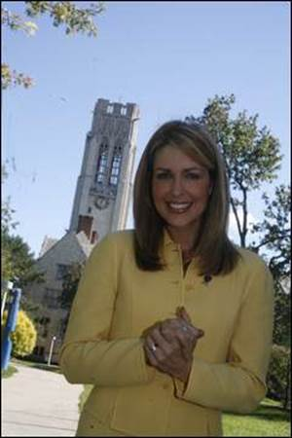
CNN Anchor/Reporter and Host of the CNN Weekend New Day and HLN’s The Daily Share programs
Ms. Paul is from Bellevue, Ohio and she graduated from The University of Toledo in 1993 with a B.A. in Communication with a focus on broadcast journalism. She then began her career at WDTV in Clarksburg, West Virginia as a “one-man band” –a person who serves as a news reporter/editor, photographer and anchor. After that, her broadcast journalism career took her to the NBC Affiliate KTVB in Boise, Idaho where the Idaho Press Club honored her for her series about Julianne Prudhomme, a 4-year old girl who underwent a 5-organ transplant.
After spending several years at KTVB, Ms. Paul moved to Phoenix, Arizona where she worked as a news anchor, consumer reporter and weathercaster, first at the ABC Affiliate KNXV and then at the CNN Affiliate KTVK. At the CNN Affiliate, Ms. Paul created a segment with the Arizona Humane Society that helped hundreds of abandoned animals find new homes with families in the valley.
In 2003, Ms. Paul accepted a position with CNN and over the years she has served as an anchor on Morning Express with Robin Meade and Headline News. Currently, she is the weekend anchor of CNN New Day as well as anchoring and reporting on HLN's The Daily Share during the week.
In her current roles, Ms. Paul has been at the forefront of many major news stories including the following:
- covering President Obama's 2nd Inauguration in Washington, DC, as well as other Presidential elections,
- anchoring the coverage of the 2012 Sandy Hook, Newtown, CT school shooting (she was on the news desk during the first 5 hours as the story was breaking) and also the 2007 Virginia Tech campus shooting,
- reporting extensively on Hurricane Sandy and its aftermath in fall 2012,
- securing an exclusive interview with Vice-President Joe Biden in 2013, talking about his motivation to combat domestic violence as well as addressing issues with the Obamacare website rollout, and
- covering high profile court cases, including the Casey Anthony, Warren Jeffs, Drew Peterson and Dr. Conrad Murray trials.

Ms. Paul also has been very active in social justice issues. She went beyond simply reporting the news stories about missing children to taking action by founding "Find Our Children"-a partnership with The National Center for Missing and Exploited Children (NCMEC) in Washington, DC. Since HLN featured a segment about missing children and asking viewers to help find them, 35 of the profiled children have been brought home safely to date. In 2012, the NCMEC honored Ms. Paul with their prestigious Hope Award- an award she shares with past winners that include former Secretary of State Colin Powell, then Senator Joe Biden, and actor Ben Affleck.
As noted above, Ms. Paul secured an exclusive HLN interview with Vice President Joe Biden who spoke with her on air at the National Domestic Violence Hotline headquarters in Austin, Texas to commemorate National Domestic Violence Awareness Month. Ms. Paul is a longtime advocate for domestic violence awareness and has written a book entitled “Love Isn’t Supposed to Hurt” that discusses her personal journey in overcoming verbal and emotional abuse. Upon its publication, it rocketed to Amazon's top 20. Partial proceeds from her 2012 book go to support the National Domestic Violence Hotline. She also recorded two songs in Nashville that coincided with the book - "Wake Up In It" and "Free" (on iTunes).
Ms. Paul is a wife and mother of 3 daughters with a passion for helping children and teens. She serves on the National Advisory Council for the One Love Foundation in honor of Yeardley Love, the University of Virginia lacrosse player beaten to death by her boyfriend. She is also involved with Girl Talk Inc., an organization that has high school girls mentoring middle school girls to help build self-esteem and combat bullying. She also serves on the board of Safe Kids, Georgia and is an ambassador for the Starlight Starbright Children’s Foundation. She was recognized by The University of Toledo as an Outstanding Alumna of the former College of Arts and Sciences in 2006.

