INITIATE Lesson Plan: Who makes up this population
Lesson plan at a glance...  Name: Who makes up this population  Course: Demographics  Grade Level: 9th to 12th  Prerequisites: How to surf internet  Time: Preparation: 2 minutes Instruction: 1 hour  Standard(s): | In this lesson plan…  - Lesson Overview  - Driving Questions  - Materials and Equipment  - Preparation Tasks  - The Lesson  - Learning Objectives and Standards  - Additional Information and Resources

Lesson Overview
In this lesson students will learn how to look for demographics’ status of different types population and make sense out of those.

Driving Questions
Overarching Driving Questions for Bowsher Wide Project:
- How the smart car technology affects the differently abled people?
Lesson Specific Question:
- Who makes up this population?

Materials and Equipment
- Tablets
- Internet Connection

Preparation Tasks
 | Connect your tablets to the Wi-Fi and open google. | 2 minutes

The Lesson
Warm-up Activity: Overview of the lesson’s objective | 10 minutes
Activity 1: Find the demographics based on Age Groups | 15 minutes
Activity 2: Find the data for types of disabilities people have | 25 minutes
Wrap-up Activity: Discussion | 10 minutes

Warm-up Activity: Title (10 minutes)
Activity Overview: In this activity, teacher will explain how this lesson plan is important.

Activity: In this activity, teacher will explain why automation transportation is a trending topic nowadays. A video will be played for better understanding. (https://www.youtube.com/watch?v=OGrDUx14sEs )
After this video, teacher will ask the students to discuss what do they think about who makes up this population?

Activity: Find the demographics based on Age Groups (15 minutes)
Activity Overview: In this activity, students will surf internet to get the data of demographics based on different age groups.

Section 1: What is the demographic status of Ohio based on age groups? (25-30 minutes)

Problem Statement: Look for Demographics for Ohio (not older than 2018) and present different types of population (which will matter for deciding the number of populations benefitting from automated transportation) in a graphical form.
What is the population of Ohio based on different age groups? Find the percentage of the combined specific age groups (both and female) and create a graph.

Note: Graphs should be presented in percentage values for better understanding.

Solution: https://www.infoplease.com/us/comprehensive-census-data-state/demographic-statistics-48 For Lucas County

- http://worldpopulationreview.com/states/ohio-population/
- https://www.census.gov/quickfacts/oh
- https://www.infoplease.com/us/comprehensive-census-data-state/demographic-statistics-48

Solution:
For link no.1 :> The link has the distribution of OHIO population based on race and ethnicity. Transportation system does not get affected based on this.
For link no.2 :> It provides the demographic data based on age groups. It divides the total population into 3 categories: Under 5 years, under 18 years and 65 years and over. But when we add the data it does not give us 100 percent. Thus, this one does not contain clear understanding.
For link no.3:> it provides the data accurately based on age groups. But the data is old (last updates: 2018).
For link no.4:> This has the data which we require. But in numbers. They must find out the percentage values and make the graph out of it.

Data Given in the Link:

The data is divided into two parts: Male and Female. For transportation, gender does not matter. Thus, they must combine respective same age groups and convert it into percentage.

Total Population: 11,230,238
For age group under 5 years: 367032(male) + 352953(female) = 719985
Percentage = (719985/11230238) * 100 = 6.41%Detailed solution. Any expression in words if required, include it.

Teaching Tips:Ask them to modify the age groups. For ex, 14-19, younger working population (20-44) , older working age group ( 45-64), and senior citizens (65+)
- Teacher should let the students to find out the data by their own.
Have to come up with a nice closure
What is the CONCLUSION?
Write down the final discussion which should be at the end.
Focus on the age group 65+ for the trip table.
Captions and labels for each graph.
Come up with my own possible narrative for each solution
Keywords in Teaching Tips Section

Activity: How can we make the data of the disabled population suffer from transportation
Activity Overview:
Section 1: What is the prevalence of disability among non-institutionalized people of all ages in the United States?

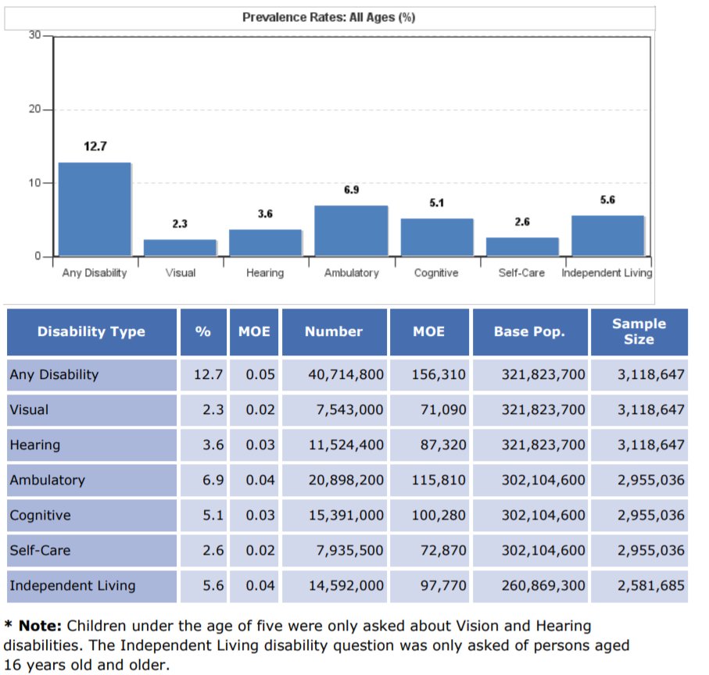

Section 2: Do different types of disability affect ability to move, walk or drive?

https://www.ncbi.nlm.nih.gov/books/NBK11420/

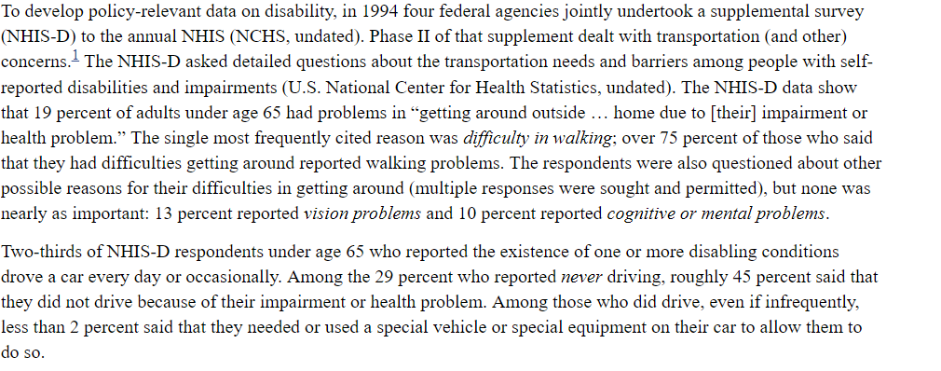

Type the whole screen shot and re-arrange the paragraphs to make more sense.
Section 3: Does people with disabilities who can drive suffer due to bad weather conditions or busy traffic?

https://www.ncbi.nlm.nih.gov/books/NBK11420/

(Table G-3)

Section 4: What is the demographic status of Ohio based on age groups? (25-30 minutes)

Problem Statement: Look for Demographics for Ohio (not older than 2018) and present different types of population (which will matter for deciding the number of populations benefitting from automated transportation) in a graphical form.
What is the population of Ohio based on different age groups? Find the percentage of the combined specific age groups (both male and female) and create a graph.

https://www.infoplease.com/us/comprehensive-census-data-state/demographic-statistics-48 For Lucas County

Section 5: What is the travel-limiting disability reporting rate by age groups?

https://www.bts.gov/topics/passenger-travel/travel-patterns-american-adults-disabilities

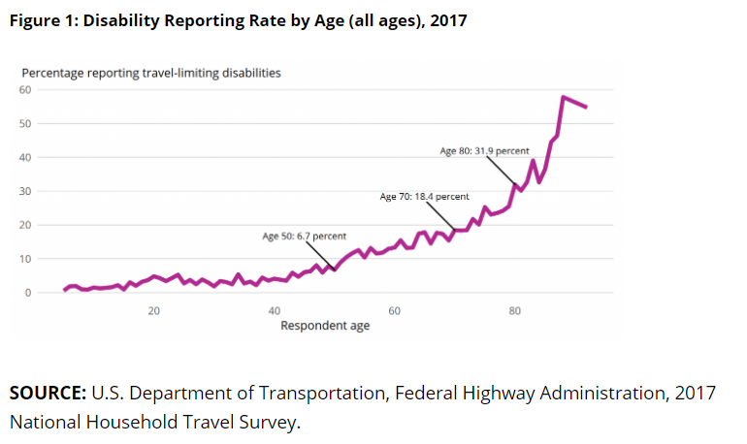

Section 6: How do Employment and Household Income differ for people with Disabilities?

https://www.bts.gov/topics/passenger-travel/travel-patterns-american-adults-disabilities

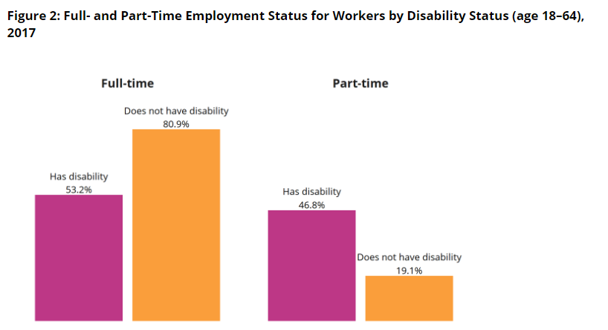
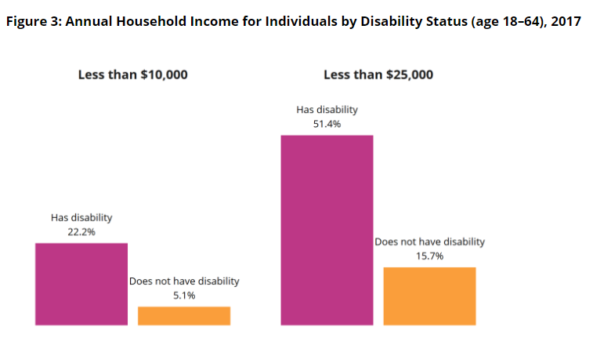

Section 7: How Do Vehicle Ownership and Vehicle Access Differ for People with Disabilities?

https://www.bts.gov/topics/passenger-travel/travel-patterns-american-adults-disabilities

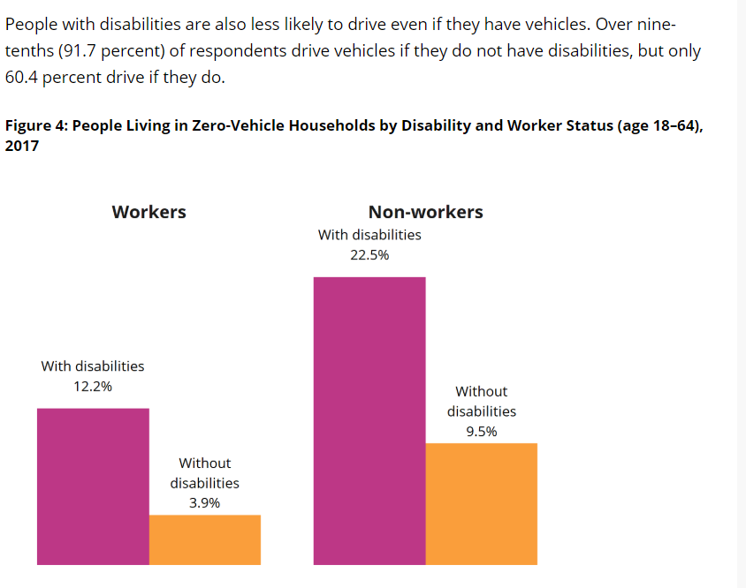

Section 8: How Does Travel Vary by Trip Purpose?

https://www.bts.gov/topics/passenger-travel/travel-patterns-american-adults-disabilities

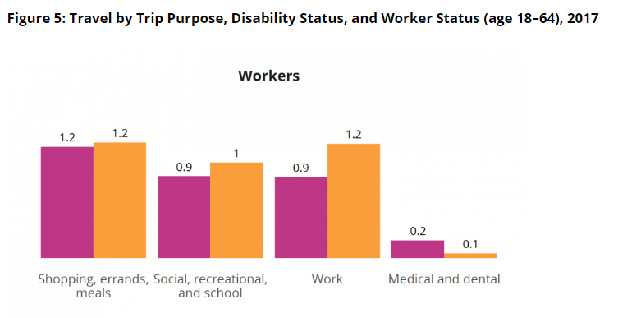
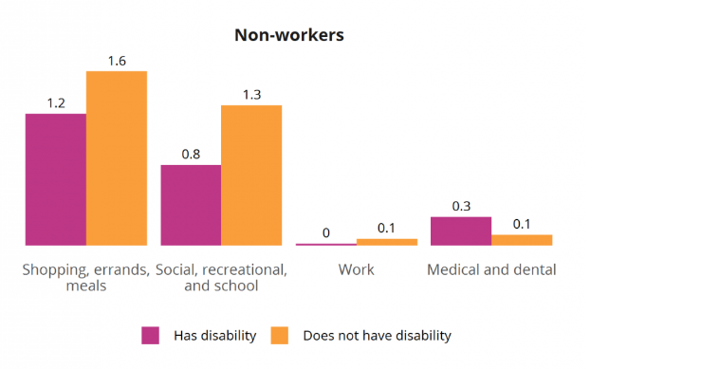
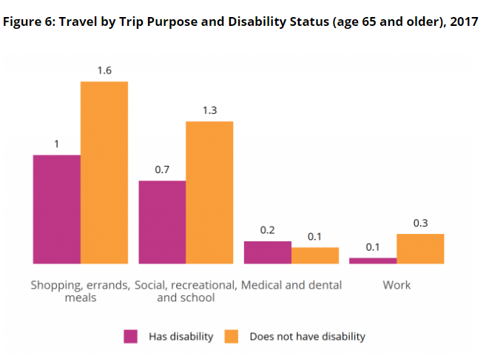

Section 9: How Does Mode Choice Differ?

https://www.bts.gov/topics/passenger-travel/travel-patterns-american-adults-disabilities

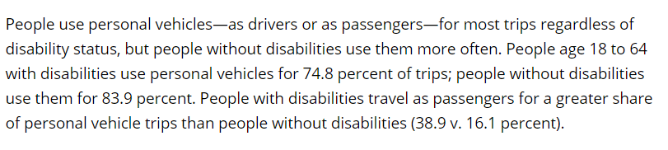

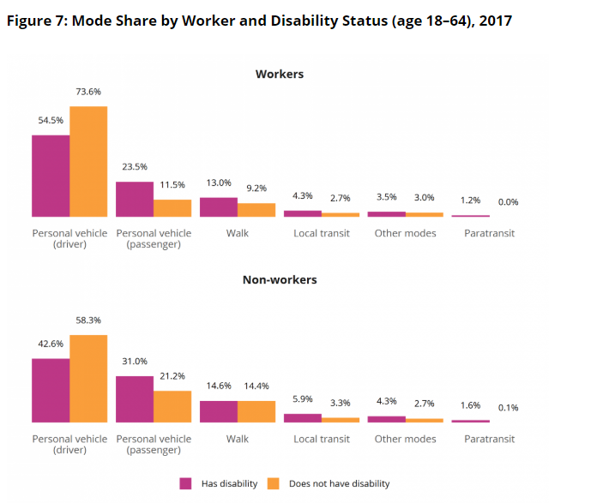

If they type “disabled people suffer from transportation” the first link they will get is https://dreamscapefoundation.org/why-accessibility/?gclid=CjwKCAjwq-TmBRBdEiwAaO1enyis4Wnqr52Uv_UkVhVu4oTllR54Exbre6KOJsn-eXUTCJqhi8swYRoCfQQQAvD_BwE. But this link will tell them that what percent of disabled people are employed (only 35%). Means around 65% disabled people from working age group are unemployed. What can be the reasons? Their inability to work or somehow transportation is also a huge hindrance for certain portion of this group?
The second link which will they get is https://www.ncbi.nlm.nih.gov/books/NBK11420/. If they read through this article, they will understand transportation is a problem for many disabled people.
The third link https://www.bts.gov/topics/passenger-travel/travel-patterns-american-adults-disabilities will describe how is the travel limiting disabilities cost these group of population.
To help them understand the distribution of demographics based on age groups and types of disabilities, guide them to
https://www.bts.gov/topics/passenger-travel/travel-patterns-american-adults-disabilities
What portion of the population can get benefitted from the transportation service?
What age groups may get benefitted most?
Is lack of transportation is getting obstacle for employment?
How is the travel limiting disabilities cost these group of population?
Note: Articles should not be older than 2017.

As there are many types of disabilities, each causes different problems. To have an idea of how many people may have the real need of transportation, we should find out the data for different types of disabilities. Ask them to create their own graph from the found data based on different age groups. Define specific graphs, data which I want them to show.
How many types of disabilities are there in this population?
We will know what types of data they are going to see; such that based on that prepared set of questions such that they will focus on those graphs.
Ask them to make claims and come up with data to prove their claims.
2017

Solution: Guide them to https://disabilitycompendium.org/sites/default/files/user-uploads/2017_AnnualReport_2017_FINAL.pdf.
To create their own graph direct them to https://beam.venngage.com/

Section 2: Problem Statement (15 minutes)
Based on different types of disabilities, represent a graph which will show the impact on employment rate.
Solution: Guide them to https://rudermanfoundation.org/wp-content/uploads/2017/08/Self-Driving-Cars-The-Impact-on-People-with-Disabilities_FINAL.pdf
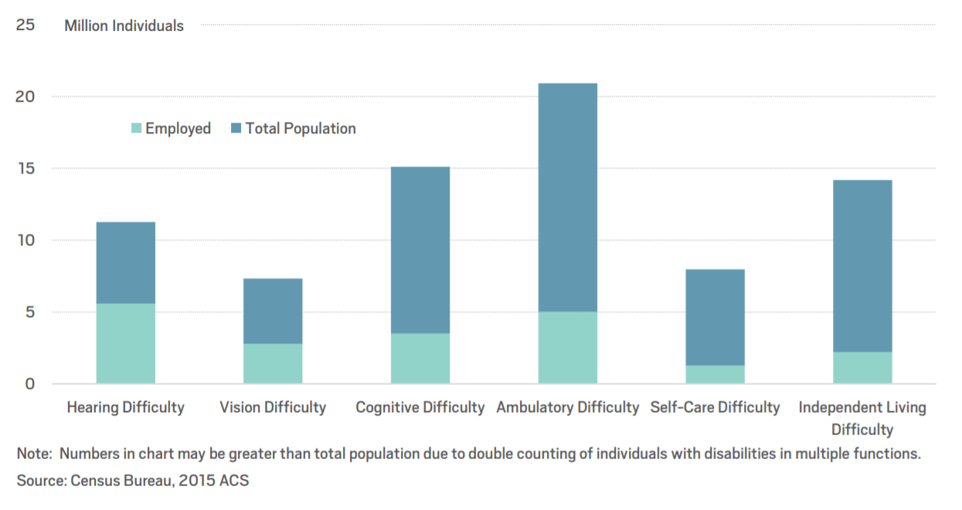
Ask them to create a graph where the bars of employed and total population are not overlapping for better understanding (In percentage). (label the following graph)
What this data could mean? For example, people with vision disability will need the transportation more.

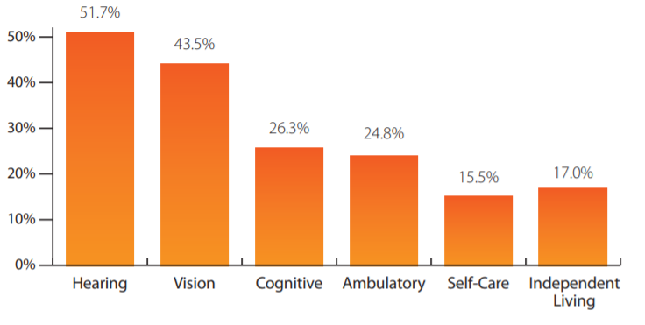
Section 3: Transportation modes (10 minutes)
Ask the teachers to describe that how physically challenged people suffer from availing different types of transportation from a presented graph. (https://rudermanfoundation.org/wp-content/uploads/2017/08/Self-Driving-Cars-The-Impact-on-People-with-Disabilities_FINAL.pdf)

Solution:
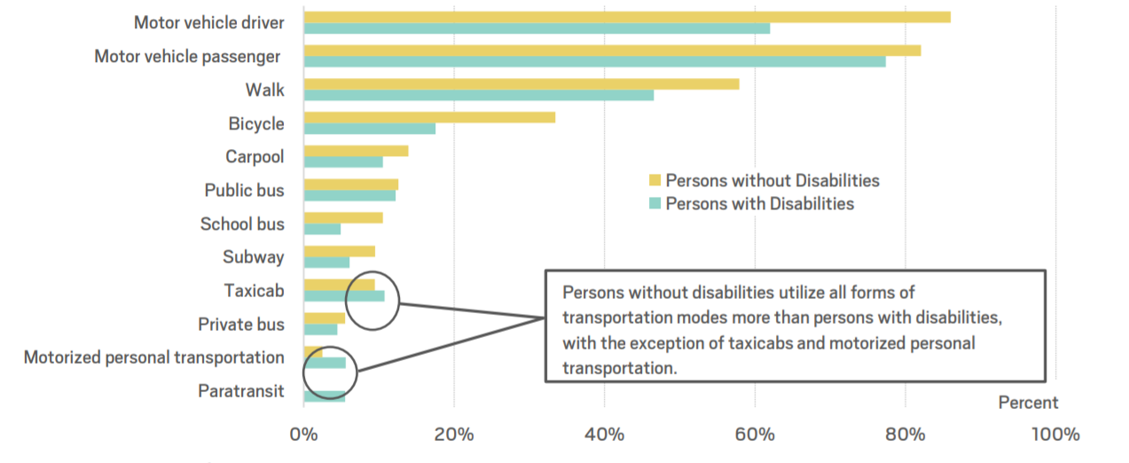

Teaching Tips:
- Teacher should let the students to find out the data by their own.

Learning Objectives and Standards
Learning Objectives | Standards

Additional Information and Resources

Project-based Learning Features
Feature | Where does this occur in the lesson?
Driving Question | At the beginning of this lesson. The question was how to make smart cars more convenient and safer. To make more convenient the smart car should be able to navigate by itself. In this lesson plan, the students have learnt what mathematical calculations could be done to make a smart car capable to navigate itself.
Making Sense of Data | In Activity 1, the students had to come up with the idea after reading the linear equations that those have to be changed into the standard form of a straight line.  In Activity 3, the students had to make sense of the given data to create the functions.
Investigation and Problem Solving | In Activity 2, the students had to investigate the given figure, and think about the possible ways in which the problem could be solved.  Also in Activity 3, the given data had to be investigated by the students to get converted into the form of functions.
Technology Incorporation | In every activity, the students may had used the calculators to calculate the values. Nonetheless, they have used their smart cars and tablets to program the cars.  Also in Section 5 of Activity 3, students are using Microsoft Excel to solve the problem.
Collaborative Opportunities | In every activity, student share their ideas, procedures, and solution with each other.
Assessment Techniques | Activity 2 was a continuous process of the previous activities because it was using all the concepts used in the earlier activities.

Computational Thinking Concepts
Concept | Where does this occur in the lesson?
Decomposition | In activity 2 students are breaking down the problem in smaller problems like the warm up activity and activity 1.
Data Representation | In Activity 3 and Activity 4, students are depicting and organizing data in appropriate graphs, charts, words, or images.
Pattern Generalization: | In Activity 3 and Activity 4, students were creating models and theories of observed patters to test predicted outcomes.
Algorithm Design: | In Activity 2, students are creating an ordered series of instructions for solving similar problems or for doing a task.

Administrative Details
Contact info:
Sources:
Date Written:
Template adapted from: | https://edu.google.com/resources/programs/exploring-computational-thinking/

