INITIATE Lesson Plan: How will attractions like the Toledo Zoo use smart car technology for people with disabilities?
Lesson plan at a glance...  Name: Design the routes for Toledo Zoo  Course: Algebra, Geometry, Trigonometry  Grade Level: 9th to 12th  Prerequisites: How to use rulers and protractor  Time: Preparation: 2 minutes Instruction: 2 hours  Standard(s): | In this lesson plan…  - Lesson Overview  - Driving Questions  - Materials and Equipment  - Preparation Tasks  - The Lesson  - Learning Objectives and Standards  - Additional Information and Resources

Lesson Overview
In this lesson students will learn how to imitate the Toledo zoo map for designing routes. Then they will program their respective cars to move along the designed routes.

Driving Questions
Overarching Driving Questions for Bowsher Wide Project:
- How the smart car technology affects the differently abled people?
Lesson Specific Question:
- How to design routes in Toledo Zoo for autonomous pods?

Materials and Equipment
- Tablets
- Internet Connection
- Large White Sheet
- Rulers
- Protractors

Preparation Tasks
 | Connect your tablets to the Wi-Fi and open google. | 2 minutes

The Lesson
Warm-up Activity: Overview of the lesson’s objective | 10 minutes
Activity 1: Toledo Zoo Model | 90 minutes
Activity 2: Bloxter Programming | 90 minutes
Wrap-up Activity: Discussion | 10 minutes

Warm-up Activity: Title (10 minutes)
Activity Overview: In this activity, teacher will explain how this lesson plan is important.

Activity: In this activity, teacher will explain why they are going to design routes inside Toledo Zoo? As this is one of the most popular attractions of Toledo. If a route can be designed for para-transit inside the zoo, it may become a wonderful service for disabled people.

Activity 1: Toledo Zoo Model (90 minutes)

Problem Statement: Design possible routes with the help of a pencil and ruler on the Toledo Zoo map. Draw a larger version (23x) of Toledo Map with stops on the big joint white trifolds (2x8) given to you with designed routes for an autonomous pod.

Analyze the respective map sections given to each group:
- Group 1
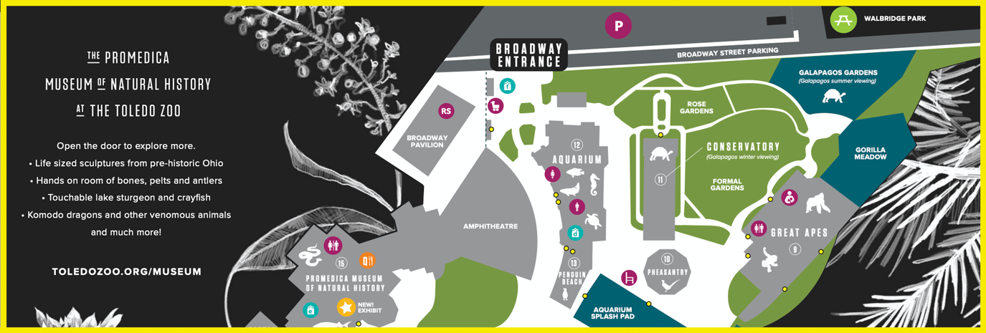
- Group 2
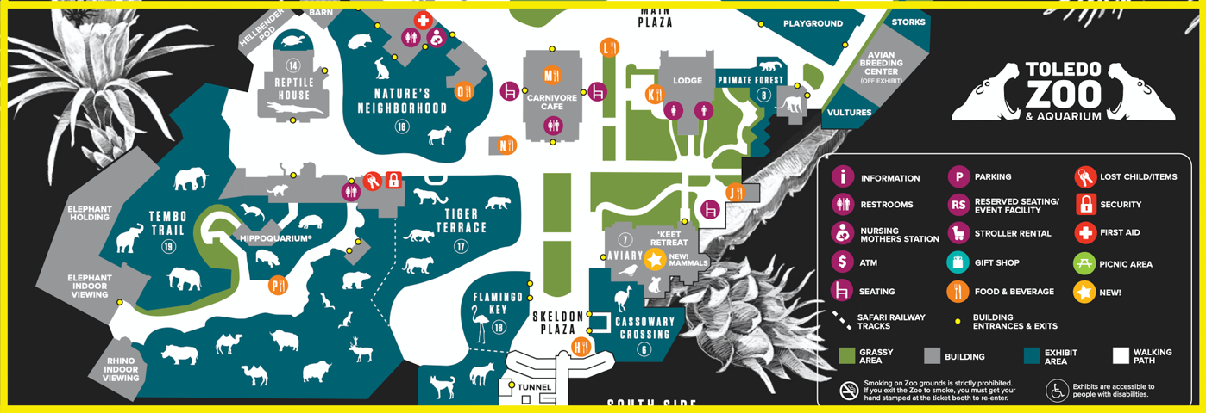

- Group 3
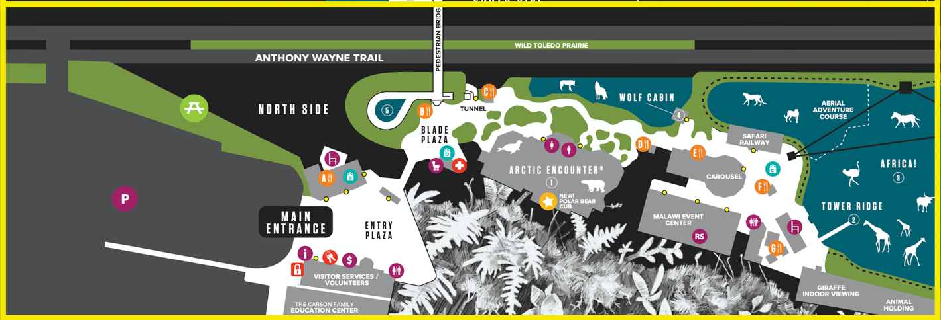

The merging points on each section of the map are fixed. Examples are given below:
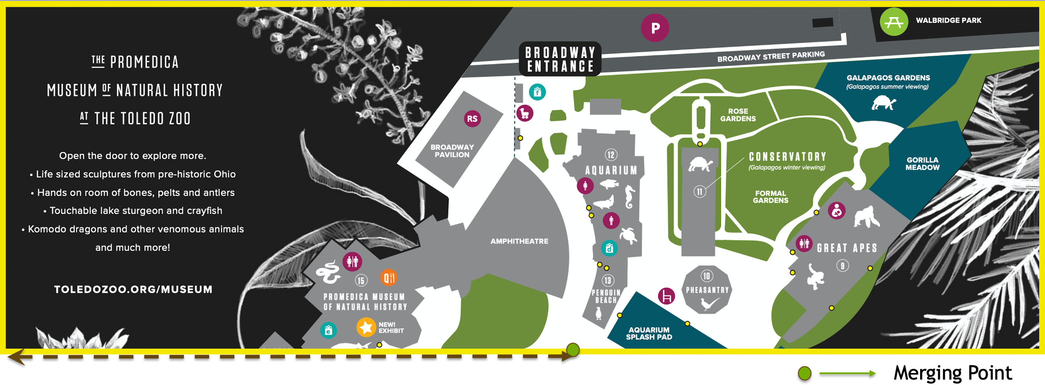
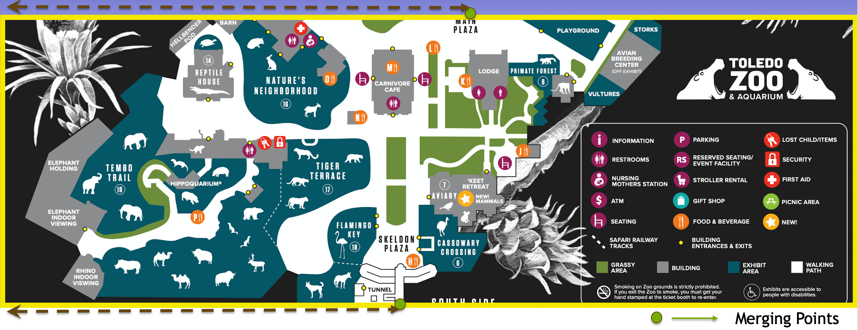
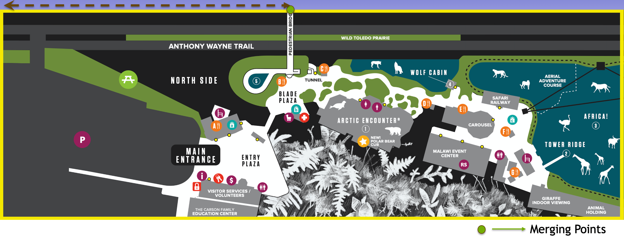

Break a non-straight possible path into multiple straight paths:

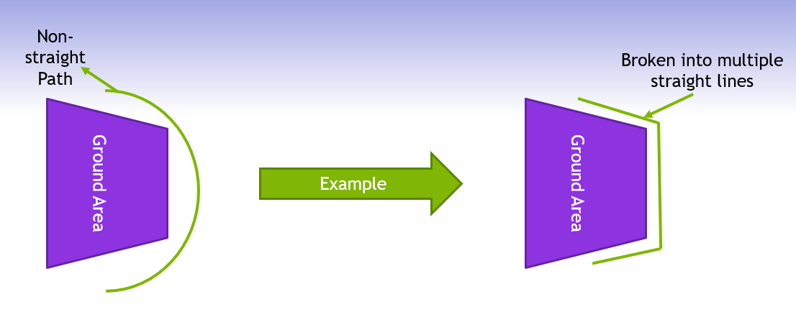

Assign a number to the joint of every two straight lines:

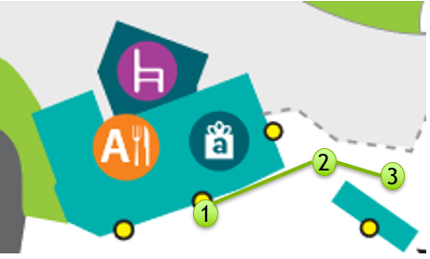

At least one entrance of each building must be covered by the route. (It is denoted by the marked legend in the legends box below:

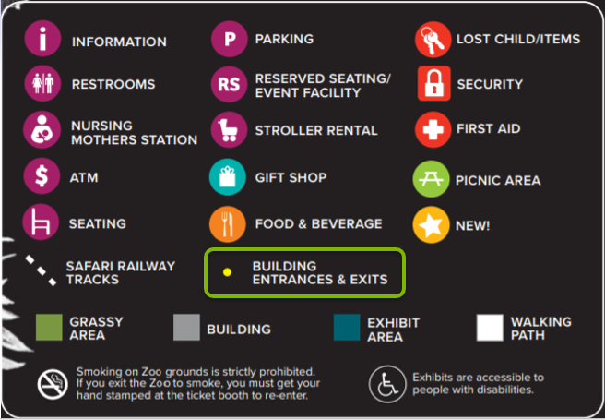
Example of designed routes in one of the map sections:
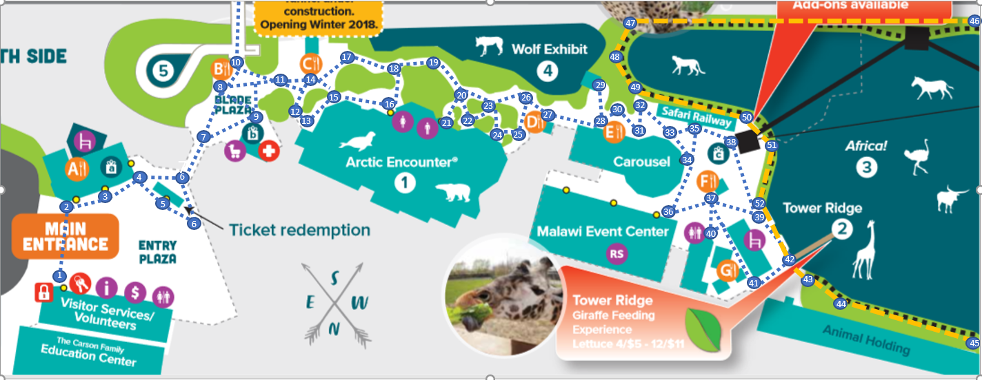

Measurements:
- Measure the distance of the merging points from the left border of the big white board.
- With respect to the merging points measure the rest of the map.
- Measure the distance between two adjacent points.
- Measure the angle between two joining lines.

Increase the ratio:
- Multiply the lengths of each path by 23.
- Keep the angles as they are.
- Note down the final measurements.

Draw The model:
- First mark your respective starting points on the large trifold (merging points).
- Using a pencil, ruler, protractor, etc., construct the rest of your scaled-up route (line segments) using your earlier measurements.

Run your GoPiGo car according to planned route:
- Use black tapes for your routes on the big white board.
- Program your car to follow the route accordingly.
- Record the time taken for the car to cover the whole map.
- The optimum route will be the one in which all the requirements are met in the least time taken.

Things to keep in mind for Bloxter Coding:
- At every entrance/exit of a building that the route covers, the car should stop for 5 seconds.
- The autonomous pod should stop whenever someone crosses its path, and resume its course after the person has moved aside.
- In dark areas (tunnels) the speed must be reduced by 20%.

Solution:
Analyze the respective printouts of Toledo Zoo and identify the required spots to design a route.
Draw the possible paths on the printouts. Scale the distance between two adjacent spots with a ruler and measure the angles with a protractor. Note these measurements down.
Use the multiplied distance and the original angles to draw the map with routes on the trifold.
The Merging points of each section of the map has to be assigned first on the trifold. Measure the distance of the merging points from the left boundary of the map handouts and apply it on the big trifold in the same way.
Multiply each measured distance by 23.

Keep in mind:
The Physically challenged passengers must be dropped in front of the entrances/exits. Stops can be drawn by small circles.
Assign one spot to the junction of the designed route and the safari railway track.
At least one entrance/exit of each building (can choose multiple entrances according to the convenient path) must have a stop.
The required stops should be circled and given a number.

Solution:

In this activity you have used abstraction to ignore the unnecessary spaces on the maps, decomposition to break down the whole map into smaller parts and pattern recognition to recognize the possible paths through the map.

Alternative Scenario: If they have enough time left then they will program the GoPiGo car with length of each segments and the intersection angles. Otherwise, they can just use the line follower.

Activity 2: Bloxter Programming (90 minutes)

Activity Overview: Feed the derived measurement to the gopigo car and record the time for each possible route.
Problem Statement: Run your GoPiGo car along the route on the large sheet to determine the most efficient path. The car must stop for 5 secs at each entrance (which is covered by the deigned route) of every building.

Solutions: At first, calibrate the line follower. Select the “line follower” sensor on the right-hand side panel like following:
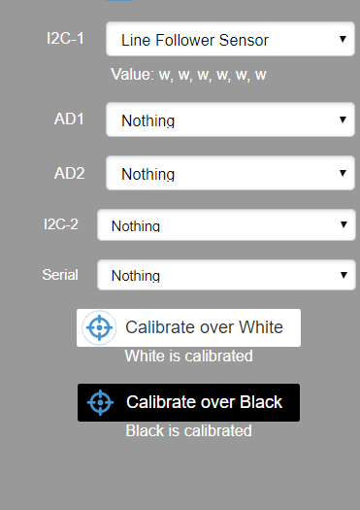
Keep the line follower on white colored surface and click “Calibrate over White”, then keep it on the black colored tape (The line follower sensor should be covered properly by the tape) and click on “Calibrate over Black”).

Use the following commands to make your gopigo follow the designed route:

First set speed to either “slowest” or “20%”.
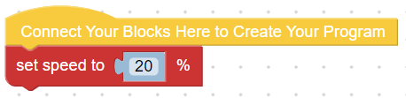

The use the command “Follow the line”

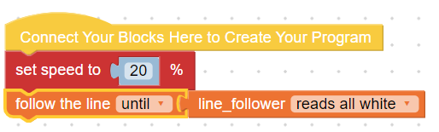

For the turns which can be detected by the sensor using “follow the line” command, use the command mentioned below:

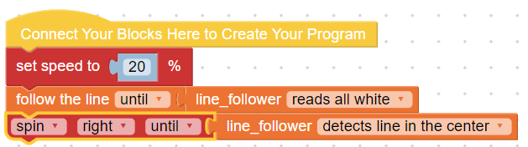
(For right turns)

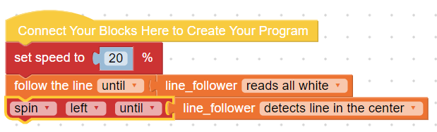
(For left turns)

Here they have used the pattern recognition to analyze the routes and algorithm design before writing the codes for the bloxter programming.

Wrap up Activity: Discussion (10 minutes)
Students may discuss using these types of functionalities of the “line follower” sensor, what else they can do? For example, if they want to make the cars stop for 5 seconds at some specific point on the route, they can put some black tape across the original route (at least the length of the line follower) so they can use the command like:
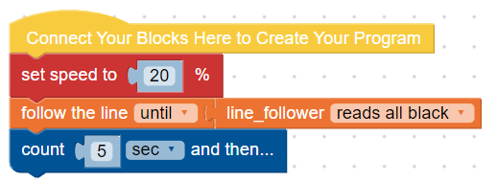
Also, they can discuss how they can include other safety measures for the car using “distance sensor” to incorporate the real-life idea of any pedestrian coming on the way of the autonomous pod.

Learning Objectives and Standards
Learning Objectives | Standards
Use units as a way to understand  problems and to guide the solution of multi-step problems; choose and  interpret units consistently in formulas; choose and interpret the scale and the origin in graphs and data displays | N.Q.1
Define appropriate quantities for  the purpose of descriptive modeling | N.Q.2

Additional Information and Resources

Project-based Learning Features
Feature | Where does this occur in the lesson?
Driving Question | At the beginning of this lesson. The question was how to model Toledo Zoo.
Making Sense of Data | In every activity, students are making sense of data given in the map of Toledo Zoo.
Investigation and Problem Solving | In all activities students are investigating the given map to come up with the required and appropriate stops to design the routes.
Technology Incorporation | In every activity, the students are using rulers, protractors and calculators.
Collaborative Opportunities | In every activity, are working in groups.
Assessment Techniques | Activity 2 was a continuous process of the previous activities because it was using all the concepts used in the earlier activities.

Computational Thinking Concepts
Concept | Where does this occur in the lesson?
Decomposition | In all activities, students are breaking down the problem in smaller problems.
Data Representation | The measurements they collected from the Toledo zoo map, have been used for increasing the scale of the entire map.
Pattern Recognition | For designing the routes, students have to analyze the optimum route.
mAlgorithm Design: | Before doing Bloxter programming, students must design algorithm for it.

Administrative Details
Contact info:
Sources:
Date Written:
Template adapted from: | https://edu.google.com/resources/programs/exploring-computational-thinking/

