INITIATE Lesson Plan: Transportation Needs of People with Disabilities

Lesson plan at a glance...  Name: Transportation Needs of People with Disabilities  Course: Demographics  Grade Level: 9th to 12th  Prerequisites: -  Time: Preparation: 2 minutes Instruction: 85 minutes  Standard(s): - S-ID: Summarize, represent, and interpret data on a single count or measurement variable: 1. Represent data with plots on the real number line (dot plots, histograms, and box plots). 2. Use statistics appropriate to the shape of the data distribution to compare center (median, mean) and spread (interquartile range, standard deviation) of two or more different data sets. - S-IC: Understand and evaluate random processes underlying statistical experiments: 1. Understand statistics as a process for making inferences about population parameters based on a random sample from that population. | In this lesson plan…  - Lesson Overview  - Driving Questions  - Materials and Equipment  - Preparation Tasks  - The Lesson  - Learning Objectives and Standards  - Additional Information and Resources

Lesson Overview
In this lesson, students will learn about the transportation needs of people with disabilities, destinations, trip times, and the ratio of the trips per week as well as their employment status.

Driving Questions
Overarching Driving Questions for Bowsher Wide Project:
- How will autonomous vehicles affect the differently abled people of our society?
Lesson Specific Question:
- Which part of population may get benefitted from autonomous transportation?

Materials and Equipment
- Tablets
- Internet Connection

Preparation Tasks
 | Connect your tablets to the Wi-Fi and open google. | 2 minutes

The Lesson
Warm-up Activity: Overview of the lesson objective | 5 minutes
Activity 1: Interpret the data for disability status, employment status, purpose of trip and trip ratio per week | 20 minutes
Activity 2: Why is paratransit important for this portion of the population (based on times leaving home per week) | 10 minutes
Activity 3: Interpret the data available online for people with zero-vehicle households considering disability and employment status | 20 minutes
Wrap-up Activity: Discussion | 30 minutes

Warm-up Activity: Information and Data Gathering (5 minutes)
Activity Overview: In this activity, teacher will explain how this lesson goes forward.

Activity: In this activity, teacher will explain the importance of paratransit and transportation methods available to people with disabilities. The teacher utilizes the slide regarding “medical appointments missed due to the lack of transportation in the US” as an introduction.
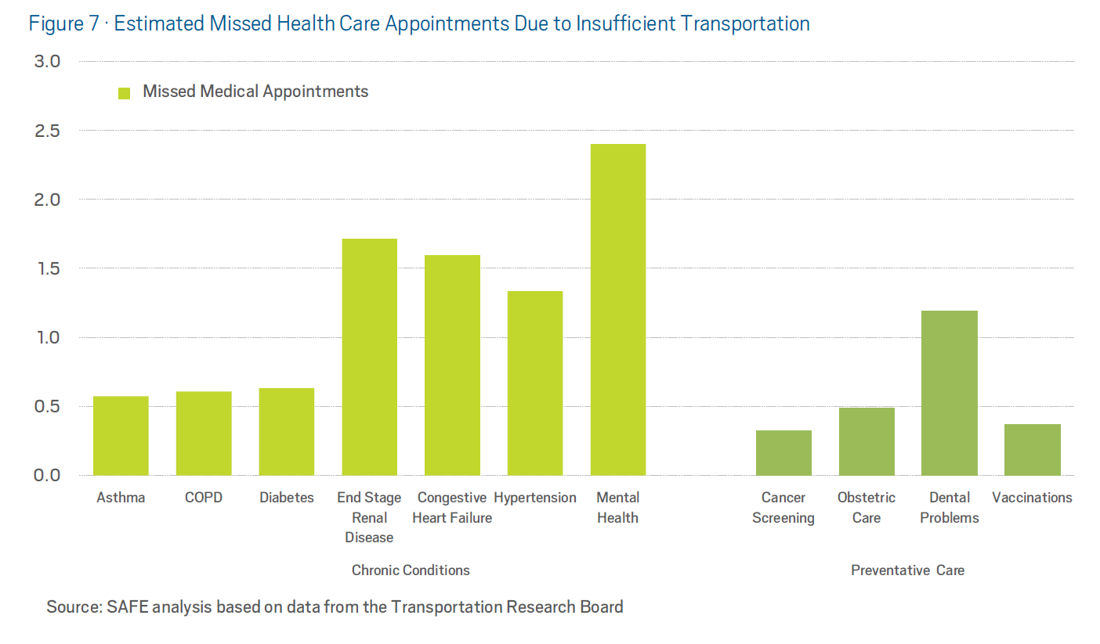
In millions (Total 11 million)
After this slide, the teacher will ask the students how do they think it would be possible to diminish the number of missed medical appointments and what would be the best approach to optimize this number.

Activity 1: Interpret the data for disability status, employment status, purpose of trip and trip ratio per week (20 minutes)
Activity Overview: In this activity, students will browse the internet to get the data of demographics regarding trip purpose, disability and employment status, and age.

Section 1: How many times do people with disabilities go out per week? (5 minutes)

Problem Statement: Interpret the ratio of trips per week for people with and without disabilities?
Solution: Students can use the internet to obtain information regarding this data and should create their own charts and diagrams for assessment. They can use:
https://www.bts.gov/sites/bts.dot.gov/files/docs/explore-topics-and-geography/topics/passenger-travel/222466/travel-patterns-american-adults-disabilities-9-6-2018_1.pdf
Or
https://ddc.ohio.gov/Portals/0/transportation-challenges-7-17.pdf
These documents will be used in further sections as well.
Or
US Department of Transportation, Federal Highway Administration, 2017 National Household Travel Survey
https://rudermanfoundation.org/the-ruderman-white-paper-self-driving-cars-the-impact-on-people-with-disabilities/

Article: An estimated 25.5 million Americans have disabilities that make traveling outside the home difficult. They accounted for 8.5 percent of the population age 5 and older in 2017. An estimated 13.4 millions of these Americans—more than half—are adults age 18 to 64 (the working age), the age group with typically high labor force participation. How do disabilities affect their travel for work, errands, socializing, and other activities?
(The statistics in this report are based on weighted percentages and means. The comparisons in this report are statistically significant at the p < 0.05 level.)
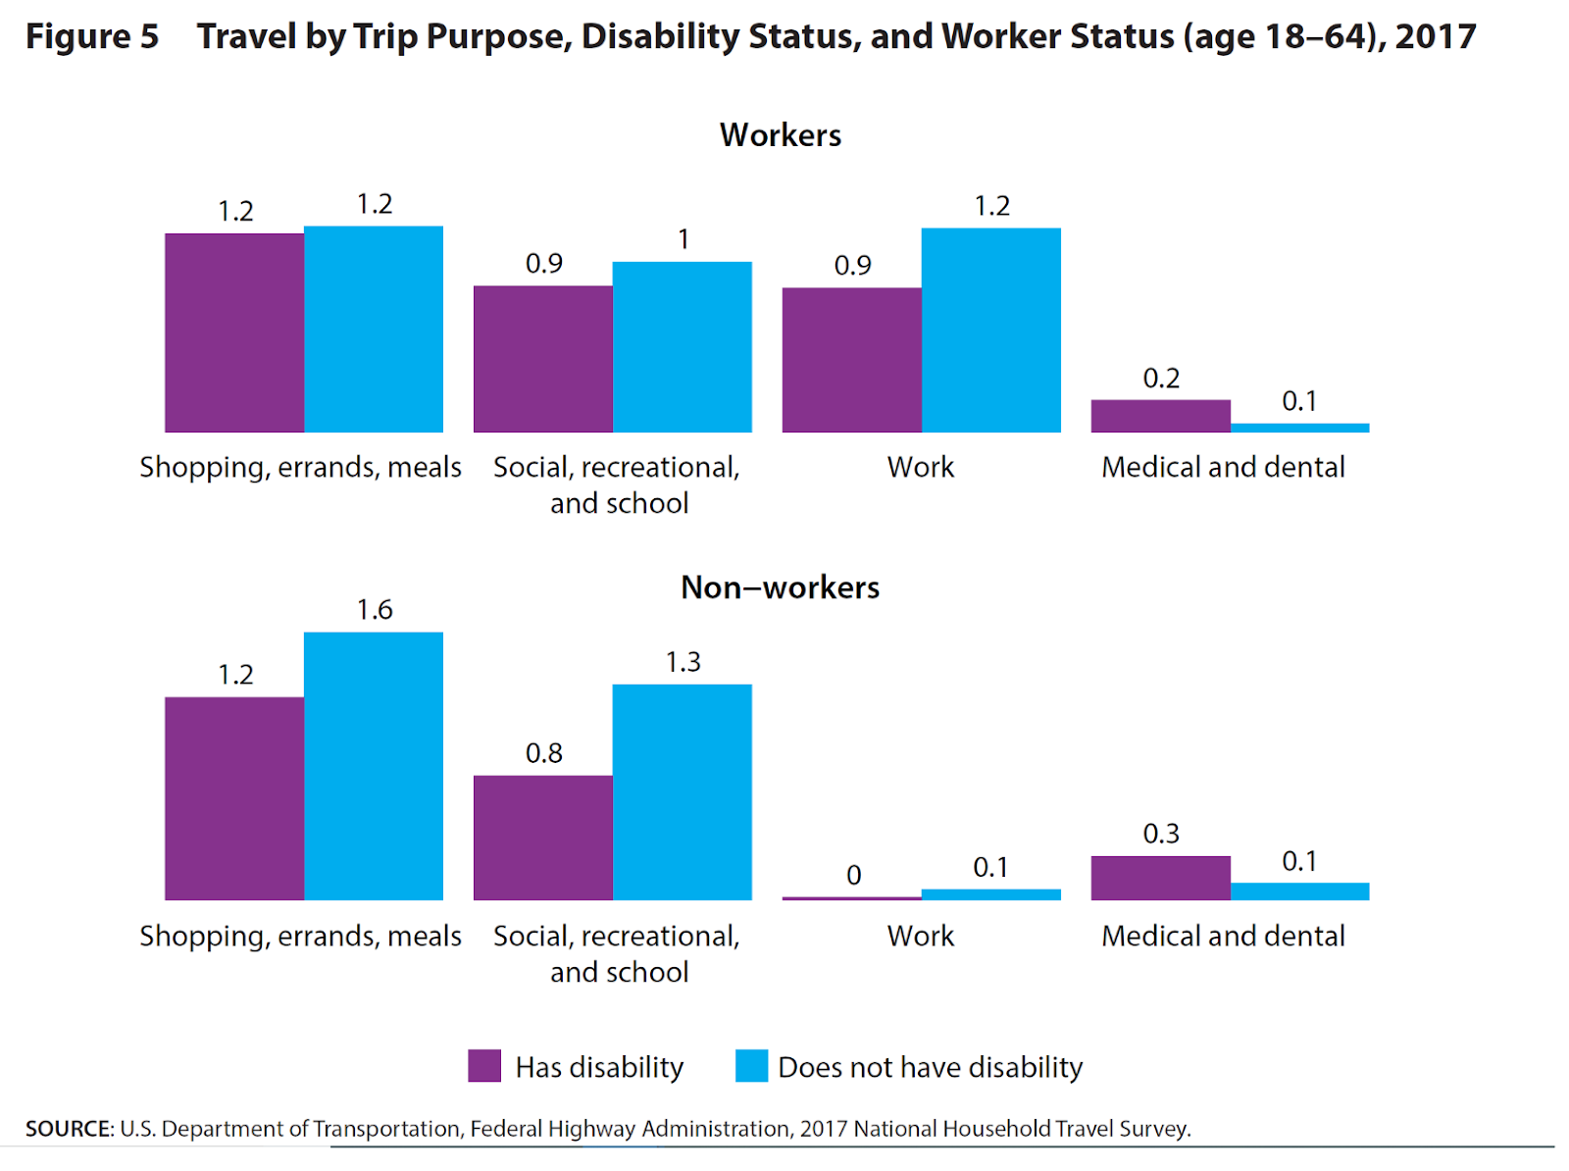
Total= 25.5 mil age 18 to 64= 13.4 mil age 65 and older=12.1 mil

(The students should now be able to explain why the number of trips per day can be in fractional format.)

THE CALCULATIONS

Who among the population aged 18-64 does Not travel and why? The NHTS asks people to record their travel for a single day. Over one-third (34.1 percent) of people aged 18 to 64 with disabilities (4.57 Million) made zero trips on the survey day versus 13.4 percent of people without disabilities. The percentage increases to 37.3 percent for rural residents with disabilities versus 16.0 percent for rural residents without disabilities. People may choose not to travel on a survey day for many reasons, but some stay home because they have no choice. Over one-third (36.5 percent) of people with disabilities who made zero trips say that they stayed home because they have disabilities or are housebound. That percentage translates to an estimated 1.7 million Americans age 18 to 64 with disabilities who do not leave their homes. They account for 46.1 percent of the 3.5 million Americans with disabilities who do not leave their homes.

Age 18 to 64 with disability who do not leave their home because of their disability= 1.7 mil

Section 2: What portion of this population is employed vs unemployed? (5 minutes)

Problem Statement: Using the obtained data, what is the employment status of this population?
Solution: Students can use the internet to obtain information regarding this data and should create their own charts and diagrams for assessment. They can use: https://ddc.ohio.gov/Portals/0/transportation-challenges-7-17.pdf

Section 3: Compare the available data for the different age groups of the population? (10 minutes)

Problem Statement: What are the significant differences between elderly people and younger people according to the available data?
Solution: Students can use the internet to obtain information regarding this data and should create their own charts and diagrams for assessment. They can use: https://www.bts.gov/sites/bts.dot.gov/files/docs/explore-topics-and-geography/topics/passenger-travel/222466/travel-patterns-american-adults-disabilities-9-6-2018_1.pdf
Or
https://ddc.ohio.gov/Portals/0/transportation-challenges-7-17.pdf
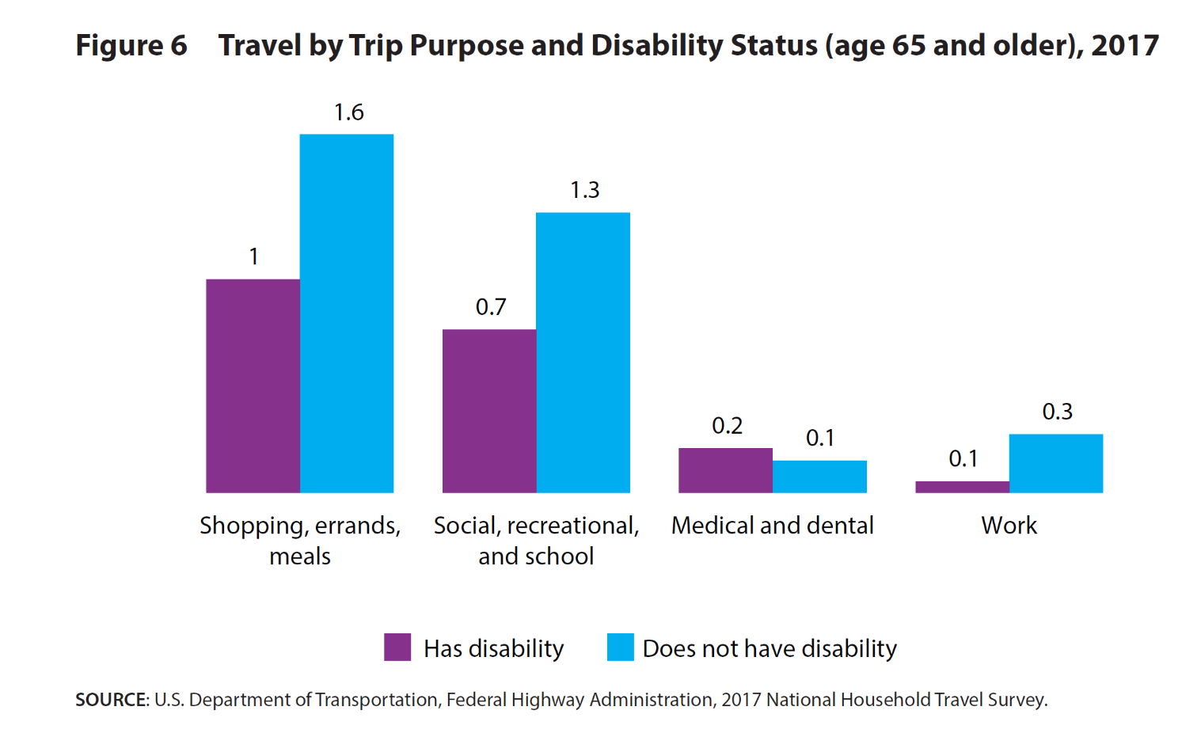

Teaching Tips:
- Teacher should ask students to provide charts and figures for each conclusion they make.

Activity 2: Why is paratransit important for this portion of the population (based on times leaving home per week) (10 minutes)
Activity Overview: In this activity, students will interpret the available data comparing the rate of trips per week for the population of people with and without disabilities.

Section 1: (10 minutes)
Problem Statement: Students should gather data regarding the number of times different groups of the population leave their home. They should analyze the data to reach understandings about the population of people with and without disabilities. Finally, the students should create their own charts and diagrams for assessment.
Solution: various online sources are available for this section, including DOT, Bureau of Transportation Statistics (https://rudermanfoundation.org/the-ruderman-white-paper-self-driving-cars-the-impact-on-people-with-disabilities/):
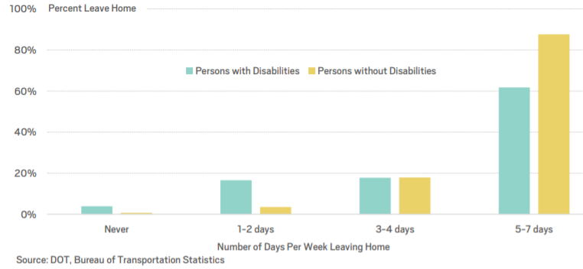
61% of persons with disabilities leave home 5-7 days per week for going to work, school, run errands, etc.

Teaching Tips:
- Teacher should ask students to provide charts and figures for each conclusion they make.

Activity 3: Process and interpret the data available online for people with zero-vehicle households considering disability and employment status (20 minutes)
Activity Overview: In this activity, students should find data online about the number people having zero vehicles available at their households, their disabilities, and their status of employment.

Section 1: (20 minutes)
Problem Statement: How many people have no vehicles at home? How many of them have disabilities? How many of them are employed?
Solution: students should be able to find data regarding this matter online, categorizing the data for disability and employment status of the people with zero-vehicle households and their needs. A good source would be 2017 National Household Travel Survey, Federal Highway Administration, US Department of Transportation:
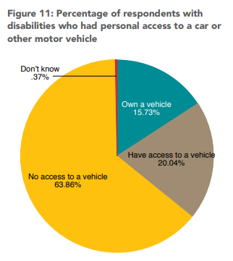
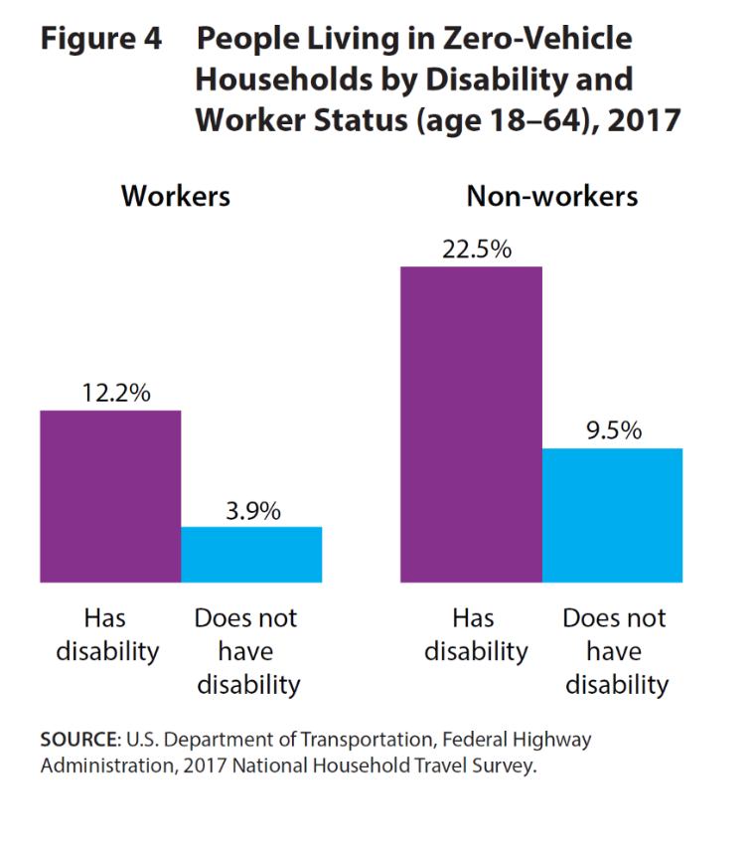
Solution: it is clear that people aged 18-64 who have disability (13.4 million), are divided into two groups:
12.2% of 13.4 mil are workers with zero-vehicle households = 1.63 million
22.5% of 13.4 mil are non-workers with zero-vehicle households = 3.01 million
Over nine-tenths (91.7 percent) of respondents drive vehicles if they do not have disabilities, but only 60.4 percent drive if they do. Therefore 39.6% of 13.4 mil=5.3 mil do not drive at all, and 1.63+3.01=4.64 mil are in zero-vehicle households. Also 15.73% of 13.4 mil=2.11 mil own a vehicle, and 20.04% of 13.4 mil=2.68 mil have access to a vehicle.
Teaching Tips:
- Teacher should ask students to provide charts and figures for each conclusion they make.
- A good closure here is to give the students a summary of their observations, asking them quick finalizing questions about the meaning of the gathered data.

Wrap-up Activity: Discussion (30 minutes)
Activity Overview: In this final activity, students are required to create a large table, summarizing all the data they have been provided to categorize the population of people with disabilities based on Age, Disability and Employment status, Trip purpose and vehicle availability in their household. After everything is categorized and summarized, students should observe the gathered data and find critical data points (abnormally high or low values) among different categories of the population, leading them to think what could be done in order for those deficiencies to be diminished, even removed ultimately.
Solution:
From previous sections, we have 1.7 million Americans age 18 to 64 with disabilities do not leave their homes due to the lack of transportation, which account for 46.1 percent of the 3.5 million Americans with disabilities who do not leave their homes. We also reached the conclusion that: 12.2% of 13.4 mil are workers with zero-vehicle households = 1.63 million and 22.5% of 13.4 mil are non-workers with zero-vehicle households = 3.01 million.
Over nine-tenths (91.7 percent) of respondents drive vehicles if they do not have disabilities, but only 60.4 percent drive if they do. Therefore 39.6% of 13.4 mil=5.3 mil do not drive at all, and 1.63+3.01=4.64 mil are in zero-vehicle households. Also 15.73% of 13.4 mil=2.11 mil own a vehicle, and 20.04% of 13.4 mil=2.68 mil have access to a vehicle.
2.11 + 2.68 = 4.79 mil
D E F

Own a car + have access to transportation method
1.7 mil
Cannot leave home (No transportation method)
5.3 mil
Do not Drive
4.64 mil
Zero-vehicle

A B C F

It is clear that C is totally uncorrelated with F, and D is uncorrelated with A. Hence C and F do not overlap, and A and D do not overlap as well. Note that the Sample Space is 13.4 mil.
Use Venn Diagram Mathematics to calculate and talk about the rest of the sets, using DeMorgan’s Law, etc.

After the students are done with their investigation about the sets they have extracted so far, the final conclusion is going to be something like:

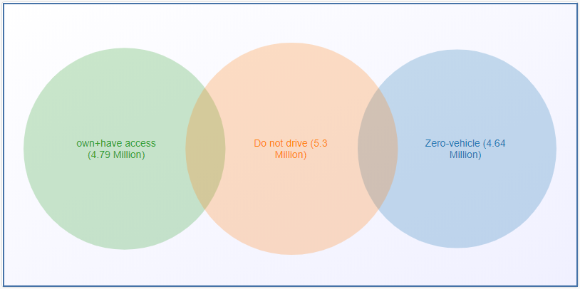
The questions that the students should be able to investigate and answer following the above analysis:
- Is the sum of all sets equal to the population of people with disabilities? Explain why.
Answer: No, the total population (sample space) we are investigating is 13.4 million, whereas the sum of all our extracted sets is more than 13.4 million (16.4 Million), and that means we are having intersections and overlaps happening between some of our sets.
- Is any piece of information or data missing? If so, see if you can find the missing data online.
Answer: Yes, based on the sets extracted previously in this lesson plan, we should investigate the overlaps between “Zero-vehicle”, “Do not drive”, and “Own + have access” sets by looking them up online.
- Is it possible to calculate the number of autonomous paratransit buses needed for Toledo?
Answer: Yes, the data considered in this work is for US Nationwide population, by using a conversion rate between US and Toledo we can easily calculate the number of buses needed for Toledo population, and we have z-tests to prove that they can be converted into each other.
- Can you find the minimum number of buses needed based on the capacity of each bus (e.g. Navya)?
Answer: Yes, since we cannot expect bus companies to manufacture a single bus for each individual with disabilities, we should consider the capacity of each bus to optimize the number of buses needed.

Learning Objectives and Standards
Learning Objectives | Standards
Summarize, represent, and interpret data on a single count or measurement variable:  1. Represent data with plots on the real number line (dot plots, histograms, and box plots).  2. Use statistics appropriate to the shape of the data distribution to compare center (median, mean) and spread (interquartile range, standard deviation) of two or more different data sets. | S-ID
Understand and evaluate random processes underlying statistical  experiments:  1. Understand statistics as a process for making inferences about population parameters based on a random sample from that population. | S-IC

Additional Information and Resources

Project-based Learning Features
Feature | Where does this occur in the lesson?
Driving Question | The question in this lesson plan is how can people with disabilities be categorized by their transportation needs, trip purposes, zero-vehicle households, ability to drive, etc.
Making Sense of Data | In all activities and sub sections, students should continuously make sense of the data obtained from the internet and make charts or diagrams to categorize and summarize them.
Investigation and Problem Solving | All activities and sub sections in this Lesson plan should be done in investigatory approaches. The students should constantly make comparisons between different groups of population and should be able to solve upcoming problems regarding the data throughout the lesson.
Technology Incorporation | In all activities and sub sections, the students use Tablets or other electronic devices with access to the internet to find relative data for each section. The students may use beam.venngage.com or Microsoft Excel to create charts, figures, and statistical tables.
Collaborative Opportunities | In every activity, student share their ideas, procedures, and solution with each other.
Assessment Techniques | The Wrap-up Activity is a summarizing and conclusive process of the previous activities because it requires the students to fully implement the gathered data to categorize every portion of the population.

Computational Thinking Concepts
Concept | Where does this occur in the lesson?
Decomposition | In activity 2 students are breaking down the problem in smaller problems like the warm up activity and activity 1.
Abstraction | In All activities
Pattern Recognition | In Wrap-up activity, students make use of the gathered data to make conclusions based on all previous activities.
Algorithm Design | -

Administrative Details
Contact info: | Kiyan.khaloozadeh@rockets.utoledo.edu  www.utoledo.edu/research/initiate
Sources: | - https://www.bts.gov/topics/passenger-travel/travel-patterns-american-adults-disabilities  - https://www.bts.gov/sites/bts.dot.gov/files/docs/explore-topics-and-geography/topics/passenger-travel/222466/travel-patterns-american-adults-disabilities-9-6-2018_1.pdf  - https://rudermanfoundation.org/the-ruderman-white-paper-self-driving-cars-the-impact-on-people-with-disabilities/  - National Household Travel Survey, Federal Highway Administration, US Department of Transportation, 2017  - DOT, Bureau of Transportation Statistics  - https://ddc.ohio.gov/Portals/0/transportation-challenges-7-17.pdf  - MyCurveFit.com  - beam.venngage.com for creating charts  - Google Classroom, 2019. URL: https://classroom.google.com/
Date Written: | 05/05/2019
Template adapted from: | https://edu.google.com/resources/programs/exploring-computational-thinking/

