INITIATE Lesson Plan: Facial and Speech Recognition, and QR Code Detection based Security

Lesson plan at a glance...  Name: Facial and Speech Recognition, and QR Code Detection based Security  Course: Cyber Security  Grade Level: 9th to 12th  Prerequisites: -  Time: Preparation: 2 minutes Instruction: 85 minutes  Standard(s): Common Core: TPS CTE: Analog Based Electronic Devices Standards: Strand 5: Pre‐Engineering: Design and Development | In this lesson plan…  - Lesson Overview  - Driving Questions  - Materials and Equipment  - Preparation Tasks  - The Lesson  - Learning Objectives and Standards  - Additional Information and Resources

Lesson Overview
In this lesson, students will create and test various security systems, based on Facial and Speech recognition modules. These systems are available as effective examples of security measures to prevent unauthorized uses of Autonomous Vehicles. The students will briefly learn about the concept of Machine Learning technology, and recognize the presence of Machine Learning applications in their daily lives. Finally, the students will make use of the aforementioned security modules to authorize various tasks done by the car (e.g. having the car only perform/drive if the car recognizes the authorized user).

Driving Questions
Overarching Driving Questions:
- How can we make smart busses safer and more convenient for people with disabilities?
Lesson Specific Question:
- What are some useful security measures to prevent unauthorized use of Autonomous Vehicles?

Materials and Equipment
- AdventureBot Smart car kit with a functional Camera and Microphone
- Laptops with EZ-Builder software installed
- Internet Connection

Preparation Tasks
 | Connecting tablets to the smart cars | 5 minutes

The Lesson
Warm-up Activity: Overview of the lesson objective | 5 minutes
Activity 1: A brief introduction on Machine Learning | 25 minutes
Activity 2: A brief introduction on Biometrics for security | 10 minutes
Activity 3: Introducing AdventureBot and EZ-Builder Software | 30 minutes
Activity 4: Implementing the security system using the camera (Facial recognition) | 20-45 minutes
Activity 5: Implementing the security system using the camera (QR Code) | 20-45 minutes
Activity 6: Combining Facial recognition and QR code with Speech recognition | 20-45 minutes
Wrap-up Activity: Discussion | 10 minutes

Warm-up Activity: Overview of the lesson objective (10 minutes)
Activity Overview: In this activity, teacher will introduce the systems discussed in this lesson by showing the videos below to the students.
Activity: YouTube videos about Facial and Speech Recognition
https://www.youtube.com/watch?v=hgTBLLMtpUA
https://www.youtube.com/watch?v=yxxRAHVtafI

Activity 1: A brief introduction on Machine Learning (25 minutes)
Activity Overview: In this activity, the teacher presents an introduction on the Machine Learning technology to the students and its use in this lesson.
Section 1: Introduction (5 minutes)

Machine Learning is the scientific study of instructions/algorithms that could be implemented on a system, to ultimately eliminate the need for giving the system exact instructions to work. This means that Machine Learning algorithms are used to make the system function on its own, rather than relying on exact commands from its human users. Machine Learning technology is vastly used in today’s world, especially for prediction purposes because of its nature.

Section 2: Machine Learning examples in daily life (5 minutes)

The teacher could bring up real life examples of the Machine Learning technology by visiting each of the following given examples online. This could be done by asking the students to open every website given below and interact with them to see the results:
- iPhone’s Suggested Apps/Contacts to open/call next
- YouTube’s “videos you might like”
- Amazon’s “consider buying these items next”
- Instagram’s “based on the photos you’ve liked”
- Google Ads suggestions based on your previous interests

Section 3: Different stages of a Machine Learning algorithm (10 minutes)
A Machine Learning procedure usually consists of 3 phases: Training, Testing, and Evaluation.
- Training phase - An ML algorithm starts with observing/training on user’s past or current behavior, learning about their usage pattern.
- Testing phase - The algorithm proceeds to test its judgment by making a few predictions for the user, observing how the user reacts to those predictions.
- Evaluation phase - If the user was unhappy with those suggestions, the ML algorithm will learn that it was wrong and tries to tune its learning method. And if the user was happy, the algorithm continues its previous way of suggestion.
We deal with the Training aspect of Machine Learning in this lesson.

Teaching Tips: Using online and interactive examples/websites for students would be useful.

Activity 2: A brief introduction on Biometrics for security (10 minutes)
Section 1: Biometrics for security (10 minutes)

Teacher explains to the students that setting a passcode or a passphrase on their devices might be convenient for them, but it is also convenient for the bad guys to hack into their devices. Today we prefer our devices to rely on our biometrics rather than a traditional password. Biometrics include but are not limited to: Fingerprints, Facial data, Iris data, Voice, etc.
Question: Suppose you want your smart vehicle to open its doors and operate for you and only you. What could be a better security measure than using your own biometrics for that?
YouTube video on Biometrics: https://www.youtube.com/watch?v=tJw2Kf1khlA
After watching the video on Biometrics, students should be able to discuss the advantages and disadvantages of using Biometrics for securing their devices.

Activity 3: Introducing AdventureBot and EZ-Builder Software (15 minutes)
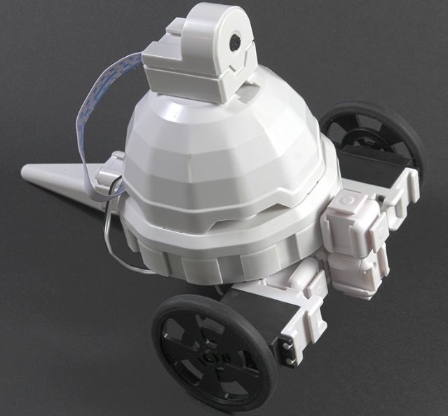
AdventureBot, by EZ-Robot

Section 1: AdventureBot (10 minutes)

The AdventureBot smart car kit comes with a Camera that has a Facial recognition module, and a Microphone that has a Speech recognition module integrated.
These modules use Machine Learning to train on different faces and voices (in our case, Authorized user’s facial and speech data), and saves them in the Robot’s memory.
Section 2: EZ-Builder

The AdventureBot also comes with a software that helps us program and control it. The EZ-Builder software installs on Microsoft Windows, and it also has a Mobile App for iOS and Android.
EZ-Builder Install Webpage URL: https://www.ez-robot.com/EZ-Builder/
The INITIATE team has made their own interpretation in the Mobile App, which can be accessed and downloaded once the user installs the app on their smart device.

Section 3: EZ-Builder Mobile App (optional- not required for this lesson, skip to Section 4 if not interested in the mobile app)

Here is how to access the INITIATE profile on EZ-Builder mobile app:
- Make sure you have an active Internet connection, then install the mobile app using the following URL: https://www.ez-robot.com/EZ-Builder/mobile
- Open the app, navigate to “Preferences” tab (if not already open) and Create a user account:
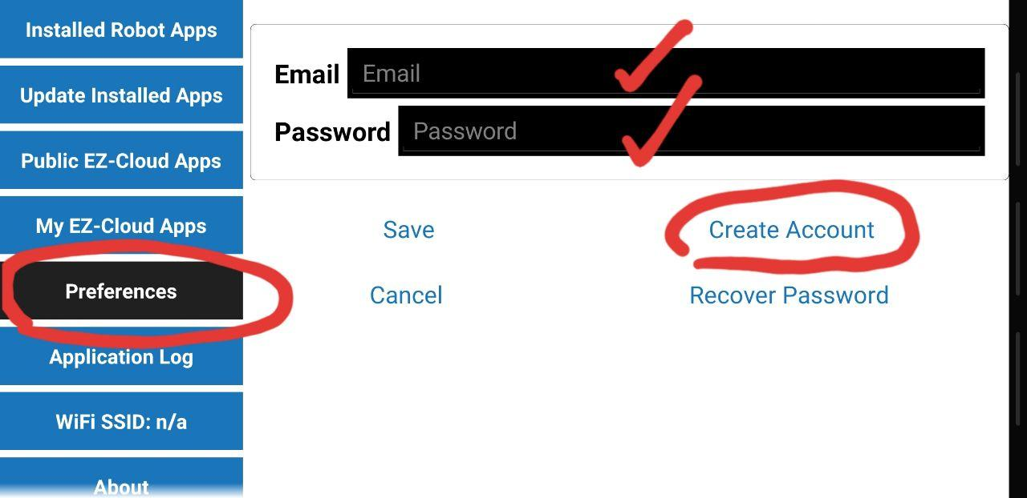
- Navigate to the “Public EZ-Cloud Apps” tab and in the “Apps Made By” field, search for “k_khal”.
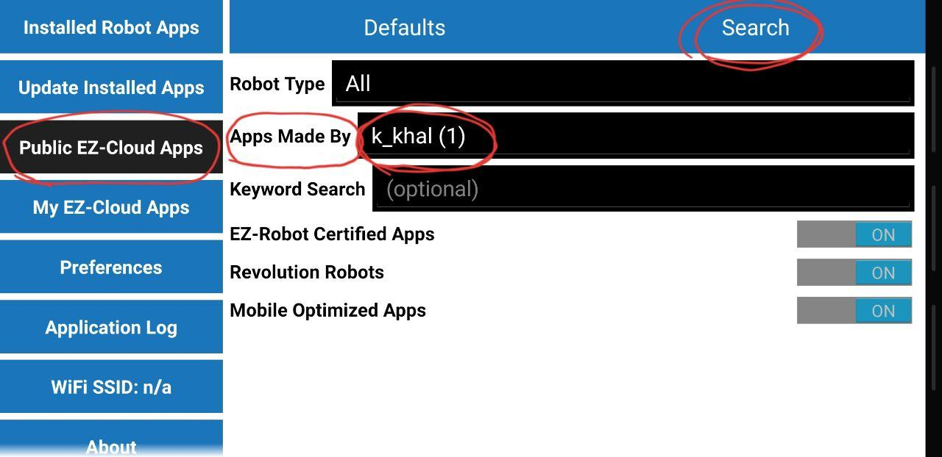
- This will bring up our profile called “INITIATE1”. Download it by following the steps shown below:
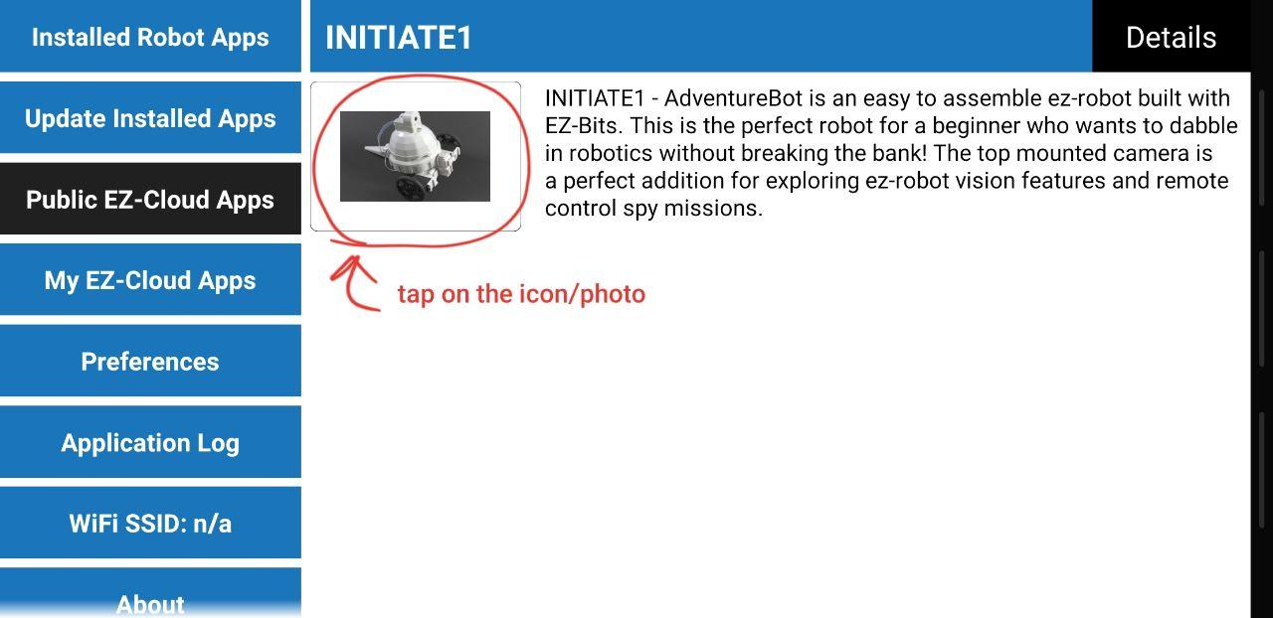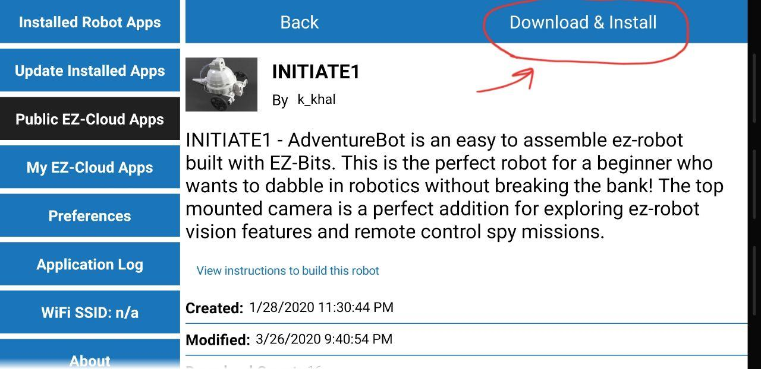
- Once INITIATE1 is downloaded and installed, power on the robot using the switch on the back of the smart car, turn on your phone/device WiFi and connect to the robot via WiFi. The robot’s connection name should start with “EZ-B v4.x”. Your phone/device WiFi will now be connected to the robot, and lose Internet connection, therefore it is best to download INITIATE1 profile Before connecting to the robot. Now navigate to the “Installed Robot Apps” tab, tap on the icon/picture of INITIATE1, then tap on “Open”, as shown in the screenshot below:
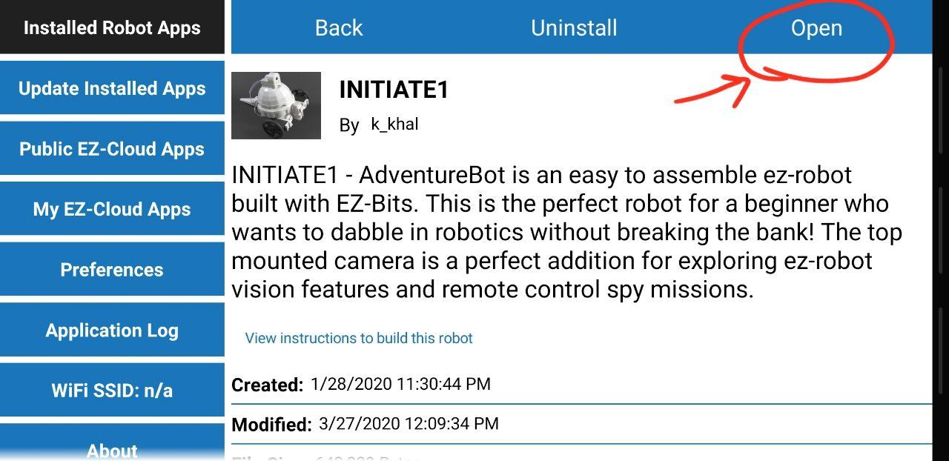
- Once the screen below appears, tap on the “Connect” icon:
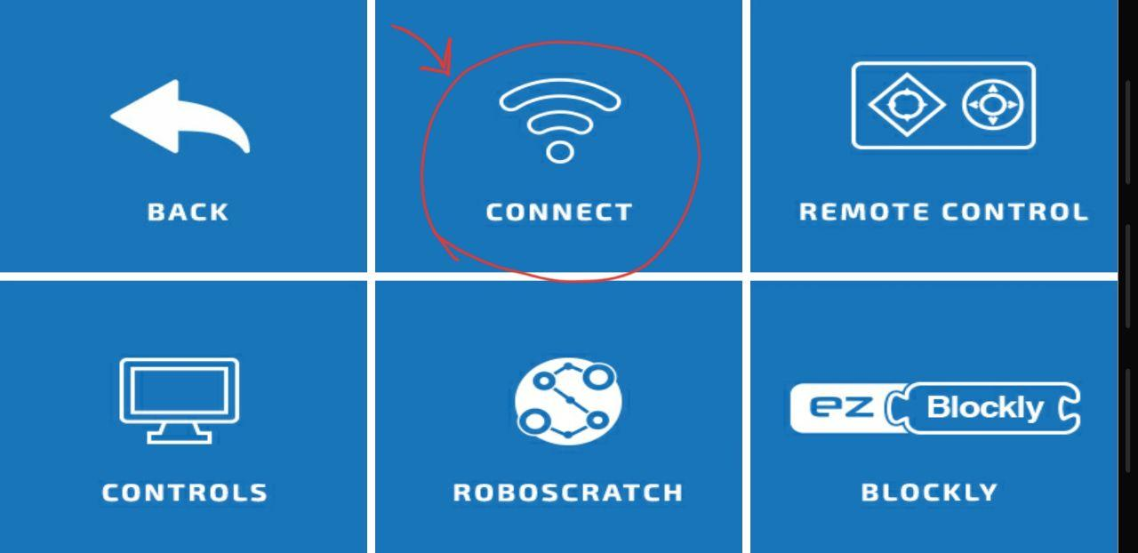
Then, in the connection screen, tap on the leftmost blue “connect” icon as shown below:
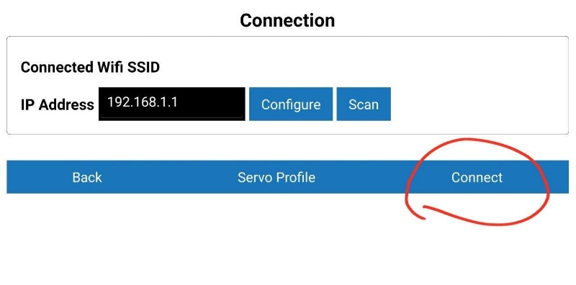
You should hear a “beep” as a confirmation from the robot. Congratulations! Your phone/device is now connected to the robot.
- You will now have access to an easy Remote Control for the AdventureBot, as well as the Blockly interface for programming, similar to Bloxter in GoPiGo3 cars. In the Remote Control section, you will have live access to Camera feed, Battery level, Distance sensor’s value, and Color tracking (for line following and general color detection) available in INITIATE1 app profile. Also, different colors can be selected for tracking purposes in the “Controls” section of the interface.

Section 4: EZ-Builder Software (required for this lesson)

Below is the steps and screenshots for initializing Facial and Speech recognition modules:

- Install EZ-Builder software on your computer
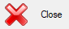
- Make sure your computer is connected to Internet, start the EZ-Builder software, and click on Close in the dialogue box (related to loading projects) that appears on your screen:

- Click on the “Open” button, under the “Synthiam App Store” section as shown below:
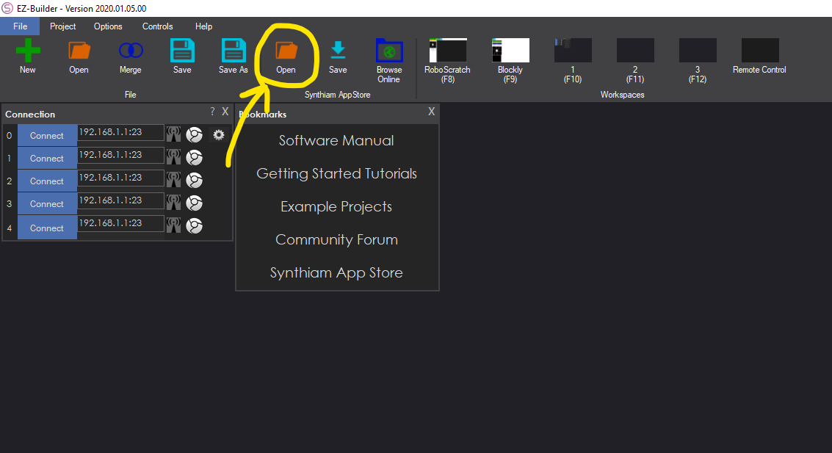

- On the new screen, on the top left corner select “Public”, and in the “User:” field scroll down and select “k_khal (1)”. Now “INITIATE1” profile will become visible. Click the blue “Open” button next to it (refer to the screenshot below):
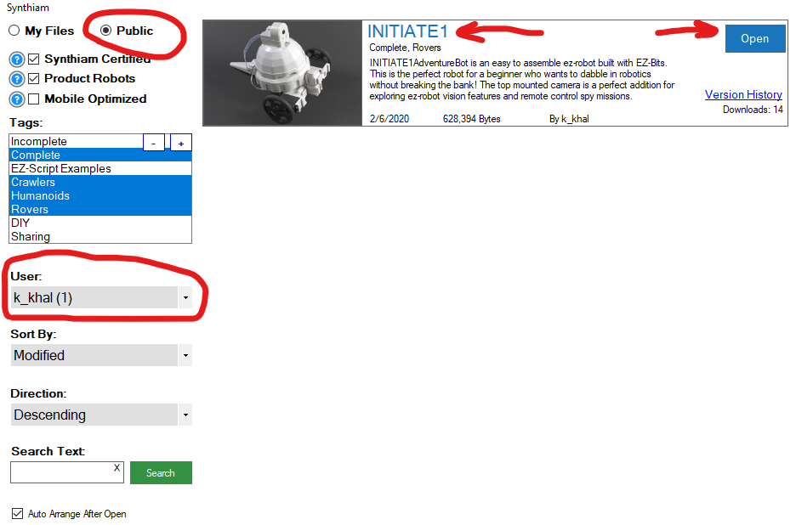

- Click on “Not Now” in the following dialogue box when it appears:
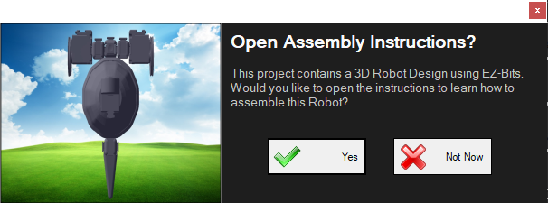

- AFTER you have made sure the screen below is showing on your computer, follow the next steps: 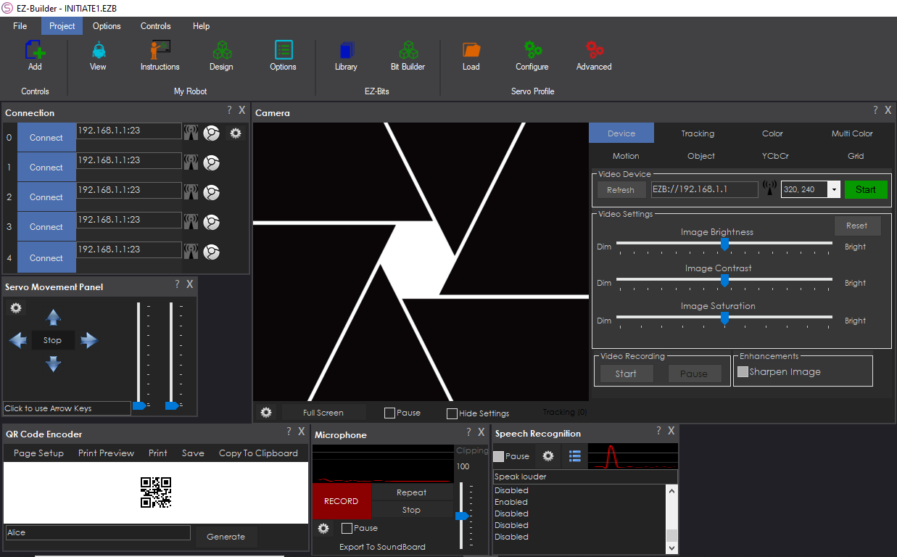

- Disconnect from the Internet (WiFi connection to the Internet).
- Power on AdventureBot (using the switch on the back of the robot):
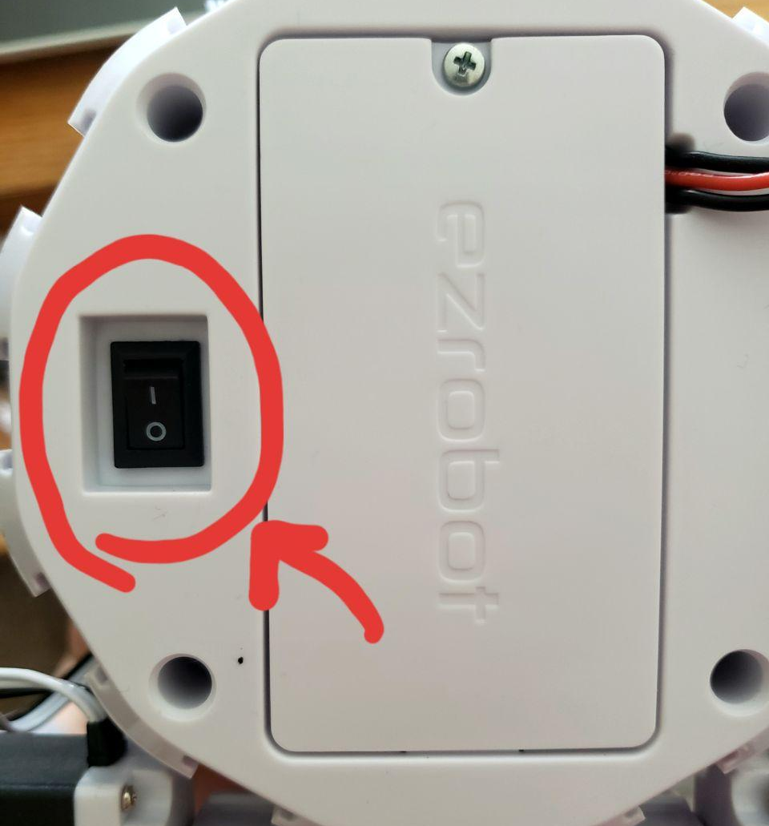
- Connect to the robot via WiFi (under the network adaptors on your computer, shown below). The robot’s name should start with “EZ-B v4.x”. Note that you will not have Internet access once you connect to the robot with your computer WiFi, therefore it is best to download the INITIATE1 profile on EZ-Builder Before connecting to the robot.
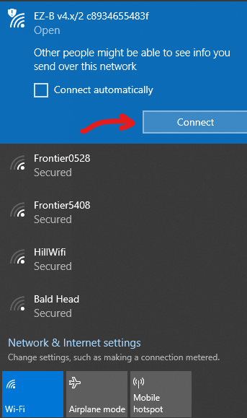
- Once the computer is connected to the robot via WiFi, in the “Connection” section in EZ-Builder, click on the blue “Connect” button with number “0” next to it on the list (shown in screenshot below). You should hear a “Beep” from the robot as confirmation. Then, as shown in the screenshot below, click on the green “Start” button under the “Video Device” section to activate the Live Camera Feed.
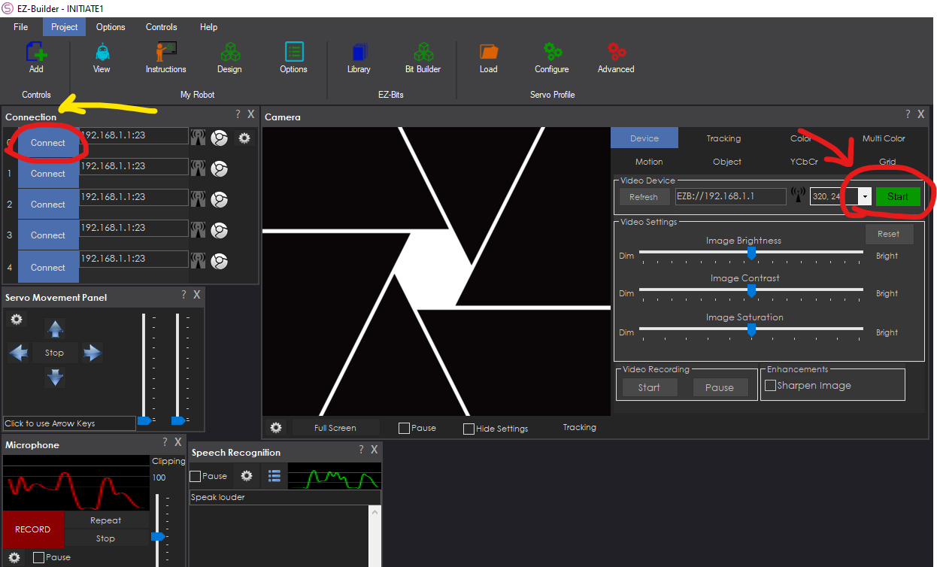
Congratulations! You are now ready to proceed with this lesson.

Activity 4: Implementing the security system using the camera (Facial recognition)

(30 minutes)

Section 1: Introduction
The Camera integrated in AdventureBot smart car kit can train (recall: Machine Learning Training Phase) on different faces, as well as different objects, and saves the data in its memory directory. It can save more than 100 facial and object recognition data in its memory that could be accessed anytime using the EZ-Builder software. Note that in order to setup and start the training module, you will need the EZ-Builder Computer software, and not the Mobile App. However, Activity 6 and the final activity in this lesson involve the use of the Mobile App.
Section 2: Training on users’ facial data (20 minutes)
- Make sure you have followed the instructions given in Section 4 of Activity 3 in this lesson plan. If successfully done, you should have the screen below showing on your computer:
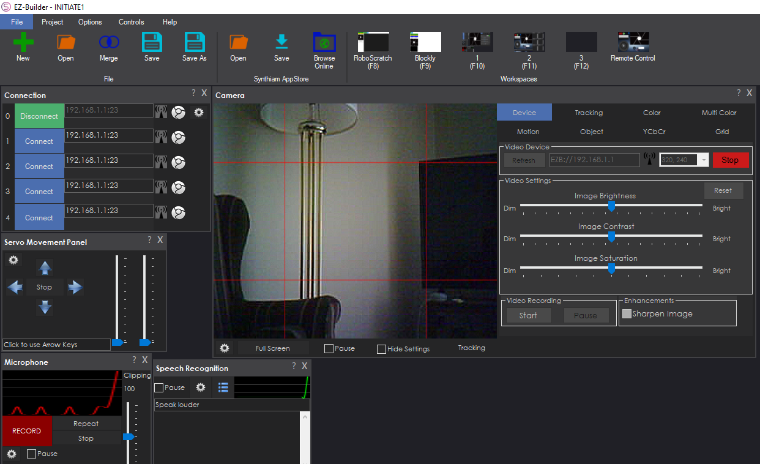
Things to check for making sure you are successfully connected to the robot (All shown in the screenshot above):
- In the “connection” box on the left, the button next to the number “0” should be Green, and read “Disconnect”
- You should have an active live Camera feed in the middle of the screen
- The button in the “Video Device” section should be Red and read “Stop”
Now that you are successfully connected to the robot and have an active camera feed, let us proceed to the next steps:
- Click on the “Tracking” tab in the camera section, then toggle-on the “Object” checkbox (as shown below):
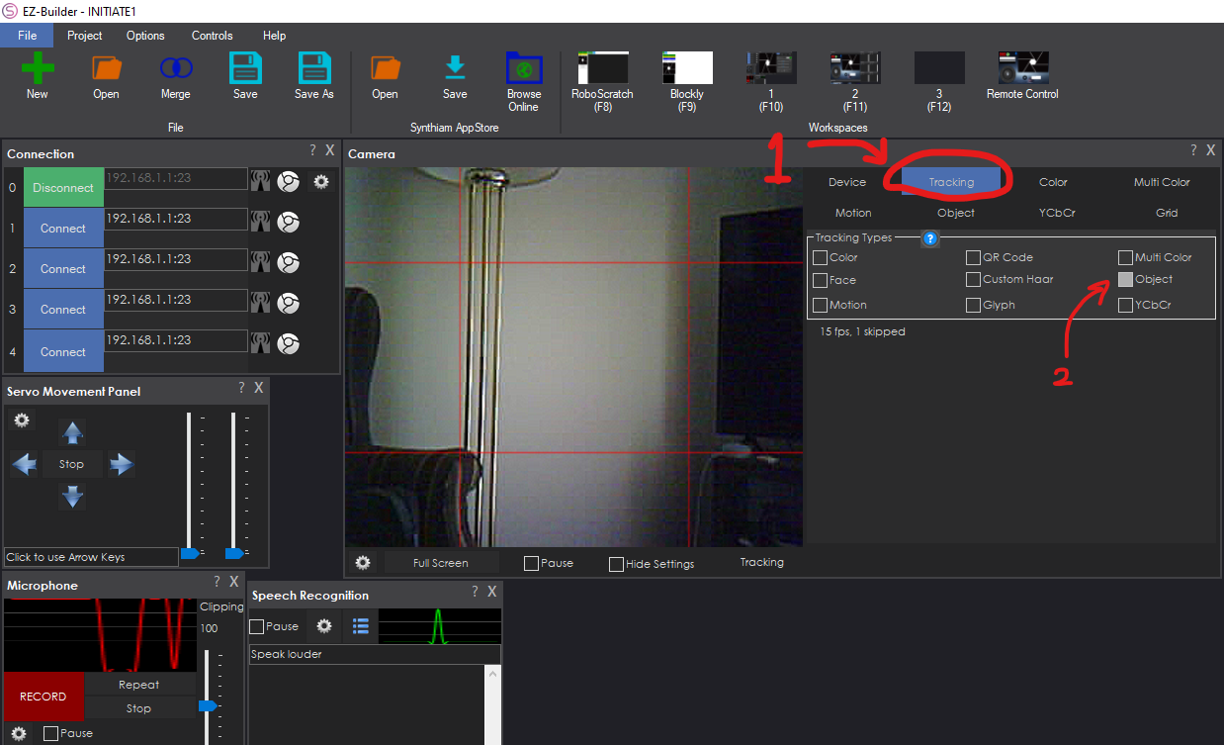
- Now click on the “Object” tab in the camera section, then click on the “Train New Object” button (shown below)
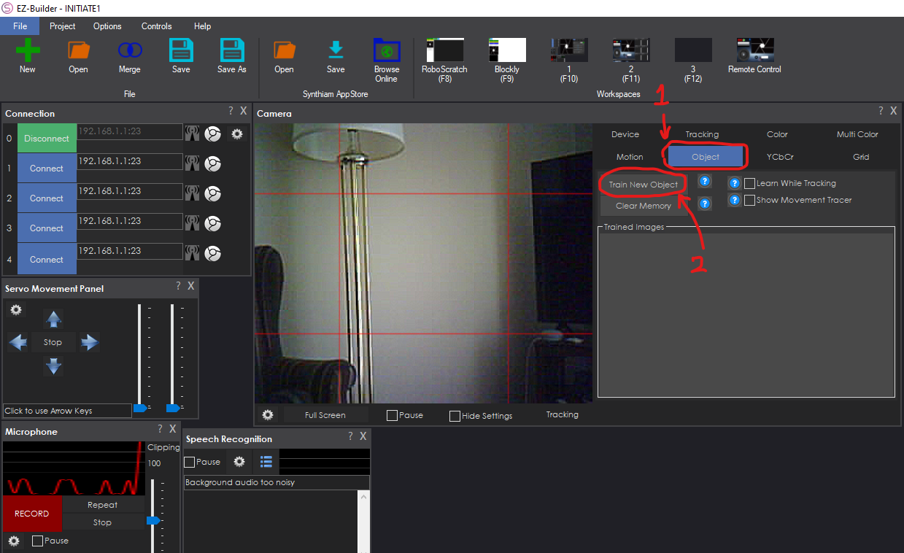
- In the new screen called “Custom Object”, choose a name for the facial data by typing in the “Name of Object” field. Then, click anywhere on the “Preview” screen (preferably in the middle) to place a purple square on the screen (as shown below):
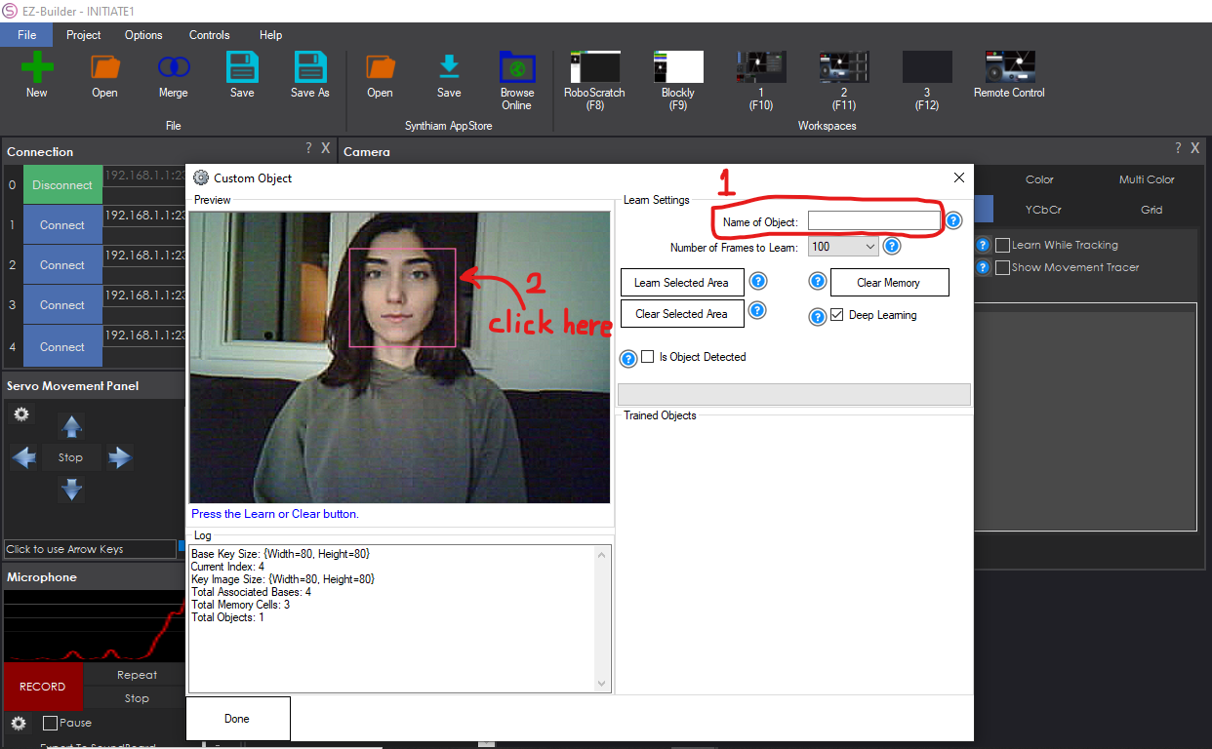
Note that the user’s face should be completely positioned inside the Purple Square when placed on the Preview screen. If you are not satisfied with the current positioning of your purple square, you can click on the “Clear Selected Area” button and then place a new square on the preview panel.
- Next, after you have made sure the user’s face is well positioned inside the purple square, click on the “Learn Selected Area” button and begin moving your head slightly in different directions, but make sure to always face forward (try not to present a side-view of your face to the camera). Wait for the green progress bar to complete (shown below):
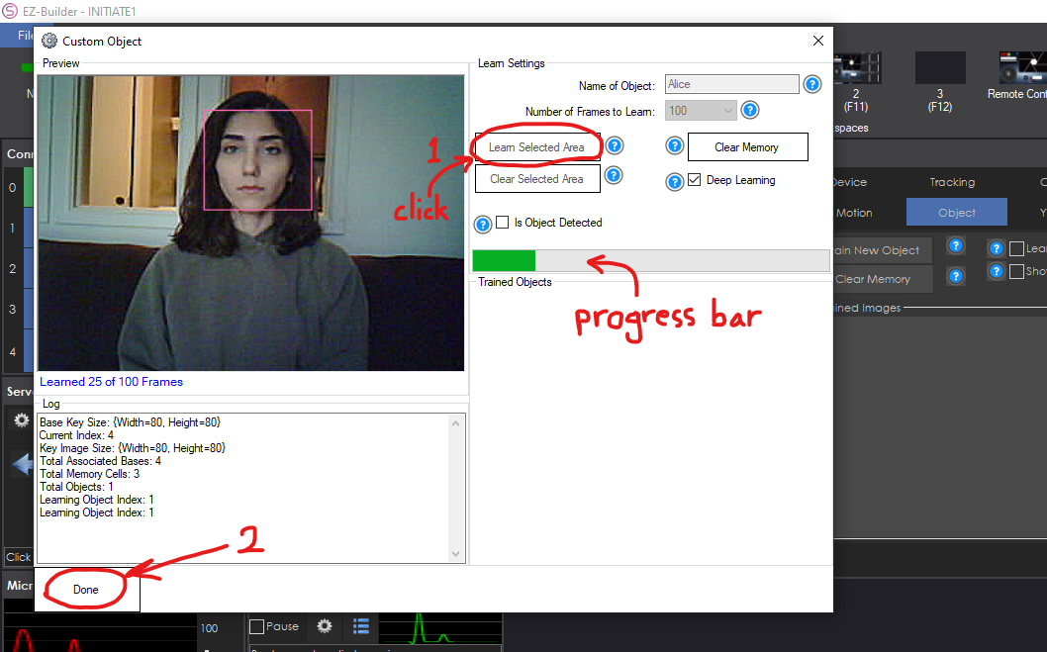
Start moving your head slightly in different directions (as mentioned earlier) while the progress bar completes. Once the process is complete, click on the “Done” button on the bottom left corner.
- If you have successfully completed all of the previous steps (remember to double-check step 2!), a Blue square will be automatically placed around the saved user’s face every time their face appears in front of the camera (as shown below):
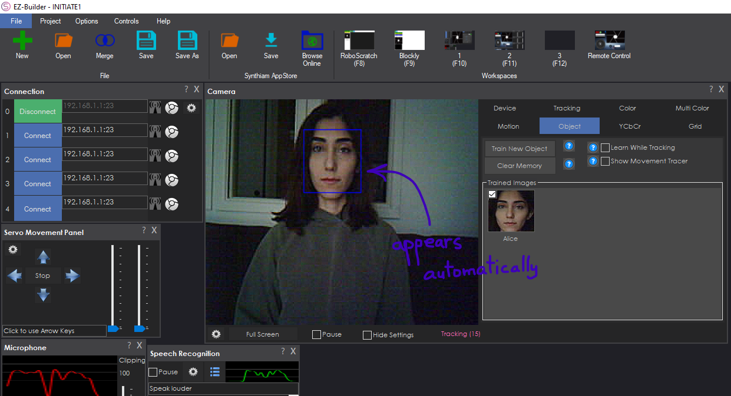
- Congratulations! You have successfully completed the process of training on Facial data. Remember that you could use the same procedure for training Objects as well. You can see all of the saved facial/object data under the “Trained Images” box.
Section 3: Triggering actions using the trained facial data (20 minutes)
Now that we have trained on different facial data, let us see if the robot is able to differentiate between different users’ faces:
- Repeat steps 3-5 in the previous section to save/train another user’s face. This is crucial because we need to have more than one saved face to see if the robot could differentiate between multiple faces.
- Once you finished training/saving multiple users’ faces, click on the Gear icon/button on the bottom-left corner of the camera feed (as shown below):
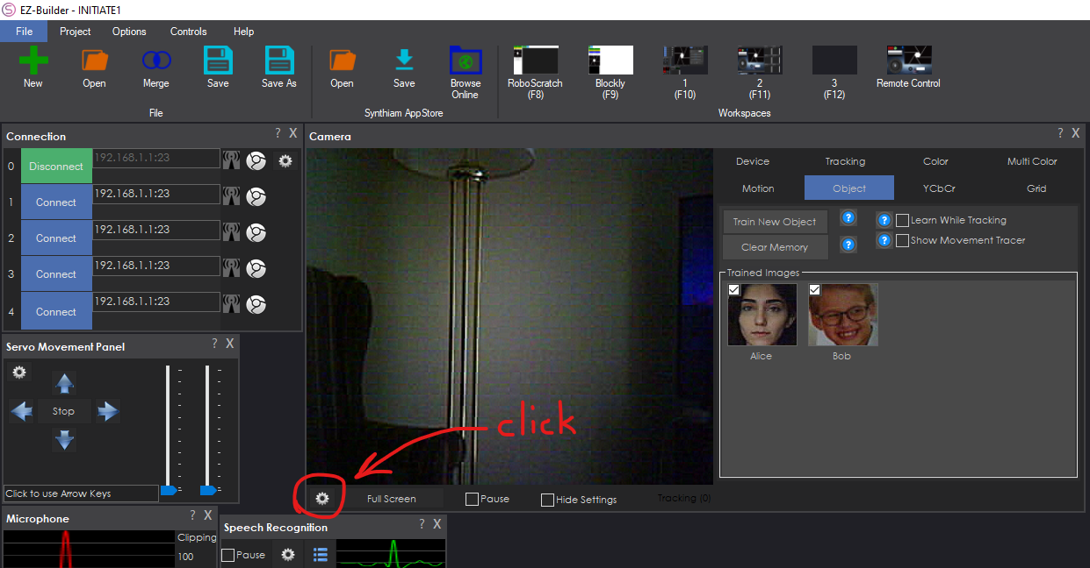
- On the new screen called “Camera Config”, select the “Scripts” tab, toggle-on the “Execute these tracking scripts when object tracking begins/ends” check box, and finally select the “Pencil” icon for “Tracking Start” box, as shown below:
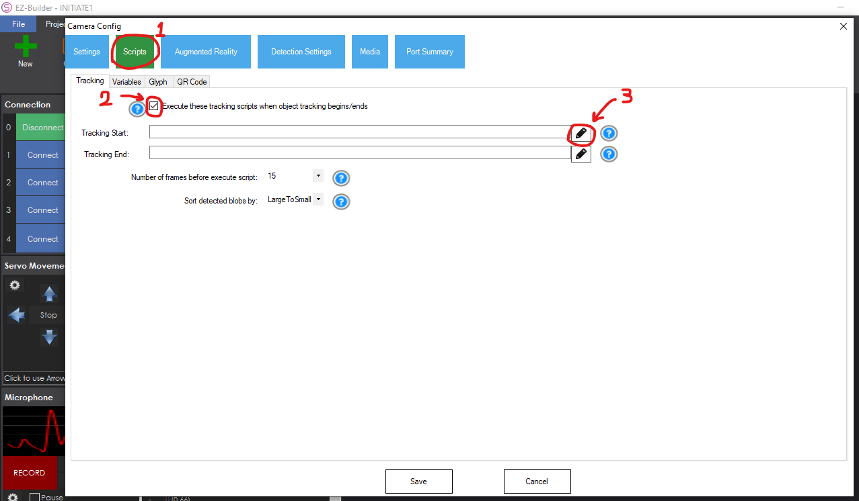
- Once you click on the pencil icon, a new screen called “Event EZ-Script Editor” appears. Click on the “Blockly” tab on the top left corner of the screen, then from the list in the middle, select “Audio” (as shown below):
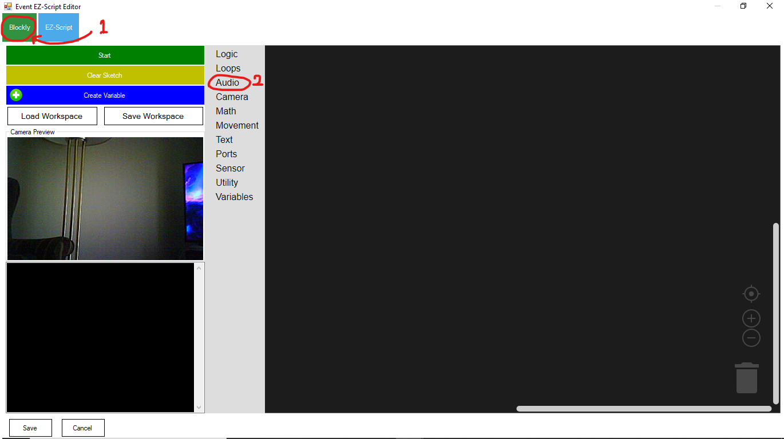
- A list of Audio commands appears; select “Say EZB” from the list and place it on the blank area:
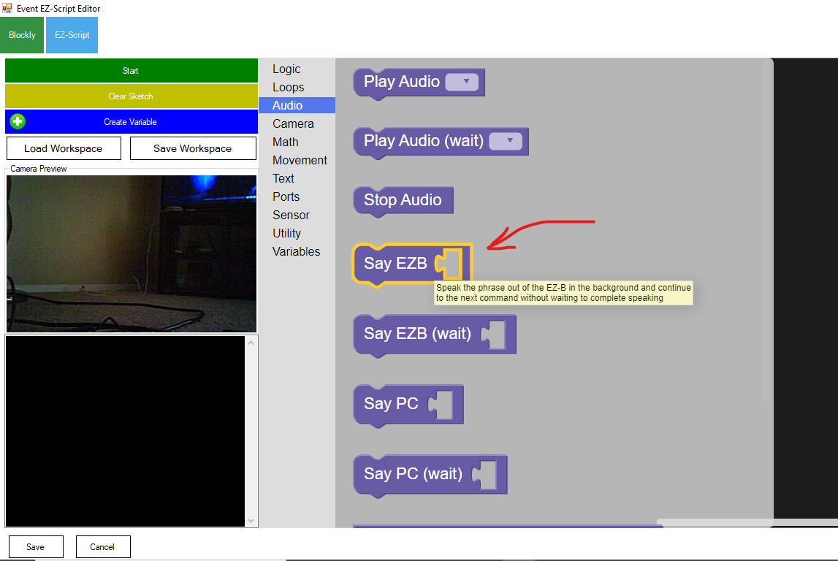
- After placing the “Say EZB” block on the screen, select “Text” from the list and place the “create text with” block inside the “Say EZB” block (screenshots below):
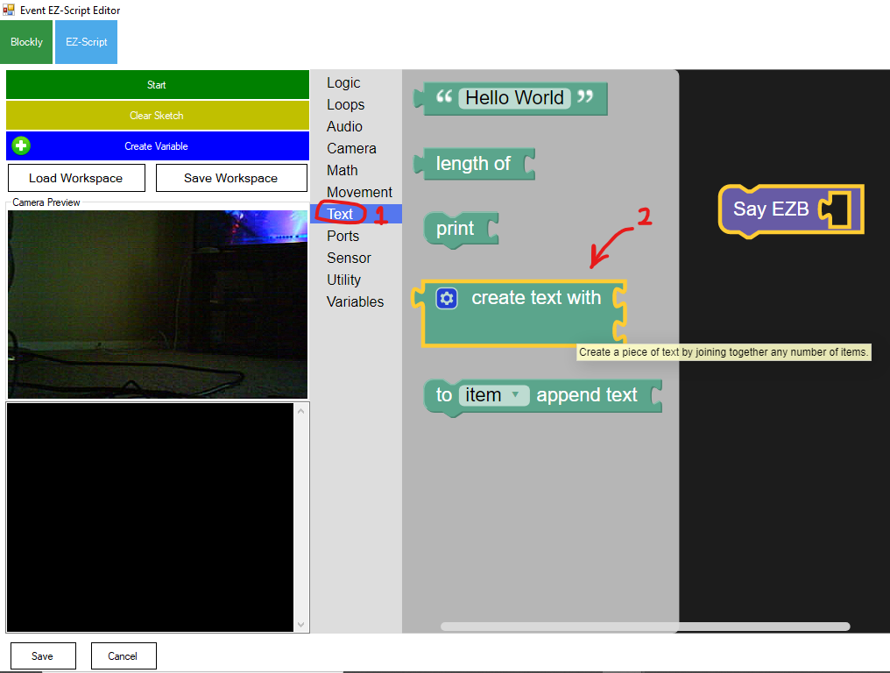
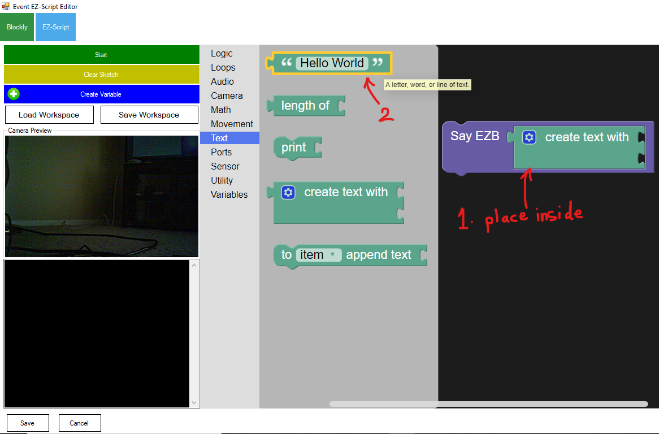
Select “Text” again from the list; this time, select the “Hello World” block and place it on the screen.
- Click on the “Hello World” text to modify it, type “I see “ with a space at the end. We are creating a command that makes the robot say “I see (someone’s face)”. We used the “Say EZB” block to make the robot speak, and used the “create text with” block to combine and connect two different phrases: One is “I see “ and the other is the name of the person.
Connect the “I see “ text block to the first gap in front of the “create text with” block, similar to the screenshot below:
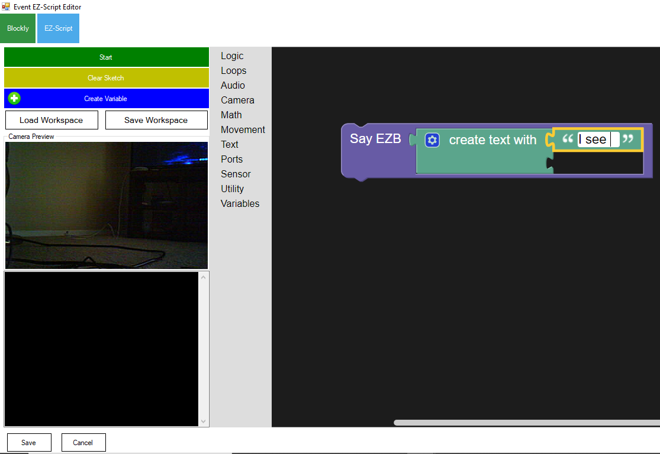
But which block should we use for specifying “someone’s name”? the block should definitely be a Variable:
- Select the “Variables” tab, then select the “item” block and place it on the blank area (as shown below):
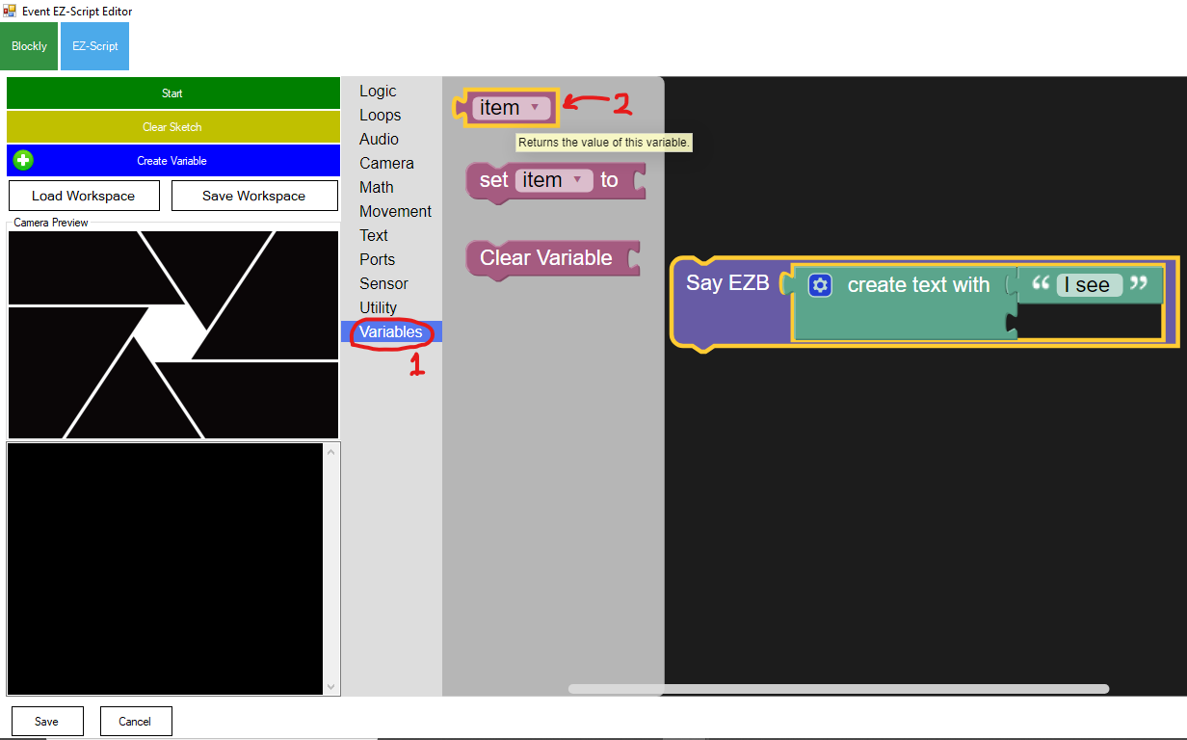
Click on the little arrow next to the “item” block to open a drop-down menu list, and select “CameraObjectName” from the drop-down list (as shown below):
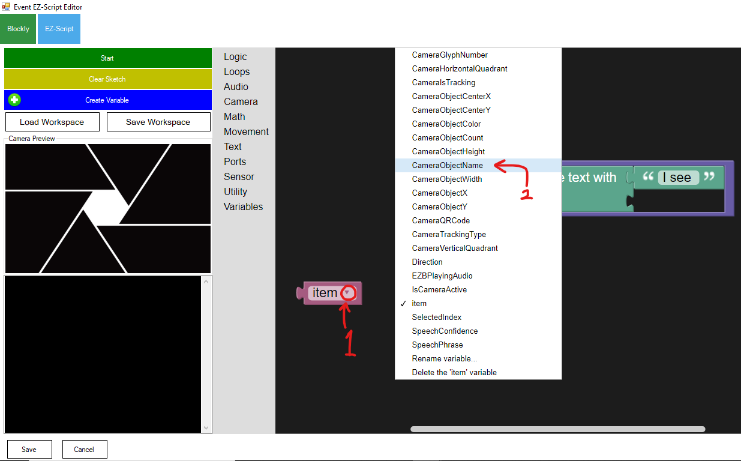
- Now place and connect the “CameraObjectName” purple block to the second gap in front of the “create text with” block (check the screenshot below for correctness). Once finished, click on the “Save” button on the bottom left corner of the screen:
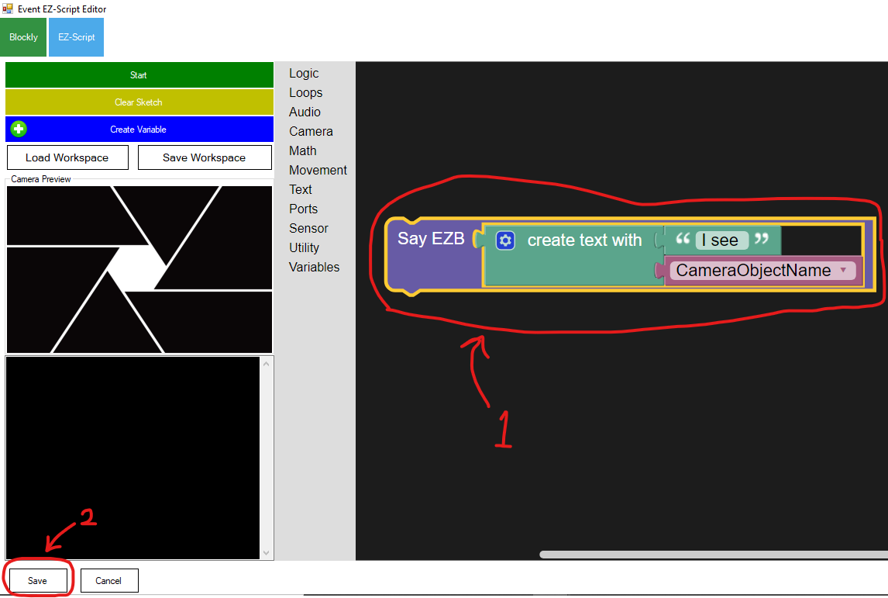
- Once you clicked on the “Save” button, you will return to the screen below. Check if the indicated check-box is selected, and if “SayEZB(("I see " + $CameraObjectName))” is written in front of “Tracking Start”. Once you made sure everything matches the screenshot below, click on the “Save” button at the bottom of the screen.
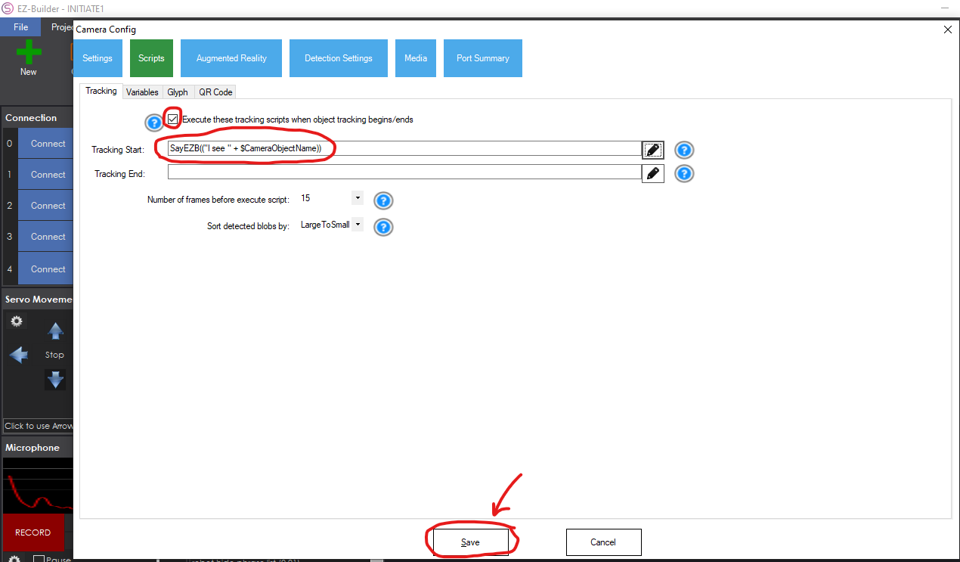
- Congratulations! You have now successfully written a script that makes the robot say “I see (someone’s name)” whenever their faces appear in front of the camera. Try it out yourself. Appear in front of the camera within the same distance you did previously for training/recording the face data.
(Note: the space at the end of the phrase: “I see “ is mandatory, because without that space, the robot would say something like “I seeAlice” or “I seeBob”)
Discussion:
- Try wearing/removing glasses after you have trained/recorded your facial data. Would this affect the recognition system? Answer: No, the module still performs well on the same face with/without glasses.
- Try training/recording your facial data in different lighting conditions. Would this affect the recognition system? Answer: Yes, the recognition system only responds to the same lighting condition while training/recording the facial data.

For a video tutorial on this Activity, visit https://www.ez-robot.com/Tutorials/Lesson/106?courseId=7

Activity 5: Implementing the security system using the camera (QR Code) (20-45 minutes)
Section 1: Introduction (2 minutes)

YouTube Video on QR Codes: https://www.youtube.com/watch?v=zZXCt1Ud_zE
Section 2: Generating QR codes with EZ-Builder software
The teacher should create separate QR codes for every student participating in this activity. This could be done by starting EZ-Builder software, opening INITIATE1 project and following the steps below:
- Once you had INITIATE1 project loaded up, locate the “QR Code Encoder” box on the bottom left corner of the screen, replace the default phrase (EZ-Robot) with a student name (in this example, Alice) and click on the "Generate” button (as shown below):
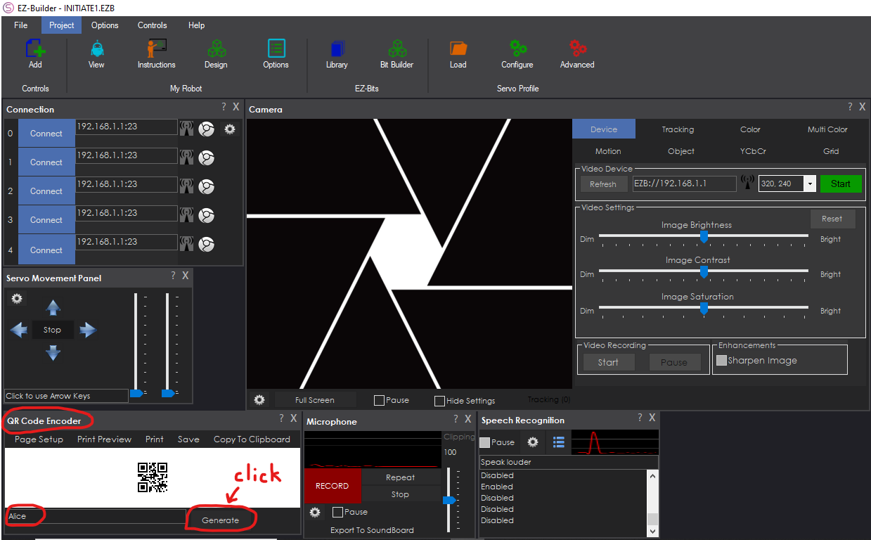
When you click on Generate, Alice’s QR code will become available. You can print the QR code by clicking on the “Print” button. Or you can copy the QR code by clicking on “Copy TO Clipboard”, as we did here:

If you scan the QR code above with your smartphone, it says “Alice”!

Section 3: Detecting QR codes with AdventureBot Camera

- Navigate to the “Tracking” tab shown in the screenshot below, toggle-on the “QR Code” checkbox, and then click on the Gear button indicated with the yellow arrow:
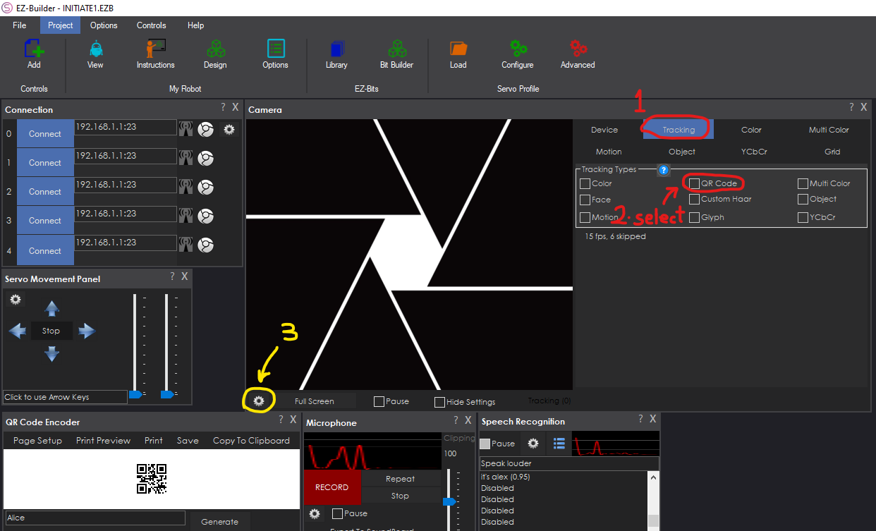

- In the new screen called “Camera Config”, click on the “Scripts” tab, select the “QR Code” tab, write the student name (e.g. Alice), and then click on the Pencil icon in front of it (all steps shown below):
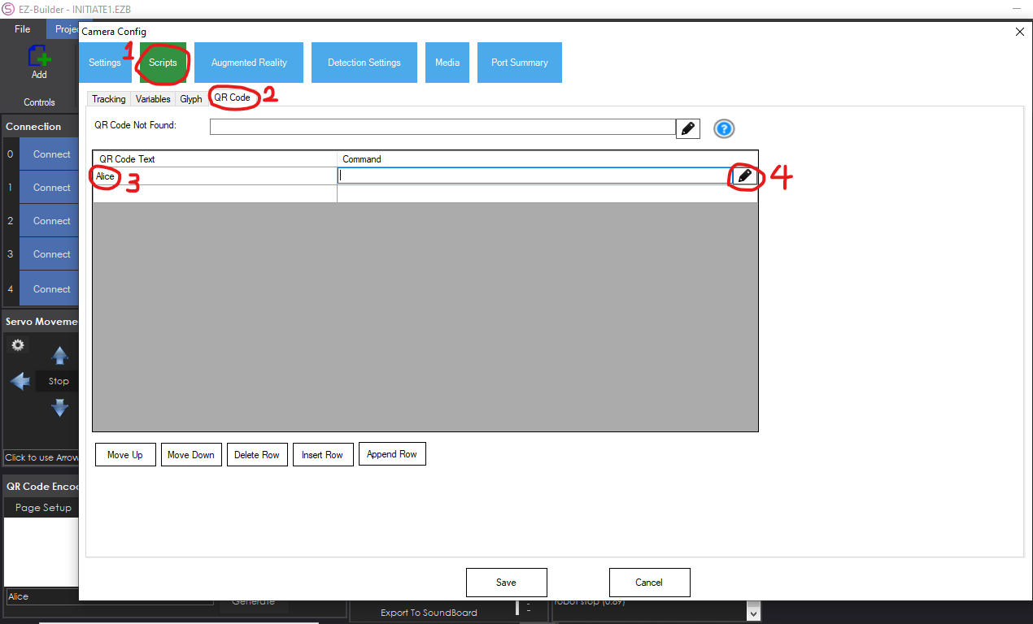
- Similar to Activity 4, we want to design an algorithm that enables the robot to say “QR code reads (someone’s name)”, whenever the camera detects a readable QR code. For that, we first need the “Say EZB (wait)” command from the Audio tab. Then, for creating the text “QR code reads (someone’s name)”, we need two parts for the text. The first part would be “QR code reads “ and the second part would be “(someone’s name)”, which is a Variable. Select the “item” from the Variables tab and change it to “CameraQRCode” as shown in the screenshot below. Once you successfully created the algorithm, click on “Save” on the bottom-left corner of the screen:
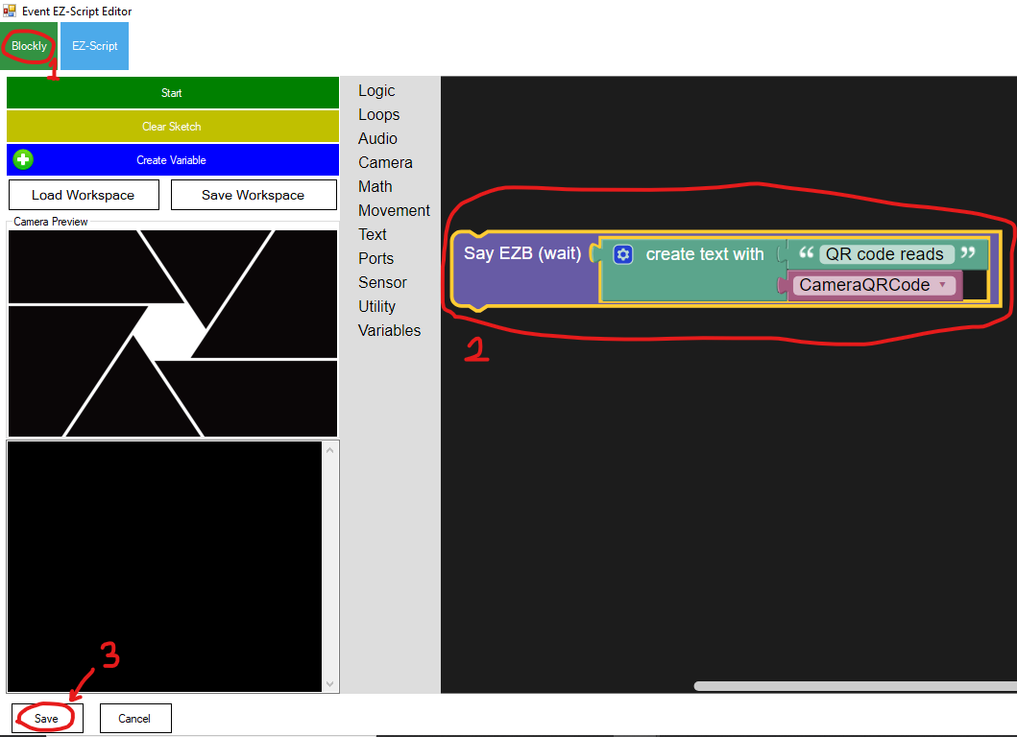

- Congratulations! You have now successfully enabled the robot to say “QR code reads (student’s name)” whenever a student’s QR code is held in front of the camera. Because of the nature of the algorithm you created and the use of Variables in it, you can hold different QR codes of different students in front of the camera and the robot will say their name.
For a combination of Facial recognition, QR Codes, and Speech recognition, refer to Activity 6.

Activity 6: Combining Facial recognition and QR code with Speech recognition (45 minutes)
Section 1: Introduction (2 minutes)
In activities 4 and 5, the functionalities of Facial recognition and QR codes in AdventureBot were discussed. In this activity, we will discuss using Facial recognition and QR codes as functional Security measures in autonomous vehicles. This activity contains 2 parts: the first part will discuss the combination of Facial recognition and QR codes, and the second part will guide you through adding a third layer of security, which is Speech recognition.
Section 2: Combining Facial recognition and QR code detection
Having facial recognition as a security measure is a useful feature for an autonomous vehicle, but it certainly will not be enough. That is why having a QR code could serve as your Private Key to your car, alongside with your face.
Here is a step-by-step guide for creating an algorithm that enables AdventureBot to authorize the user using their Facial data and QR code combined:
- Open INITIATE1 project in EZ-Builder software, and record at least two users’ facial data using the guides from Activity 4 in this lesson plan.
- Create separate QR codes (refer to Activity 5) for the users with recorded facial data in the previous step.
- For example, we create Alice’s and Bob’s both facial data and QR codes in this activity.
- To make this combination happen, we need AdventureBot to ask for a user’s face, then ask for their QR code. Navigate to the “Tracking” tab in Camera section, toggle-on “QR Code” and “Object” check-boxes, and click on the Gear button on the bottom-left corner of the Camera section (shown in the screenshot below):
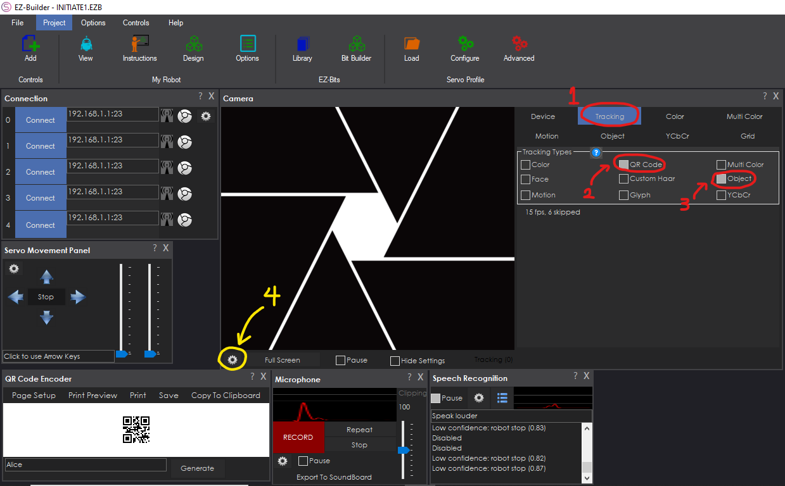
- In the “Camera Config” screen, click on the “Scripts” tab, select the “Tracking” tab, toggle-on the checkbox, and click on the Pencil icon in front of the “Tracking Start” field (all steps shown in the screenshot below):
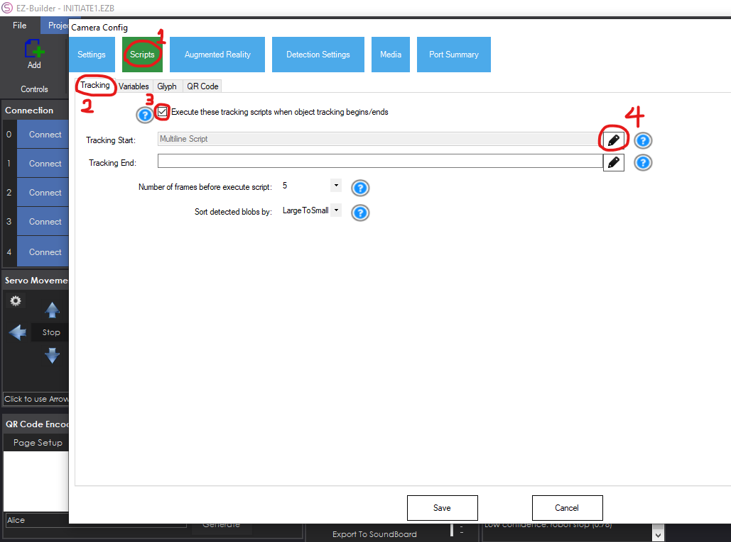
- Now in the “Event EZ-Script Editor” screen, we want to create an algorithm that:
- When sees Alice’s face, ask for her QR code. If her QR code also says “Alice”, the algorithm should say “Alice authorized”. If the QR code does not match Alice’s, the algorithms should not proceed.
- When sees Bob’s face, ask for his QR code. If his QR code also says “Bob”, the algorithm should say “Bob authorized”. If the QR code does not match Bob’s, the algorithms should not proceed.
Your algorithm should resemble the following Blockly environment:
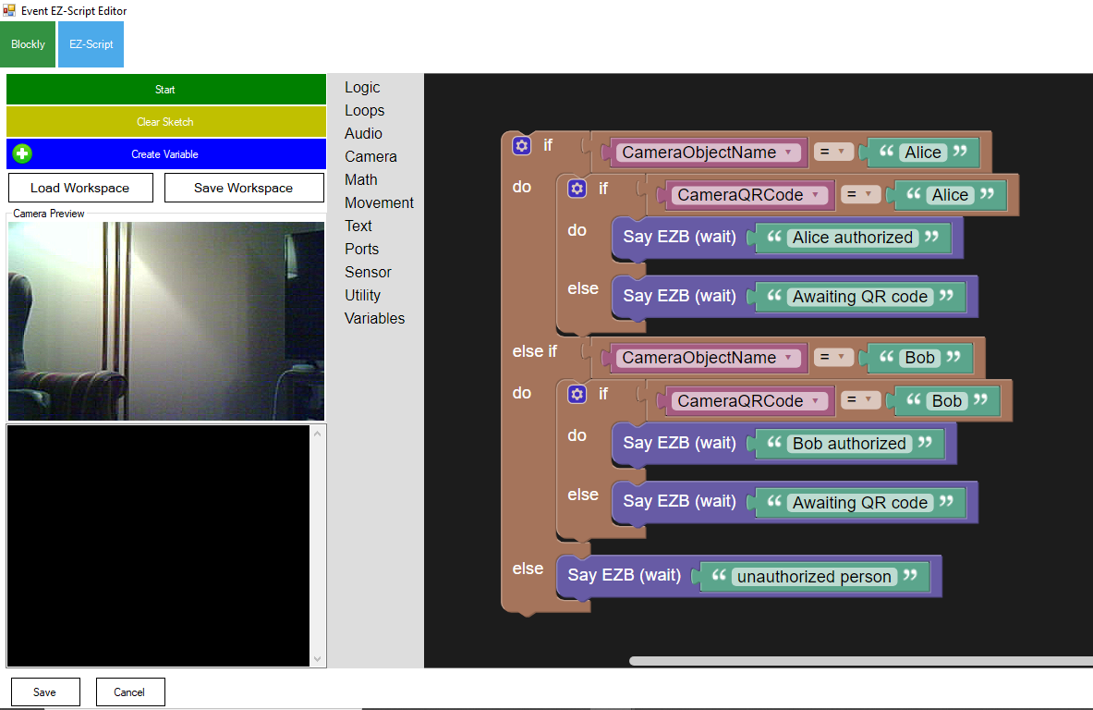
- Save your Blockly algorithm and click on “Save” on the “Camera Config” screen. Now when AdventureBot sees Alice’s face, it says “Awaiting QR code”. Once you hold Alice’s QR code in front of the camera, the robot will say “Alice authorized”.
Algorithm Tips: instead of writing separate sections for each person’s name and using separate “else if” commands, you can use Variables for the person’s name (refer to Activities 4 and 5). This could be done by appending two text parts to each other, such as “(someone’s name)”+”is authorized”. You should use “CameraObjectName” for the Variable from the dropdown list.
Section 3: Combining Facial recognition, QR code detection, and Speech recognition
To add a third layer of security to our Facial recognition combined with QR code detection, we will demonstrate the use of Speech recognition. To make this happen, we will need the user’s face to be presented to the camera, then their respective QR code should be held in front of the camera, and finally the user will say their name or selected special phrase for the final authentication.
The following step-by-step will guide you through this process:
- Open INITIATE1 project on EZ-Builder software. Navigate to the “Tracking” tab in the Camera section and make sure all the checkboxes are toggled off. Then locate the “Speech Recognition” box on the bottom of the screen, and click on the Gear icon (all steps shown in the screenshot below):
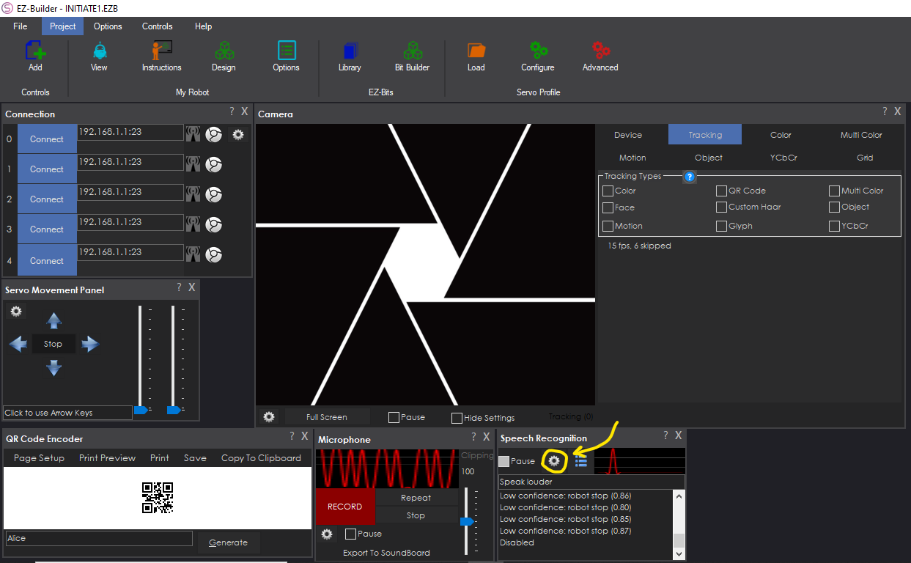
- On the new screen, locate the “It’s Alice” row in the Phrase list and write the name of an authorized user in it. Then click on the Pencil icon in front of its command field (shown in the screenshot below):
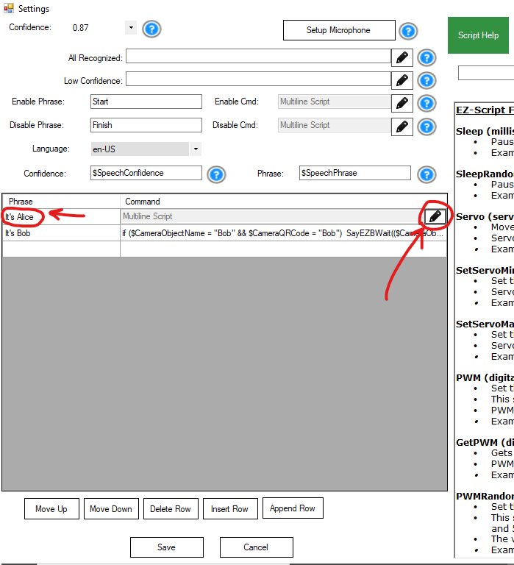
- On the next screen, you will only need to replace “Alice” with your desired name (shown below). Click on “Save” once finished:
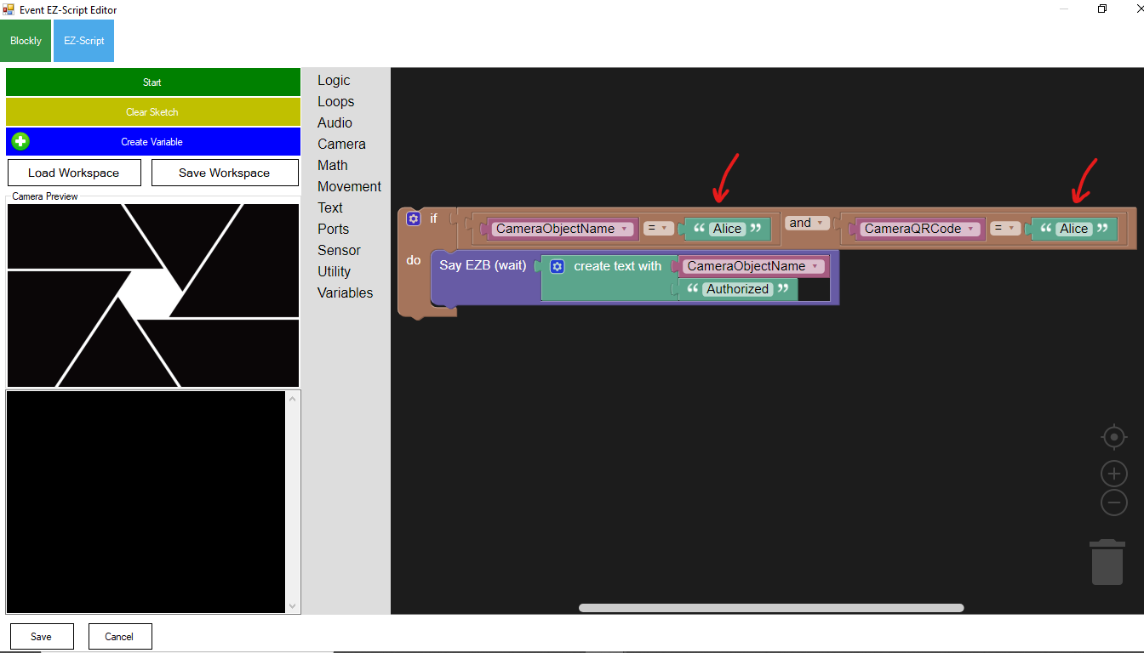
- Perform the same steps for Bob, and whomever you also want to add to the authorized users list. Once you’re finished adding the users, click on “Save”.
- Now the fun part begins. Perform the following steps thoroughly and in the correct order:
- Say “Start” clearly into your computer’s microphone
- Show a user’s face to the AdventureBot’s camera
- Hold the same user’s QR code in front of the camera
- Now say your special phrase clearly into the computer’s microphone, AdventureBot now says that you are authorized!
- And finally (this is an important step), say “Finish” clearly into the mic.
- For example: Alice says “Start” into the mic, then Alice shows her face to the camera, then Alice hold her QR code in front of the camera, and finally she says “It’s Alice” into the mic. AdventureBot will then say “Alice is authorized”, and finally she should say “Finish” into the mic.

For a video tutorial on Speech Recognition, visit https://www.ez-robot.com/Tutorials/Lesson/110?courseId=7

Wrap-up Activity: Discussion (10 minutes)

Learning Objectives and Standards
Learning Objectives | Standards

Additional Information and Resources

Project-based Learning Features
Feature | Where does this occur in the lesson?
Driving Question
Making Sense of Data
Investigation and Problem Solving
Technology Incorporation
Collaborative Opportunities
Assessment Techniques

Computational Thinking Concepts
Concept | Where does this occur in the lesson?
Decomposition
Abstraction
Pattern Recognition
Algorithm Design

Administrative Details
Contact info: | Kiyan.khaloozadeh@rockets.utoledo.edu  www.utoledo.edu/research/initiate
Sources: | - Google Classroom, 2019. URL: https://classroom.google.com/
Date Written: | 03/26/2020
Template adapted from: | https://edu.google.com/resources/programs/exploring-computational-thinking/

