INITIATE Lesson Plan: ADA Compliant Bus Floor Design

Lesson plan at a glance...  Name: ADA Compliant Bus Floor Design  Course: CTE  Grade Level: 9th to 12th  Prerequisites: -  Time: Preparation: 2 minutes Instruction: 85 minutes  Standard(s): TPS CTE Standards: Strand 5: Pre‐Engineering: Design and Development | In this lesson plan…  - Lesson Overview  - Driving Questions  - Materials and Equipment  - Preparation Tasks  - The Lesson  - Learning Objectives and Standards  - Additional Information and Resources

Lesson Overview
In this lesson, students will design and 3D print an ADA compliant bus floor using actual dimensions of a Navya autonomous bus in smaller scale.

Driving Questions
Overarching Driving Questions for Bowsher Wide Project:
- How can we make smart busses safer and more convenient for people with disabilities?
Lesson Specific Question:
- What would be a suitable design for an ADA compliant bus floor in order to meet certain needs of people with disabilities?

Materials and Equipment
- PC/Mac with FreeCAD (or any other CAD design tool) installed
- 3D Printer and 3D printing filament
- Ramp
- Bus exterior model (using trifold board, etc)
- Tape measure

Preparation Tasks
 | Setting up and preparing the computer and the software | 5 minutes

The Lesson
Warm-up Activity: Overview of the lesson objective | 5 minutes
Activity 1: Studying the necessary documentations | 10 minutes
Activity 2: Designing the bus floor model in FreeCAD | 60 minutes
Activity 3: Exporting the design to the slicing software for printing | 15 minutes
Activity 4: Building the ramp | 20 minutes
Wrap-up Activity: Present results to Navya

Warm-up Activity: Overview of the lesson objective (5 minutes)
Activity Overview: In this activity, teacher will explain how this lesson goes forward.

Activity: YouTube video about ADA Compliance guidelines and autonomous buses

Activity 1: Studying the necessary documentations (10 minutes)
Activity Overview: In this activity, we go through the ADA Compliance document
ADA Document:

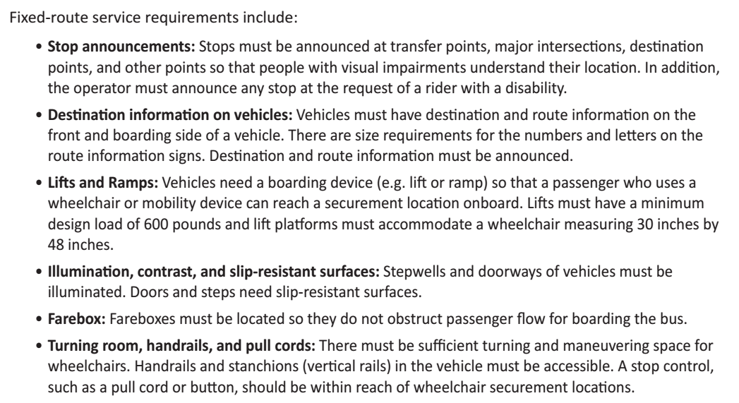

Now, it is time to find reasonable dimensions for the bus floor based on the dimensions of a Navya bus.
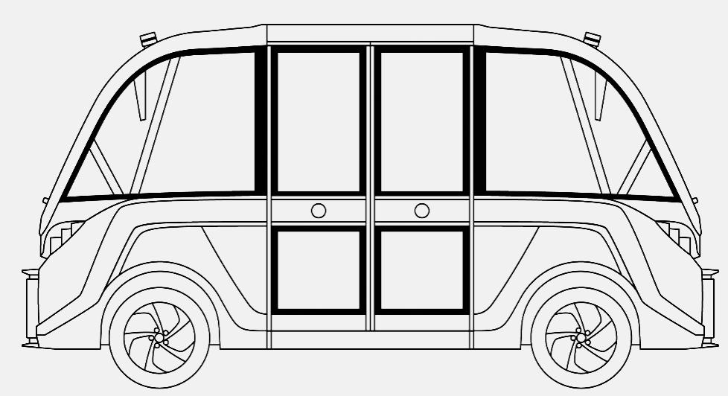
The students should first find the aspect ratio of the dimensions (2.25), then scale them down to fit into the printing area of the 3d printer. Reasonable new dimensions are: 160mm*71mm

Activity 3: Designing the floor using FreeCAD (60 minutes)
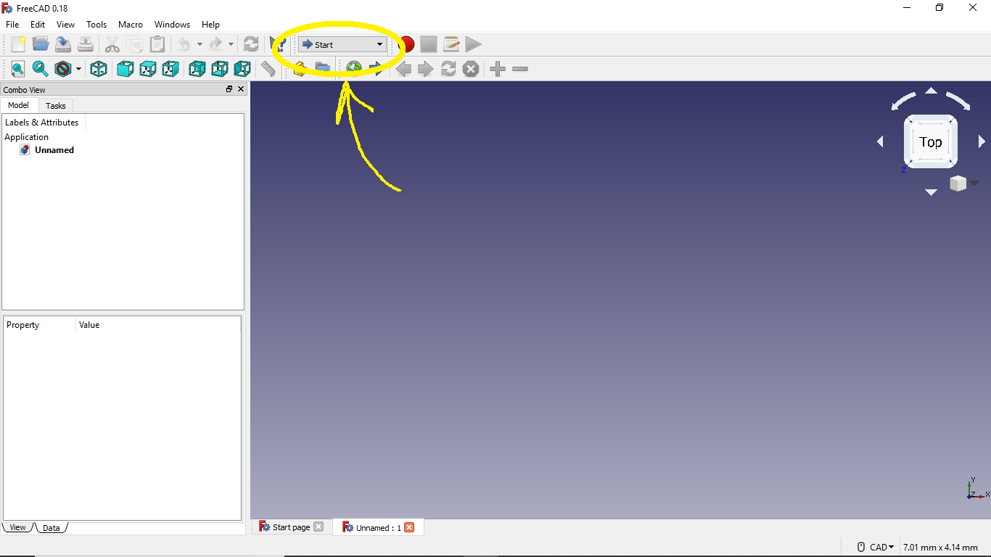
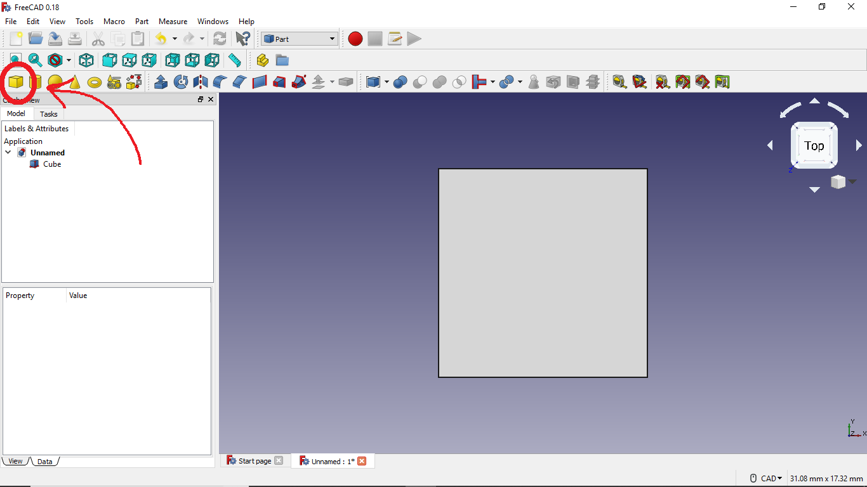
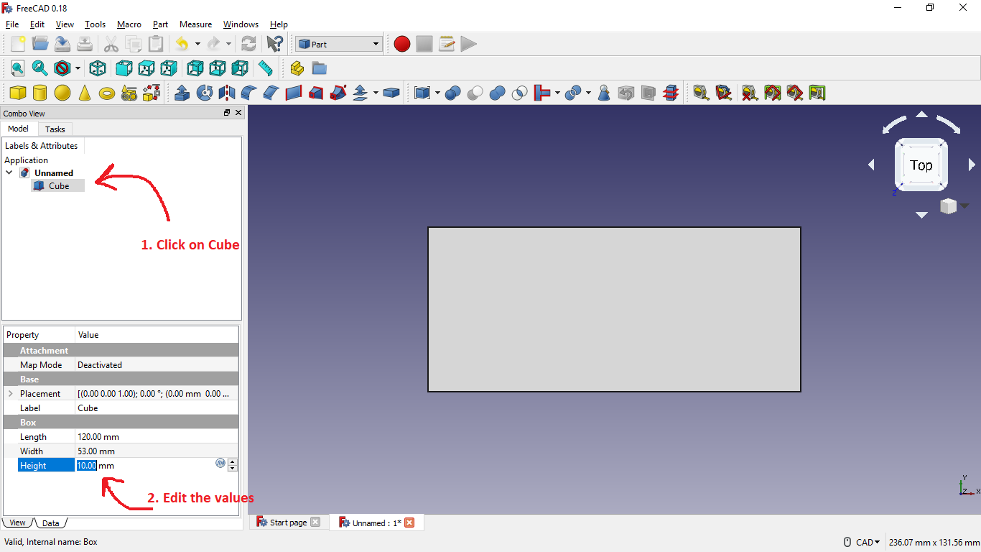
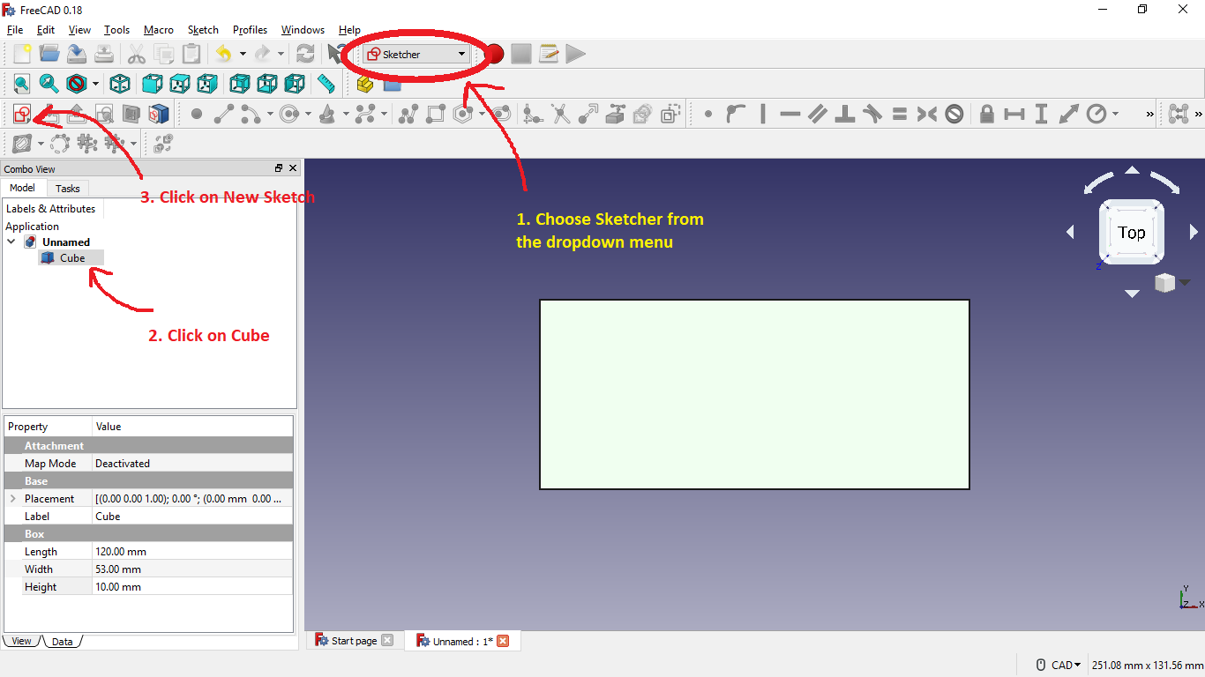
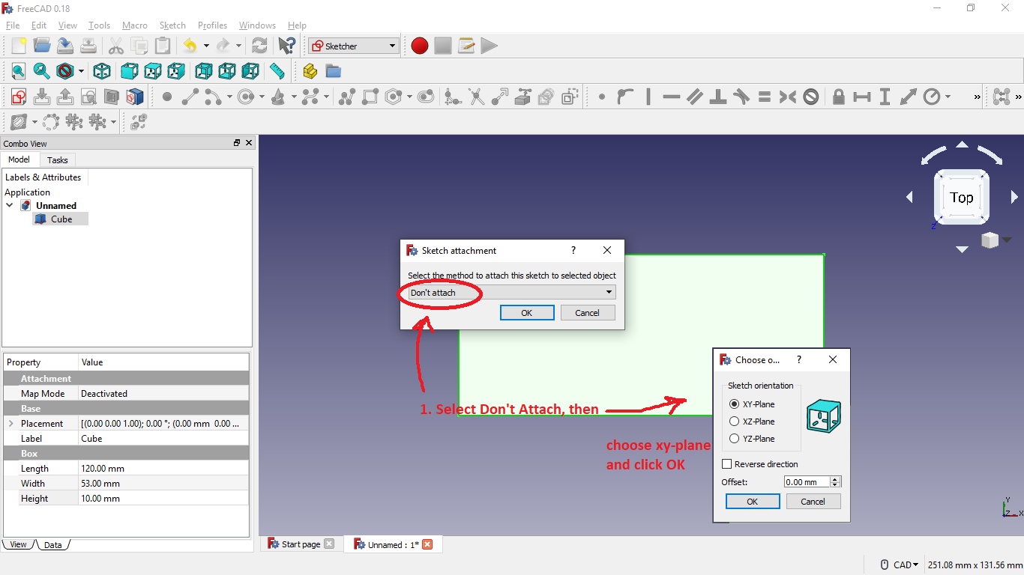

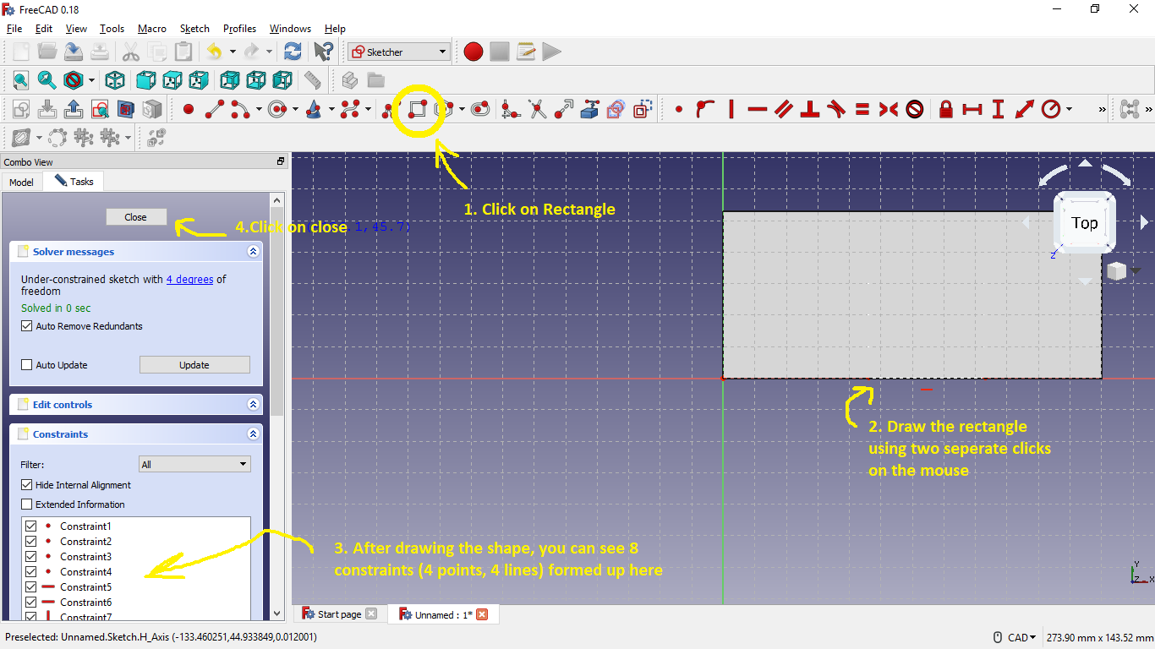

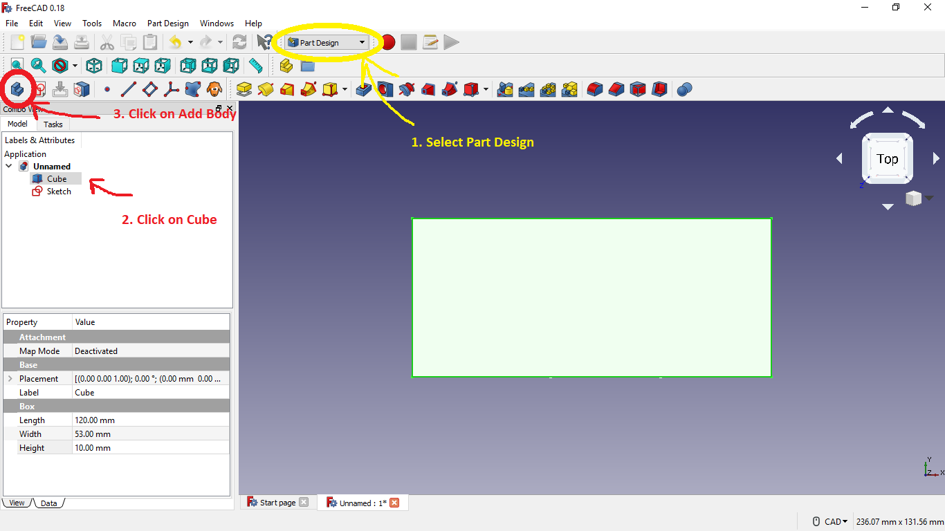

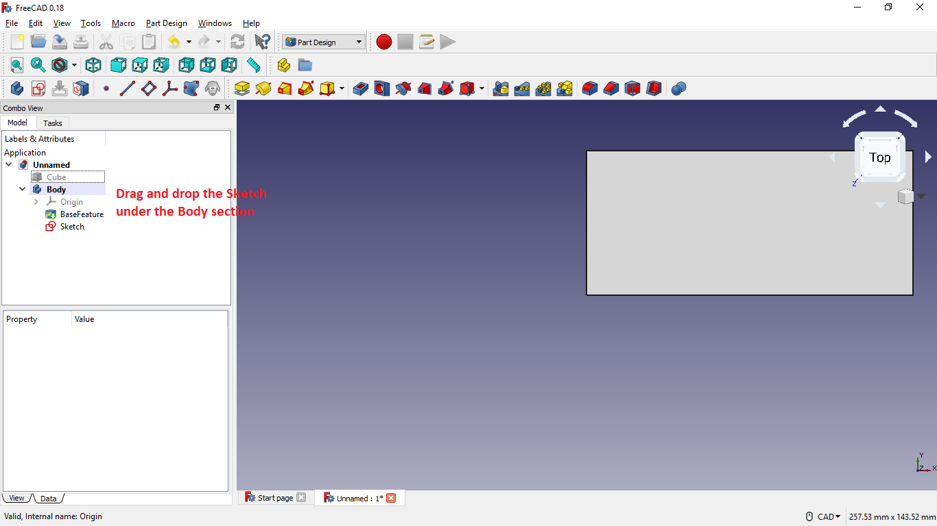

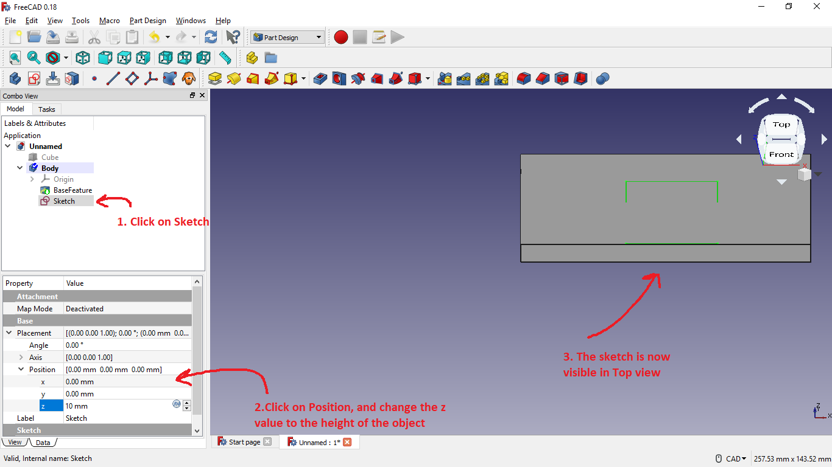

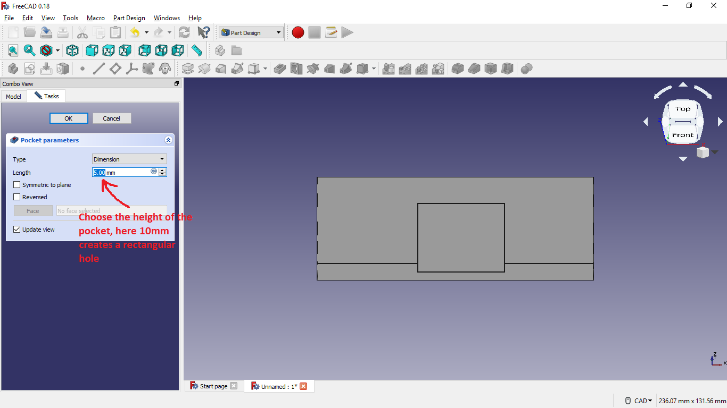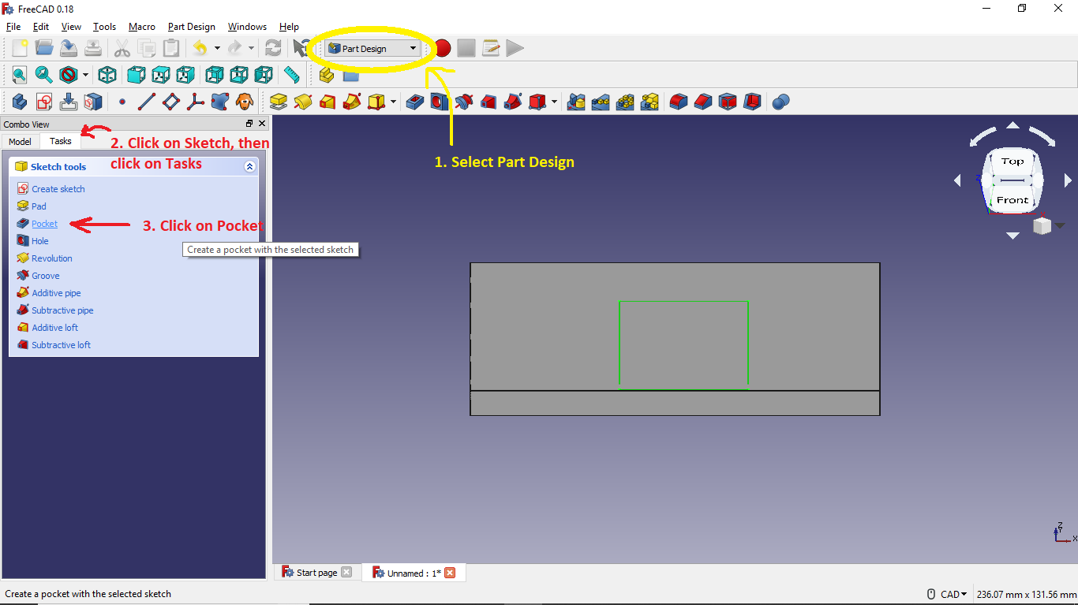
Students may make some finalizing tweaks to their designs, such as curved edges, etc. After the design is finished, it should be exported as an .STL file in order to be imported into a 3d printing software (e.g. Ultimaker Cura).

Activity 4: Building the Ramp (20 minutes)
The material used for building the ramp:
- Trifold boards
- Hinges
- Glue

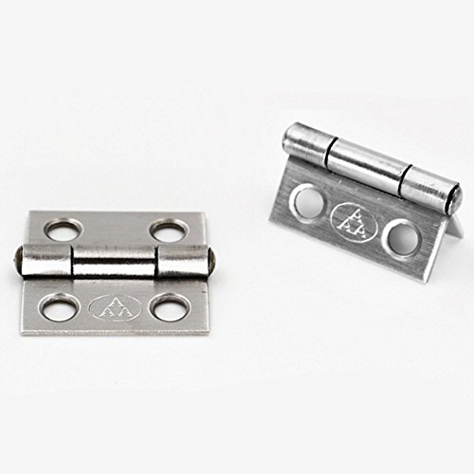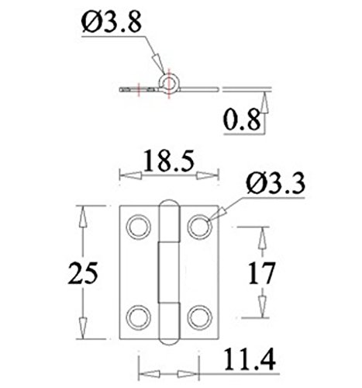
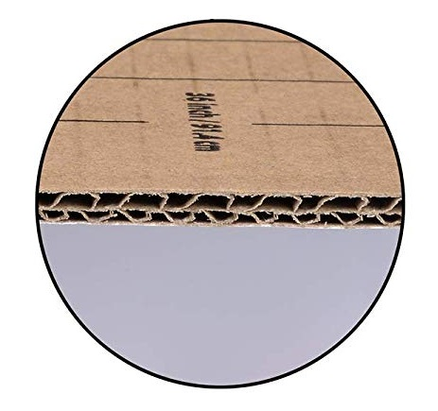

Learning Objectives and Standards
Learning Objectives | Standards

Additional Information and Resources

Project-based Learning Features
Feature | Where does this occur in the lesson?
Driving Question | How the interior and exterior of autonomous buses should be redesigned in order to meet the needs of people with disabilities?
Making Sense of Data | While reading through the ADA Guidelines document and the Navya brochure. Students make sense of data while reading the guidelines and spotting design features of a Navya bus.
Investigation and Problem Solving | While designing the CAD model with respect to the ramp design. Students should come up with a reasonable ramp design in order to build an ADA compliant bus floor.
Technology Incorporation | Using CAD design software and 3D Printing.
Collaborative Opportunities | Students in charge of the CAD design should collaborate with the students in charge of the dimensions of the floor plan because both activities are totally dependent on each other.
Assessment Techniques | The final design of the floor plan should meet all the ADA requirements, realistic dimensions, and realistic ramp design.

Computational Thinking Concepts
Concept | Where does this occur in the lesson?
Decomposition
Abstraction
Pattern Recognition
Algorithm Design

Administrative Details
Contact info: | Kiyan.khaloozadeh@rockets.utoledo.edu  www.utoledo.edu/research/initiate
Sources: | Google Classroom, 2019. URL: https://classroom.google.com/
Date Written: | 06/09/2019
Template adapted from: | https://edu.google.com/resources/programs/exploring-computational-thinking/

