INITIATE Lesson Plan: Rotating Distance Sensor

Lesson plan at a glance...  Name: Rotating Distance Sensor  Course: Advanced Bloxter  Grade Level: 9th to 12th  Prerequisites: -  Time: Preparation: 5 minutes Instruction: 150 minutes  Standard(s): | In this lesson plan…  - Lesson Overview  - Driving Questions  - Materials and Equipment  - Preparation Tasks  - The Lesson  - Learning Objectives and Standards  - Additional Information and Resources

Lesson Overview
In this lesson, the students will learn about LiDAR sensors placed on cars for object detection and route navigation. They replicate that by building a rotating distance sensor on the smart car that also changes its rotation speed based on the speed of the car itself. Students will learn about variables, logic and math operators, and functions in Bloxter programming language.

Driving Questions
Overarching Driving Questions for Bowsher Wide Project:
- How can we make smart busses safer and more convenient for people with disabilities?
Lesson Specific Question:
- What sensors does a smart bus need to operate safely?

Materials and Equipment
- GoPiGo3 smart car
- Distance sensor
- Servo motor
- Tablets/PC
- Internet connection

Preparation Tasks
2 minutes

The Lesson
Warm-up Activity: Video about LiDAR | 5 minutes
Activity 1: | 90 minutes
Activity 2: | 30 minutes
Activity 3: | 45 minutes

Warm-up Activity: Video about LiDAR (5 minutes)
Activity Overview: In this activity, teacher will explain how this lesson goes forward.

Activity: https://www.youtube.com/watch?v=JC94Y063x58&t=6s

Activity 1: (90 minutes)
After watching the LiDAR video, the teacher asks the students to come up with ideas on how they can implement the LiDAR concept on a GoPiGo smart car. They should ultimately come up with the idea of a Rotating distance sensor on the car, using the Servo Motor and the Distance Sensor.

Section 1: Introduction on variables (30 minutes)
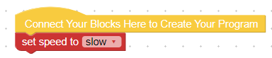
Teacher starts by showing the students different types of commands in bloxter programming for controlling the speed.

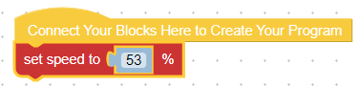

We can either use phrases such as “slow” or “faster”, or percentages for setting the speed. The teacher asks the students if they know about any method that helps eliminating multiple occurrences of a number throughout a code. The answer is Variables. Here is how to create a variable in Bloxter:
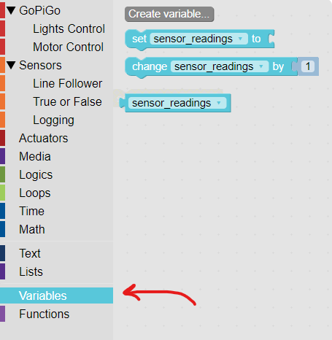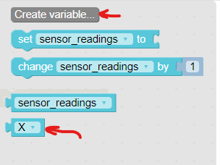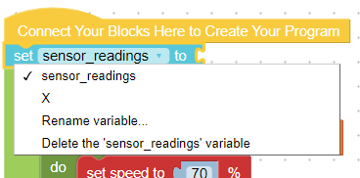

- Suppose we would like to write a code that makes the car go forward for X inches, when we set its speed to X percent.

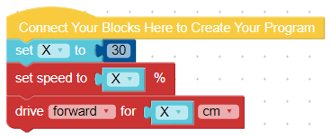

Section 2: Servo motors (30 minutes)
A GoPiGo Servo motor is a device that rotates by a certain degree given to it as an input. It is used mainly in a GoPiGo car to rotate the Distance sensor attached to it. Here are some angles recognizable by the servo motor. All angles should be between 0 and 180 degrees.
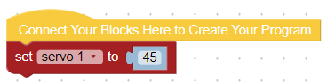
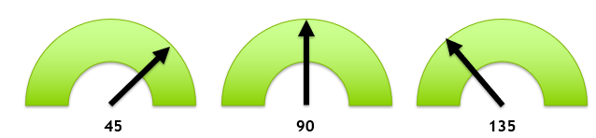

Now the students should write a code that sets the servo motor to certain angles consecutively. They should come up with a code such as below:
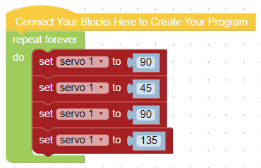
This code will not work, because due to the nature of the servo motors, there should be time delays between each angle command. A functional code will be like the one below:
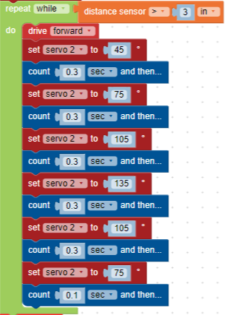

Section 3: Merging the codes (30 minutes)

Problem Statement: Write a code that makes the car drive forward while the distance sensor rotates. The car should come to a stop when an obstacle is detected.
Solution:
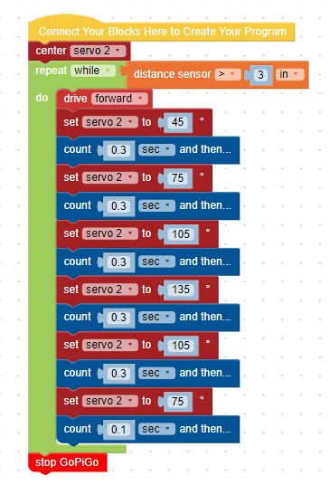

Activity 2: (30 minutes)
Activity Overview: Functions in Bloxter programming

Section 1: (10 minutes)
Problem Statement: Have you ever wondered if there is a way you could put a series of codes (tasks) in clusters?
Solution: This concept is done in Bloxter using Functions. Functions are clusters that you can put certain tasks into. They are used when you want to avoid writing same codes happening over and over again in a project.

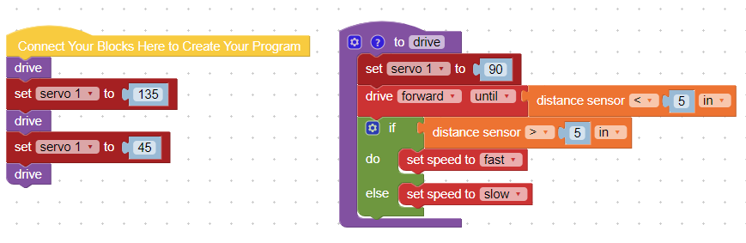

Section 2: (20 minutes)
Problem Statement: Now try to recreate the code for the rotating sensor using functions.
Solution:
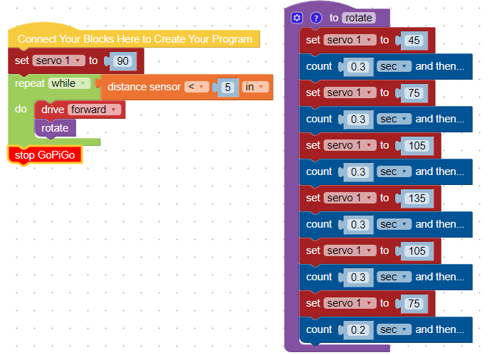

Activity 3: Bonus Challenges (45 minutes)

Write a code that makes the distance sensor rotate Faster when the car moves faster, and rotate slower when the car moves slower, respectively.

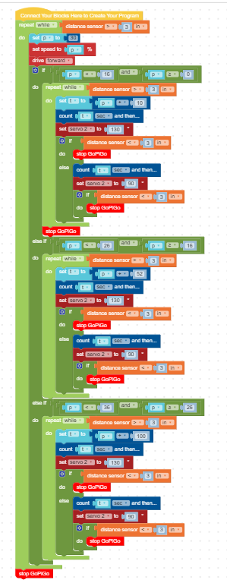

Write the code in Bonus Challenge#1 using Functions in Bloxter.
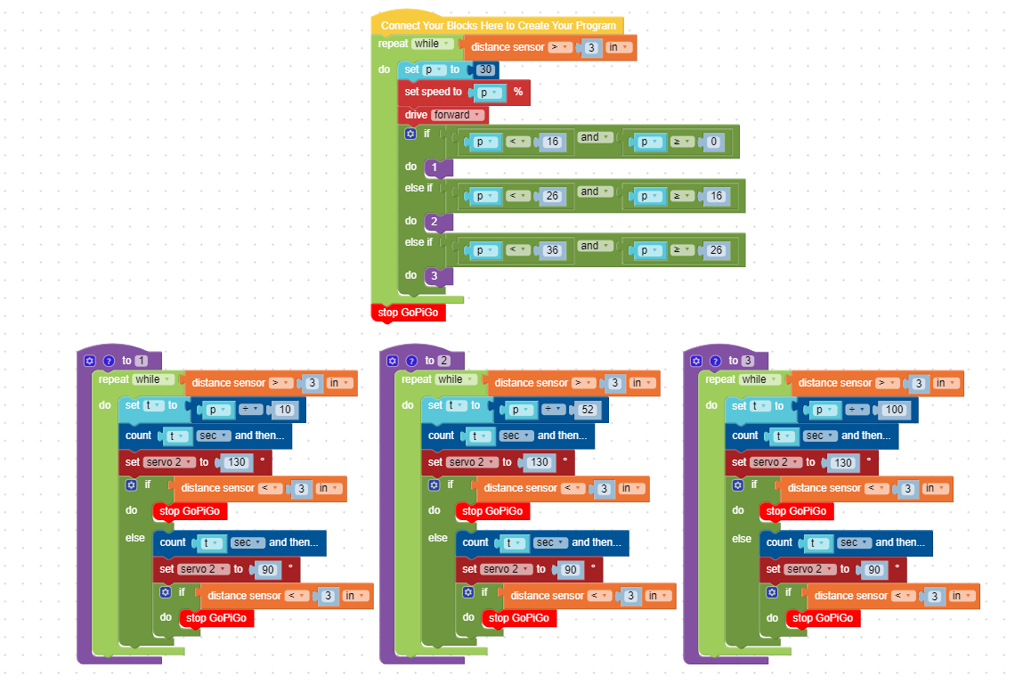

Learning Objectives and Standards
Learning Objectives | Standards
Advance Bloxter | CTE

Additional Information and Resources

Project-based Learning Features
Feature | Where does this occur in the lesson?
Driving Question | What kind of sensors exist or should be installed in an autonomous vehicle in order to make smart buses safer and more convenient?
Making Sense of Data | In all activities and sub sections, students should continuously make sense of how the distance sensor and servo motors work prior to writing the code.
Investigation and Problem Solving | The students should look for possible ways to implement the concept of a LiDAR on a smart bus.
Technology Incorporation | In all activities, students make use of distance sensors and servo motors to build a rotating sensor on a smart bus, making it possible to detect nearby objects in vicinity while moving with certain speeds.
Collaborative Opportunities | In every activity, students share ideas about how they write the code and how they come up with different ways of implementing the new concepts they learn in this lesson.
Assessment Techniques | The final code is going to be the assessment technique. It should function successfully, the sensor should be rotating accordingly with the speed of the car, and the car should stop when an obstacle is detected.

Computational Thinking Concepts
Concept | Where does this occur in the lesson?
Decomposition
Abstraction
Pattern Recognition
Algorithm Design

Administrative Details
Contact info: | Kiyan.khaloozadeh@rockets.utoledo.edu  www.utoledo.edu/research/initiate
Sources: | - Google Classroom, 2019. URL: https://classroom.google.com/
Date Written: | 06/20/2019
Template adapted from: | https://edu.google.com/resources/programs/exploring-computational-thinking/

