INITIATE Lesson Plan: Speed Maintenance System

Lesson plan at a glance...  Name: Speed Maintenance System  Course: Bloxter Coding  Grade Level: 9th to 12th  Prerequisites: -  Time: Preparation: 2 minutes Instruction: 85 minutes  Standard(s): Common Core: TPS CTE: Analog Based Electronic Devices Standards: Strand 5: Pre‐Engineering: Design and Development | In this lesson plan…  - Lesson Overview  - Driving Questions  - Materials and Equipment  - Preparation Tasks  - The Lesson  - Learning Objectives and Standards  - Additional Information and Resources

Lesson Overview
In this lesson, students will design and create a speed maintenance system for the smart cars. The system will first calculate and determine a “safe distance” that has to be maintained from any car being driven in front using different environmental parameters, such as road lighting or weather conditions. The system will then make the smart car increase or decrease its speed to respond to the mentioned parameters.

Driving Questions
Overarching Driving Questions for Bowsher Wide Project:
- How can we make smart busses safer and more convenient for people with disabilities?
Lesson Specific Question:
- What system needs to be designed in order for the moving cars to maintain a safe distance between each other?

Materials and Equipment
- GoPiGo3 Smart car kit with Distance sensor attached
- Tablets
- Internet Connection

Preparation Tasks
 | Connecting tablets to the smart cars | 5 minutes

The Lesson
Warm-up Activity: Overview of the lesson objective | 5 minutes
Activity 1: Introducing the Problem using the BMV book reference | 20 minutes
Activity 2: Writing the series of code needed for designing the system | 30 minutes
Activity 3: Implementing the codes from the previous activity in Bloxter environment | 45 minutes
Wrap-up Activity: Parameter tuning and improvements | 30 minutes

Warm-up Activity: Overview of the lesson objective (5 minutes)
Activity Overview: In this activity, teacher will explain how this lesson goes forward.

Activity: YouTube video about speed maintenance and distance sensors

Activity 1: Introducing the Problem using the Ohio BMV book reference (20 minutes)
Activity Overview: In this activity, the teacher and the students discuss about the need for a system that generates a safe distance between two cars. The teacher should start with introducing the problem based on a reference in Ohio Bureau of Motor Vehicles book.
Section 1: The reference in BMV book (5 minutes)

The Book can be accessed through this link: https://driving-tests.org/ohio/oh-bmv-drivers-handbook-manual/
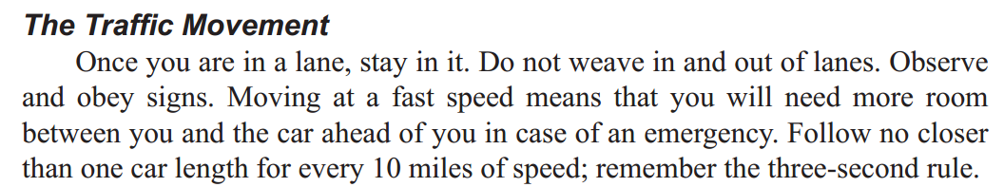

Problem Statement: Which line in this paragraph does indicate a rule for keeping the distance between two cars?
Solution: The last line. According to the BMV Book, a car should “follow no closer than one car length for every 10 miles of speed” when there is another vehicle in front.

Section 2: Moving forward with the problem (20 minutes)

Problem Statement: According to the BMV Book, a car should “follow no closer than one car length for every 10 miles of speed” when there is another vehicle in front. This distance, referred to as “Safe Distance (SD)” henceforth, should be multiplied by 1.5 and 2.5 in cases of low light conditions and total darkness, respectively.
•So if one is driving at 40 mph and it is currently midnight, the safe distance between two cars should be 10 car lengths (4*2.5).
•Write a series of conditions (codes) to design a system that generates Safe Distances corresponding to changes in cars’ speeds and road lighting conditions.
Solution: Students should begin brainstorming and eventually writing the desired codes in the following format:

•If v∈(0,10], and lighting condition is “Bright”, then SD=1*L
•If v∈(10,20], and lighting condition is “Bright”, then SD=2*L
•If v∈(20,30], and lighting condition is “Bright”, then SD=3*L
•If v∈(30,40], and lighting condition is “Bright”, then SD=4*L
•If v∈(0,10], and lighting condition is “Dim”, then SD=1.5*L
•If v∈(10,20], and lighting condition is “Dim”, then SD=2*1.5*L
•If v∈(20,30], and lighting condition is “Dim”, then SD=3*1.5*L
•If v∈(30,40], and lighting condition is “Dim”, then SD=4*1.5*L
•If v∈(0,10], and lighting condition is “Dark”, then SD=2.5*L
Where v is the speed of our car, and L is one length of a car (L is estimated to be 14ft in this system)

Section 3: An alternative problem statement and solution for more realistic approaches (20 minutes)

Problem Statement: According to the BMV Book, a car should “follow no closer than one car length for every 10 miles of speed” when there is another vehicle in front. This distance, referred to as “Safe Distance (SD)” henceforth, should be doubled and tripled in cases of rain and snow(ice), respectively.
•So if one is driving at 40 mph and there is ice on the road, the safe distance between two cars should be 12 car lengths.
•Write a series of conditions (codes) to design a system that generates Safe Distances corresponding to changes in cars’ speeds and road slipping conditions.
Solution: Students should begin brainstorming and eventually writing the desired codes in the following format:

•If v∈(0,10], and the road is “Dry”, then SD=1*L
•If v∈(10,20], and the road is “Dry”, then SD=2*L
•If v∈(20,30], and the road is “Dry”, then SD=3*L
•If v∈(30,40], and the road is “Dry”, then SD=4*L
•If v∈(0,10], and the road is “Wet”, then SD=2*L
•If v∈(10,20], and the road is “Wet”, then SD=4*L
•If v∈(20,30], and the road is “Wet”, then SD=6*L
•If v∈(30,40], and the road is “Wet”, then SD=8*L
•If v∈(0,10], and the road is “Icy”, then SD=3*L
Where v is the speed of our car, and L is one length of a car (L is estimated to be 14ft in this system)

Both of the code sets above represent great ways to initialize building the SD generator system, however, due to the lack of availability of Moisture Sensors for GoPiGo3 cars, the lesson should proceed with the first approach (not the alternative one).

Section 4: Moving forward with the problem (20 minutes)
•The sensors on the smart vehicles nowadays give us the actual distance between two cars (∆x) and their relative speed (∆v).
•Using ∆x, ∆v, and the Safe distances obtained in the previous part, write a series of conditions that forces the car to follow and maintain the desired safe distance corresponding to the lighting (or existing weather) conditions.

Solution:

Assuming that the current speed is constant with no acceleration applied,
•If ∆x=12 and ∆v=-2 and SD=14, then Moderately brake
•If ∆x=40 and ∆v=+2 and SD=28, then Slightly Increase speed
•If ∆x=28 and ∆v=-1 and SD=28, then Slightly brake
•If ∆x=28 and ∆v=0 and SD=28, then do nothing
•If ∆x=14 and ∆v=-4 and SD=28, then Slam on the brakes!
•If ∆x=30 and ∆v=-2 and SD=14, then Slightly brake
•If ∆x=30 and ∆v=+1 and SD=14, then Moderately Increase speed

The relative speed between the cars (∆v) is obtained by special sensors designed for this task, same devices that police radars use for detecting the speed of other cars.

Section 5: Recreating the previous section for GoPiGo3 functionality (20 minutes)
•Since GoPiGo3 kits do not include any speed measurement device or sensor that can be used to detect the speed of the car in front, use only ∆x and the Safe distances obtained in the previous part to write a series of conditions that force the GoPiGo3 car to follow and maintain the desired safe distance corresponding to the lighting (or existing weather) conditions.

Solution:

Assuming that the current speed is set to 50%,
•If ∆x=12 and ∆v=-2 and SD=14, then set speed to 40%
•If ∆x=40 and ∆v=+2 and SD=28, then set speed to 55%
•If ∆x=28 and ∆v=-1 and SD=28, then set speed to 45%
•If ∆x=28 and ∆v=0 and SD=28, then set speed to 50% (do nothing)
•If ∆x=14 and ∆v=-4 and SD=28, then set speed to 15%
•If ∆x=30 and ∆v=-2 and SD=14, then set speed to 45%
•If ∆x=30 and ∆v=+1 and SD=14, then set speed to 60%

Teaching Tips:
- Teacher should ask students to provide charts and figures for each conclusion they make.

Activity 3: Writing the series of code needed for designing the system (10 minutes)
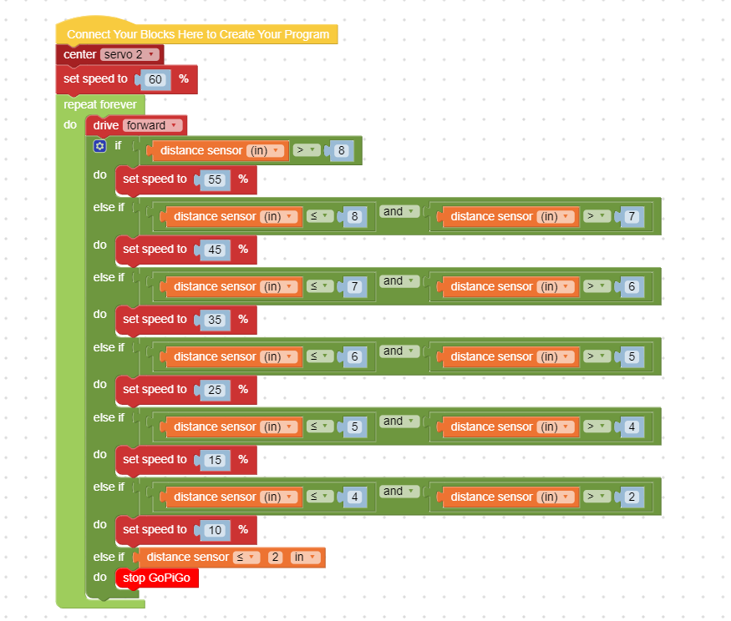

Sample Scenario:
Distance between the cars= 25 meters
Our speed=17m/s (61.2km/h)
Front vehicle speed=15m/s (54km/h)
(Road slipping: 0=dry, 50=rain, 100=ice)

Road slipping (OR LIGHTING) conditions generated in this scenario:
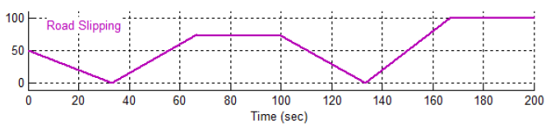

Results:
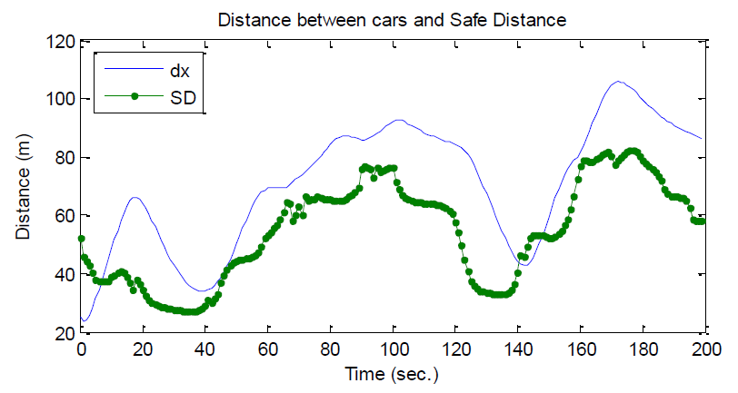
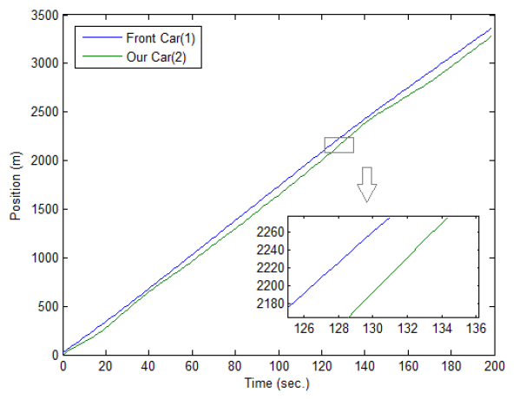

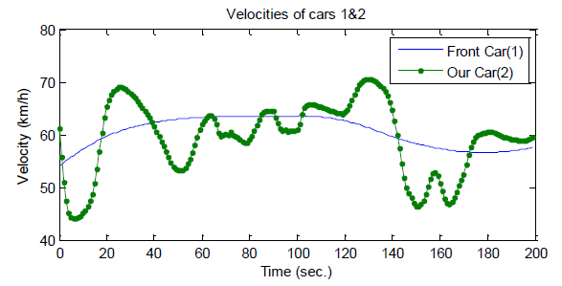
Cars 1&2 Speeds

Learning Objectives and Standards
Learning Objectives | Standards

Additional Information and Resources

Project-based Learning Features
Feature | Where does this occur in the lesson?
Driving Question
Making Sense of Data
Investigation and Problem Solving
Technology Incorporation
Collaborative Opportunities
Assessment Techniques

Computational Thinking Concepts
Concept | Where does this occur in the lesson?
Decomposition
Abstraction
Pattern Recognition
Algorithm Design

Administrative Details
Contact info: | Kiyan.khaloozadeh@rockets.utoledo.edu  www.utoledo.edu/research/initiate
Sources: | - https://driving-tests.org/ohio/oh-bmv-drivers-handbook-manual/  - beam.venngage.com for creating charts  - Google Classroom, 2019. URL: https://classroom.google.com/
Date Written: | 05/27/2019
Template adapted from: | https://edu.google.com/resources/programs/exploring-computational-thinking/

