CREATING A SMARTS/GENIUS PROFILE

Go to the SMARTS/GENIUS portion of the SPINPlus database. Once there, you will want to select the ‘Create a New Profile’ link.

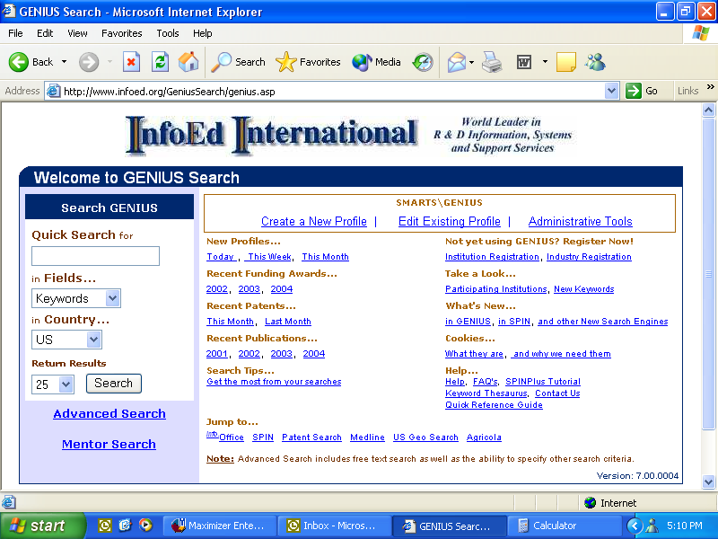

You will then be brought to a pick list of participating institutions. Scroll down the list and select your affiliated institution.

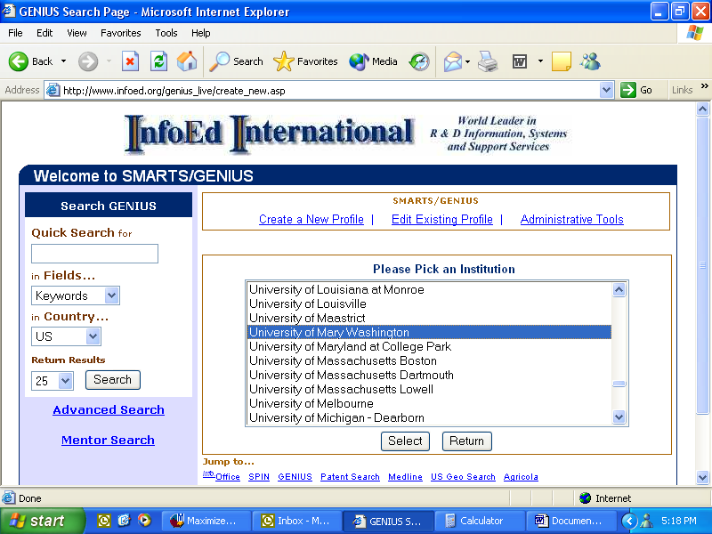

You will now enter the ‘New Profile Registration’ screen. Here you will want to populate the information requested, select your affiliated department, and create a unique User Name and Password.

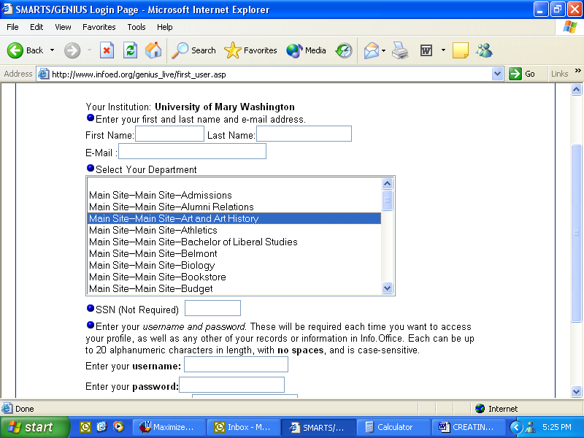

Once you have completed these steps, you will be transported to the ‘Profile Summary Page.’ For the purpose of creating a profile which will allow you to begin receiving the SMARTS daily e-mail alerts - containing new funding opportunities, you will need to populate the following categories:

- General
- Keywords
- Applicant Type
- Award Types
- Geographical Restrictions
- Sponsor Types
- Locations Tenable
- Position

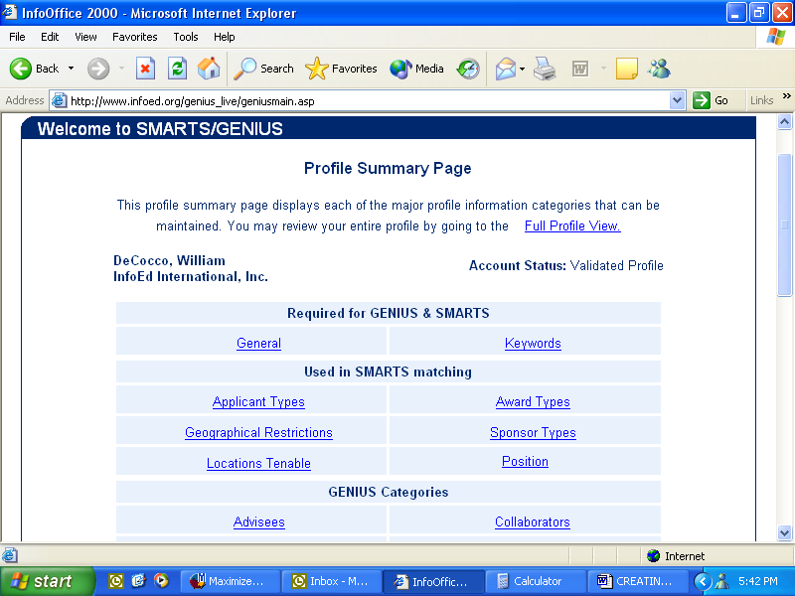

Let us review the first eight fields above in greater detail.

- General: Here you will want to provide your basic information which is requested. This is also where you set the parameters regarding your SMARTS daily e-mail alerts.
- Keywords: The Keywords link is where you will select all keywords which fall in your area(s) of research interest. To the left will be blue hyperlink keywords which are the main categories (ie: Agriculture, Education, Energy, etc.), by clicking on the blue hyperlink you will populate the keyword box to the right with all subtopic keywords associated with the main topic. If you would like to include all the subtopic keywords in your search criteria, you may place a check in the box next to the main category keyword. If you are looking to select multiple subtopic keywords, this is achieved by holding down the control key on your keyboard while making your selections. You may also mix and match subtopic keywords from various main topics in your selection process if you choose. Please note that choosing Exact Matches will narrow your results returned and choosing Hierarchical Matches will broaden your results. A list of all keywords may be obtained from the Help section of the main SMARTS/GENIUS page for your reference.
- Applicant Type: You will want to choose all fields which apply to you in the Applicant Type area.
- Award Types: Here you will want to choose all funding mechanisms which you are interested in. You may choose to not check any of the options and if so, all will be used in your SMARTS matching which will increase the number of opportunities received on a daily basis.
- Geographical Restrictions: When you click into this field the first thing you will notice is that ‘No Restrictions’ is already checked – this is a default setting and it is important for it to remain checked. You should proceed to check your geographic region as well as your state.
- Sponsor Types: Within this field you will want to select all sponsor types from which you will accept funding. If you make no selections, all categories will be used in your SMARTS matching. This will increase the number of opportunities you will receive in your SMARTS mail.
- Locations Tenable: Choose all countries/regions in which you would be interested in carrying out your project. If you make no selections, all categories will be used in your SMARTS matching. This will increase the number of opportunities you will receive in your SMARTS mail.
- Position: Please select all positions (roles) which properly represent you.

Once you have populated the fields outlined above for the purpose of receiving SMARTS e-mail alerts, you may opt to continue on and populate the GENIUS Categories if you so choose. The GENIUS Categories will allow you to build a more comprehensive profile. The primary purpose of completing the GENIUS portion is so individuals at other participating institutions may browse your profile and contact you if they have similar research interests.

Once you have completed populating the fields required to build out your SMARTS/GENIUS profile, your institution’s SPINPlus Administrator will receive an e-mail notifying them that your profile has been completed. They will then validate your newly created profile and you will be ready to begin receiving your daily SMARTS mail, alerting you of relevant funding opportunities.

During the creation of your SMARTS/GENIUS profile if you encounter any questions or need further assistance – you may contact your institution’s SPINPlus Administrator or you may contact InfoEd directly at 1-800-727-6427.

