The Disability Studies Program *presents*

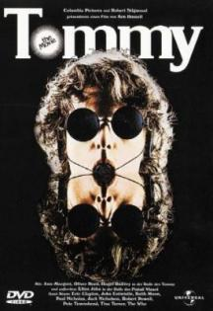

*That deaf, dumb, and blind kid sure plays a mean pinball*

**Robert Daltry  Eric Clapton**

**Elton John  Ann Margaret**

**Jack Nicholson**

**Tina Turner**

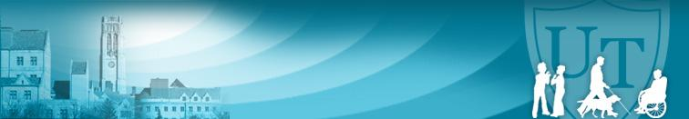

What does the legendary rock opera, TOMMY, have to do with disability?

Watch the film and find out.

In cooperation with The Disability Studies Student Organization

**7:00 p.m.**

**September 27**

**Memorial Field House**

**Room 2100**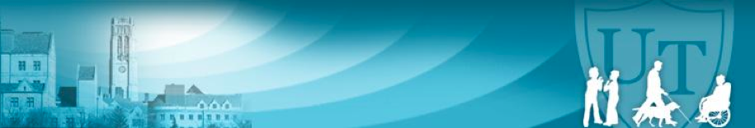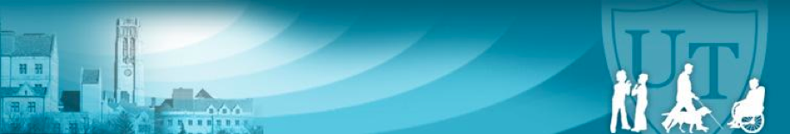

THIS EVENT IS FREE AND OPEN TO THE PUBLIC.

light refreshments provided.

**Disability Studies Program**

**University Hall 2100, Mail Stop 920**

**2801 W. Bancroft Toledo OH 43606**

**Ph. 419-530-7244**