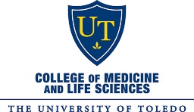

UTCOMLS’ Global Health Program

GLOBAL HEALTH STUDENT CHECK LIST
[For Completion Prior to Participation in a University-Approved Global Health Elective]

Participating Global Health student,

Congratulations on participating in an approved University of Toledo College of Medicine and Life Sciences’ (UTCOMLS) Global Health elective/medical mission! Let this form serve as your elective checklist. For your convenience, a checkbox has been added to all requirements. Please indicate completed requirements with . Thank you!

To ensure compliance with all Global Health requirements mandated by UT Legal & Risk Management Offices, all students participating in approved UTCOMLS’ Global Health electives/medical missions are required to complete Global Health Forms 1 – 4 prior to departure. All forms may be found on the UT Global Health website under Student Forms (http://www.utoledo.edu/med/globalhealth/GHStudentForms.html).

Global Health Student Form 1: Request for Global Health Experience (with HSC Letter of Good Academic Standing).
Global Health Student Form 2: Acknowledgment of Informed Consent, Waiver, & Release Agreement.
Global Health Student Form 3: Proof of CDC-Recommended Vaccinations.
Global Health Student Form 4: Travel Itinerary & Contact Information.

Additionally, all students completing an approved UTCOMLS’ Global Health elective must provide Deb Krohn (UTCOMLS Global Health Program Advisor) and/or your UTCOMLS’ student team leader(s) with a copy of your current passport and visa (if required).

Passports: If your passport is set to expire within 6 months of your intended travel return date, you will need to acquire a new passport prior to your departure. The University of Toledo’s Center for International Studies and Programs’ (CISP) Office (housed on the Main Campus in Snyder Memorial, Suite 1000) is a certified passport acceptance facility and accepts passport applications on behalf of the U.S. Department of State. All passport renewals/acquisitions may be completed with the CISP office by appointment only. Please call 419.530.5268 to schedule a passport appointment.

Visas: If you are required to attain a tourist visa for your intended rotation, Deb Krohn will walk you through the visa acquisition process. The Global Health Program recommends using Washington Passport Visa Service (WPVS) courier to acquire all student visas. The WPVS website is as follows: http://www.wpvs.com/ and their phone number is 1.800.272.7776. FYI: if you call the WPVS 800 number, their representatives will answer all application questions; they are quite helpful and will walk you through all visa requirements to make sure visa applications are complete prior to mailing them to WPVS to avoid any processing delays.

Required Foreign Travel Insurance: All UT students participating in an approved UTCOMLS’ Global Health elective/medical mission are required by UT Legal and Risk Management to secure travel health insurance.

Students participating in approved UTCOMLS’ traditional, month-long, clinical rotations are required to purchase UT’s CISI (Cultural Insurance Services International) travel insurance which will provide them with the following foreign coverage limits.

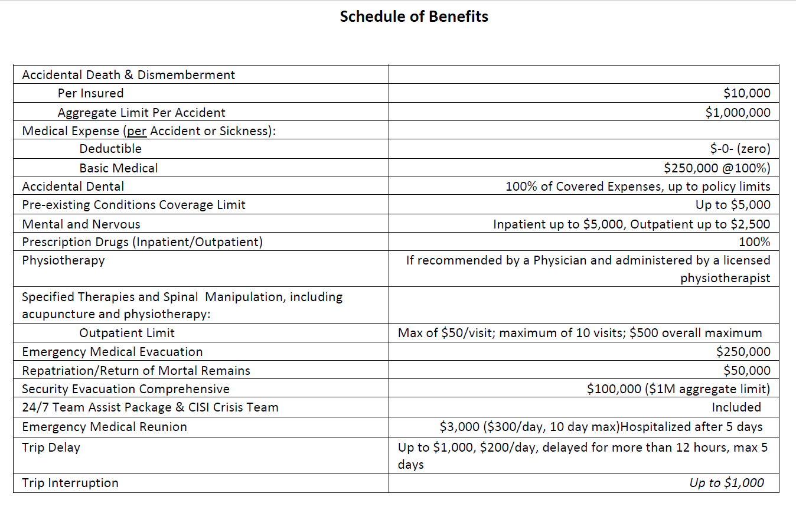
UT students are required to self-enroll and purchase The University of Toledo-designated policy via the CISI website. The discounted cost of the premium is only available at this University of Toledo associated link: https://www.mycisi.com/CISIPortalWeb/pub/SelfEnrollment.aspx?sponsor=UTOL.

Students participating in approved UTCOMLS’ faculty-led, team-based medical missions have the option to purchase either CISI’s month-long travel insurance (listed above) or United Healthcare Global’s Safe Trip 2 coverage ($500,000 Medical/Accidental Coverage amount with zero deductible) since CISI no longer offers short-term/weekly coverage. United Healthcare Global’s Safe Trip 2 ($500,000 Medical/Accidental Coverage amount with zero deductible) will provide you with the following foreign coverage limits.
- $500,000 Medical/Accident coverage amount per person.
- Zero deductible.
- $1,000,000 Medical Evacuation.
- Medical Repatriation.
- Return of Children.
- Emergency Reunion.
- Return of Mortal Remains.
- $25,000 Accidental Death Dismemberment.
- Baggage Loss - $250 per Article / $1,000 max limit / $50 deductible.
- Baggage Delay - $250 / 24-hour delay.
- Medical Assistance, Travel Assistance, and Destination Intelligence included
Students may purchase United Healthcare Global’s Safe Trip 2 coverage via the following website: https://www.uhcsafetrip.com/.
Please note that students are required to demonstrate proof of CISI or United Healthcare Global Safe Trip 2 ($500,000 Medical/Accidental Coverage amount with zero deductible) insurance coverage to either Deb Krohn or their medical mission student/faculty leader(s).
Required International Travel Registration with U.S. Department of State and UT CISP Office: All participating Global Health students are required to register their travels with the U.S. Department of State’s Smart Traveler Enrollment Program (STEP) via the following website: https://step.state.gov/step/ .
Additionally, students are required to complete the UT CISP Office’s Student Travel Registry via the following website: https://www.utoledo.edu/cisp/webforms/student-travel-registry.html .
Please print off copies of both your U.S. Department of State’s STEP registration as well as your UT CISP Student Travel Registration.
Post Global Health Elective Evaluation: All students participating in an approved Global Health elective for academic credit are required to complete their UTCOMLS’ MedEd evaluation within 5 days of their rotation end date .
Please direct all questions in regards to required Global Health forms to Deborah Krohn, UTCOMLS’ Global Health Program Advisor. Thank you!

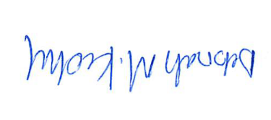
Deborah M. Krohn, M.Ed.
Global Health Program Advisor – College of Medicine and Life Sciences, Health Science Campus
Study Abroad Specialist – College of Business and Innovation, Main Campus
Scholarship Chair – Professional Staff Council
The University of Toledo
2801 W. Bancroft St.
Stranahan Hall, Room 1022 A/Mail Stop 103
Toledo, OH 43606
phone: 419.530.2549
fax: 419.530.5353
email: deborah.krohn@utoledo.edu

Revised 6/2019_DMK

If you are a 4th year UTCOMLS student participating in a traditional, month-long Global Health elective with one of our approved affiliate partners, please turn all required paperwork into Deborah Krohn, Global Health Program Advisor, at your pre-departure orientation. If you are a UT student participating in one of our approved UTCOMLS’ faculty-led, team-based medical missions, please turn all required paperwork into your student team leader(s) prior to your departure.
Please note all students are required to provide the Global Health Program with copies of their current passports. Passports must not expire within 6 months of student’s intended return date.
Deb Krohn will let you know if a visa is required for traditional, month-long Global Health electives and your UTCOMLS’ faculty team leader will inform you if a visa is required for your participation in his/her medical mission.
The monthly rate for this plan is $48.05. All rates are valid through July 31, 2019.

